

Faculty Hiring

Prioritization and Planning

Supporting Information

Educational Services and Technology

DRAFT-WORK IN PROGRESS-10/3/2013

**Fall 2013**

Contents

Purpose of this document 3

External Data 3

Employment 3

Orange County Labor Market 3

Emerging Industry Clusters 5

Industry Sector Overview 8

Occupational Overview 10

Education and workforce training trends 12

High School Graduate Trends in Orange County 12

Educational Attainment for the Population 25 Years and Over 16

Demographic Estimates for Coast District Service Area Cities 17

Internal Data 18

Students Enrolled at Coast Colleges 18

Students Enrolled (FTES) by College by Residency Status 18

Students Enrolled (FTES) by College by Discipline by Residency Status 19

Enrollments (Fall 2013 Census) in 200 Level Classes 25

Faculty 27

Faculty (FTEF) by College by Status (FT/PT) 27

Faculty (FTEF) by College by Discipline (6 Digit TOP Code) by Status (FT/PT) 27

No Full-Time Faculty at any College 49

Disciplines with No Full-Time Faculty at One College Where There is One at Another College 49

Productivity 50

WSCH/FTES (595) by College 50

WSCH/FTES (595) by College by Discipline 51

Student Course Success Rate by College 57

Student Course Success Rate by College by Discipline 57

Finance and Administration Perspective 64

Background 64

Recent Budget Strategy and Stability Funding 65

Strategic Direction and Growth 65

Current College Faculty Hiring Prioritization Processes 67

Process Description/Maps 67

Criteria Used at the Colleges for Prioritizing Faculty Requests 72

Data Elements Considered/Provided to the Prioritization Process 75

Forms Used at the College for Faculty Requests 76

# Purpose of this document

The purpose of this document is to prompt and inform the initial District-wide discussions of prioritizing and planning faculty hiring. It is not intended to be an exhaustive source of information but serve as collection of information regarding current processes and sample some of the internal and external information available to consider.

# External Data

## Employment

This section provides some vital employment statistics relative to Orange County and the nation. In terms of numbers of jobs, the largest industry sectors are professional, scientific and technical services, retail trade, health occupations and manufacturing.

### Orange County Labor Market

The following information provides an overview of the Orange County economy.

Source: 2012-13 Orange County Workforce Indicators Report.

<http://www.ocbc.org/wp>‐content/uploads/2012‐Workforce‐Indicators‐Report.pdf on April 26, 2013

**Note: The 2013-14 Orange County Workforce Indicators Report was just released on 10/3/2013 thus there was no time to update this report with the new information. The report has not been yet posted electronically on the OCBC web site. Inserted here are the summary findings in pdf format (*double-click on the image to open document*).**

PROJECTED LACK OF NEW JOB OPENINGS >> California’s Employment Development Department (EDD) estimates of new and replacement jobs through 2018 underscore the severity of the issue of Baby Boomers currently constraining the jobs which would traditionally fall to those just entering the workforce. New jobs are classified as openings due only to new additional job growth. Replacement jobs are defined as job openings created when workers retire or permanently leave an occupation. Actual future replacement jobs may not be as available as predicted because older generations are

pushing their retirement back.

Replacement jobs are largely concentrated in lower wage entry-level jobs in the following industries: office and administrative support; sales and related occupations; and food preparation and serving related occupations. These industries have median annual wages of $35,922, $30,659 and $19,406 respectively.

There is a trend of Baby Boomers occupying traditionally younger workforce starter jobs and using them as survival jobs. A possible explanation for this could arise from the way these jobs typically do not require extremely high levels of education but are rather built around experience. Baby Boomers, having been in the workforce longer than younger generations, are likely more qualified for these positions, if not overqualified. This older workforce cannot afford to start the long process of finding other high wage jobs because of increased competition and lack of availability.

As a result, young graduates may be unable to enter the workforce in meaningful ways or at the time they desire. Some continue advancing their education but this strategy does not securely prepare them for the economic future ahead. Even with the potential for higher eventual salaries, many students take out large student loans and accrue debt for years after graduation. Prolonged uncertainty about current and future job market trends will continue to hamper the employment and career prospects of this generation.

Orange County is home to many high-tech industries. It is a leader in several emerging technologies including advanced transportation, alternative fuels, medical devices and computer gaming. The workforce is IT savvy and there are large concentrations of colleges and universities, business incubators and venture capital investment firms.

A recent U.S. Department of Labor Workforce Innovation Fund grant was awarded to Orange County for an Information Technology Cluster Competitiveness Project. This helped establish a three-year partnership between industry, and the education and workforce training system. The partnership will engage business and education leaders in collaborative planning to help address the training needs of Orange County businesses.

Though the economy appears to be slowly turning the corner, unemployment remains high and consumer and business spending has been slow to improve. Many older workers have been forced into early retirement with others working longer than expected due to losses in retirement accounts and home values.

From 2007-2010, Orange County lost approximately 162,000 jobs or 10.7% of its payroll employment. The largest decline was in the construction industry, 28.6%. There has been some recent job growth but not rapid. The two industry sectors that suffered the least amount of decline are also those recovering the quickest. These include health services and tourism. The unemployment rate is projected to stay above 7% through 2013.

There are two components to “job openings”, new jobs and replacement jobs. Replacement jobs are openings created when workers retire or permanently leave an occupation. These types of openings are not being seen in large numbers because many older workers are pushing back retirement. Though baby boomers are typically well educated, they currently occupy many jobs traditionally considered workforce starter jobs. They are using them as survival jobs. This is making it difficult for young graduates to find work in their fields of study. Some continue their education, but this involves taking on more debt.

The job openings that are being seen are primarily concentrated in lower wage, entry-level jobs in office and admin support, sales and related occupations, and food prep and serving. These occupations have median wages of $35,922, $30,659 and $19,406 respectively.

As the population becomes more ethnically diversified, and the education system faces increasing financial pressures, Orange County will have difficulty providing a well-prepared workforce for industry. Increased college tuition exacerbates this problem.

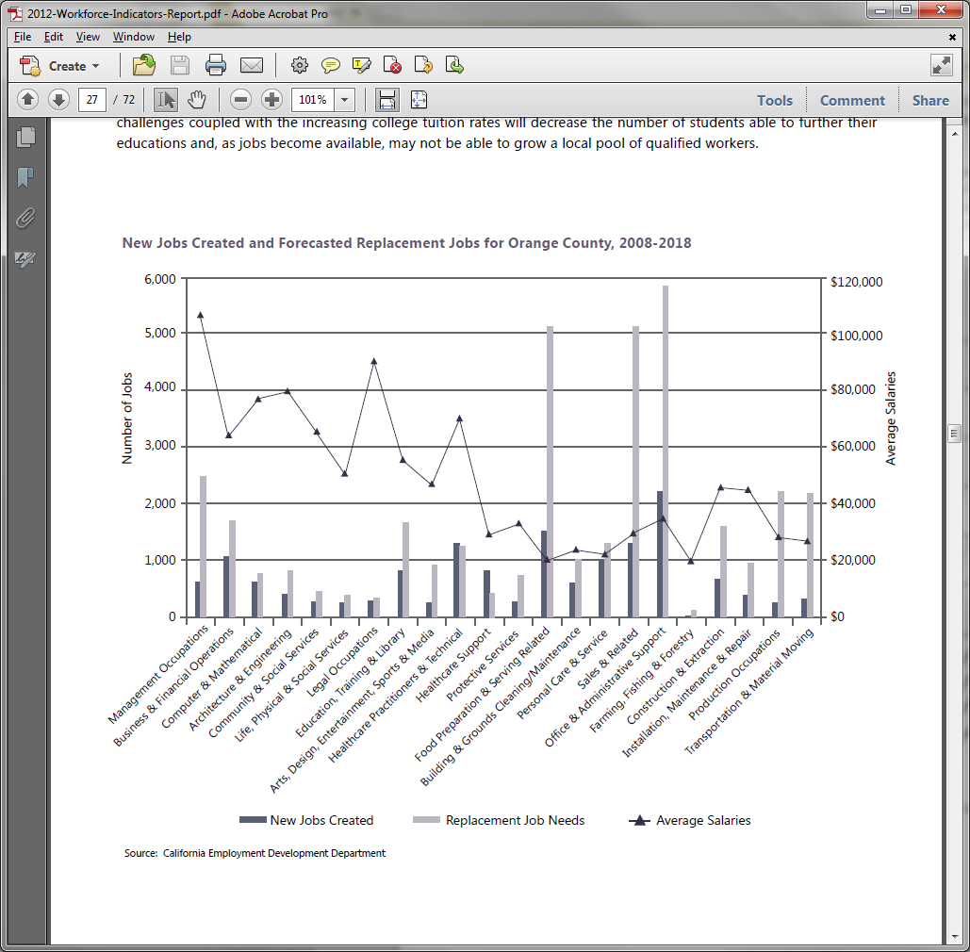

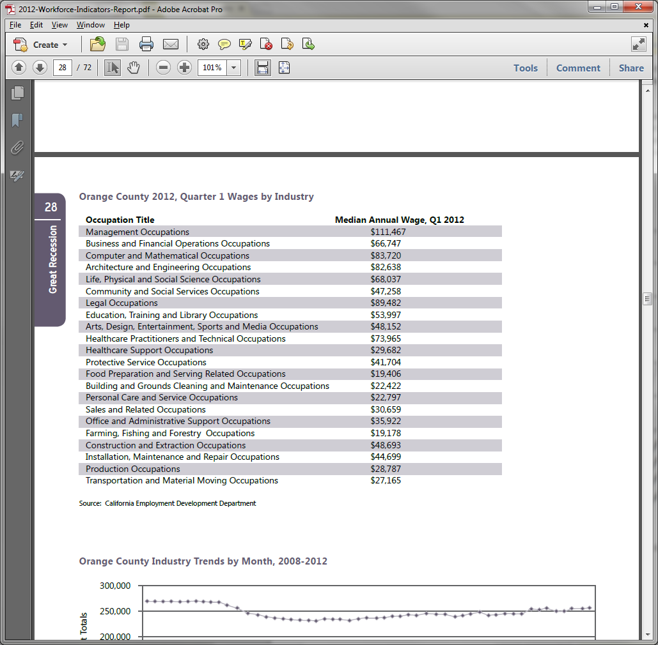

### Emerging Industry Clusters

Programs and policies should support emerging industries, or the drivers of industry clusters, to accelerate their growth and proliferation throughout traditional industry clusters. International trade, information technology, creativity and green/clean tech are helping to drive employment growth and high wage, high multiplier occupations. The recession hampered the potential growth of these industries, yet they have rebounded well and are expected to not only help grow traditional sectors but, in time, become major sources of employment and revenue for the county.

Orange County is in the midst of transitioning into a knowledge based, post-Great Recession economy. Because of the

Great Recession, many of the traditional high wage jobs of the past have disappeared and will not be coming back. New opportunities, however, are creating high wage jobs as a result of social and economic changes in the last decade due

to international trade, information technology (IT), creativity and green/clean tech—four emerging industries that are blurring traditional cluster boundaries.

These four drivers overlay and crosscut traditional clusters, offering a better understanding of the county’s workforce needs. Education and workforce development professionals began understanding the importance of these clusters in designing education and development policies. Orange County Workforce Investment Board and Orange County

Business Council started to track crosscutting clusters several years ago.

This section explores these interrelationships and how each driver overlaps and enhances existing cluster industries, creating both horizontal and vertical clusters. For example, while there are firms that are solely information technology (such as computer software and game developers such as Blizzard Entertainment), there are information technology functions and occupations within all other clusters. Creativity-oriented occupations are important components across clusters as well, such as architecture/interior design overlapping in the business and professional services, construction and tourism clusters.

These four drivers are increasingly important in developing and maintaining competitive advantage in Orange County’s clusters. They generate value-creating jobs and initiate economic growth.

According to the estimated employment in 2011, international trade, information technology, creativity and cleantech are helping to drive employment growth and high-wage, high-multiplier occupations. While the recession did hamper potential growth of these industries, they have rebounded well and are expected to not only help grow traditional sectors but, in time, become major sources of employment and revenue for the county. International trade, information technology, creativity and green/clean tech added approximately 278,691 jobs. In the past year, jobs increased in international trade and information technology, while employment in the creativity sector slightly declined and green technology moderately declined:

• International Trade: 156,997

• Information Technology: 66,236

• Creativity: 37,200

• Green Technology: 18,258

**INTERNATIONAL TRADE >>** Orange County’s geographic location provides it with distinct advantages regarding international trade. Some of these advantages include proximity to the ports of Long Beach and Los Angeles; a well-connected freeway and road system for trucking; rail lines providing national trade linkages; proximity to international and domestic airports; and a large and growing presence of an ethnically diverse population. Combine these significant trade factors with Orange County’s large and competitive manufacturing base, namely in computer software, electronics and transportation equipment. The county continues to rapidly cultivate trade relationships with growing economies such as China, Japan, South Korea, Mexico and Canada. These economic and employment opportunities emerge to drive the county’s robust global trade industry.

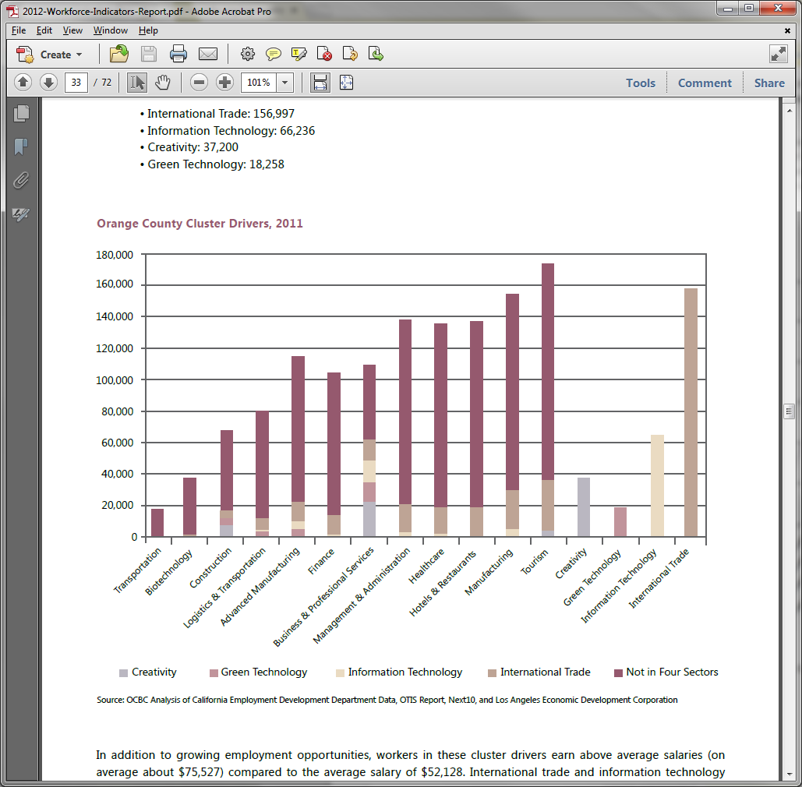

California State University, Fullerton’s Institute for Economic and Environmental Studies recently released its *2011*

*International Trade Economic Forecast: An Overview of Orange County and Southern California Exports*, which estimates that international trade accounts for well over 10 percent of Orange County’s gross product and employs nearly 500,000 residents in Southern California. From 2003 to 2007, the total volume of exports grew an average of 13 percent with export values reaching $19.7 billion in 2008—nearly doubling levels seen almost a decade ago. Although, with the onset of the Great Recession, exports experienced drastic declines and fell by 14.9 percent from $19.7 billion to $16.7 billion in 2009. Recovery from this decline is projected to occur within the next two to three years with export levels increasing by 20.8 percent in 2010, followed by increases of 12.9 percent in 2011, 7.2 percent in 2012, and 10.1 percent in 2013.

Orange County mainly exports to five countries, including Canada, China, Japan, South Korea and Mexico. Export growth is based on the expansion of the economies of those countries. China’s economy expanded by 9.2 percent in 2011, at which time South Korea’s increased by 3.5 percent and Canada’s by 2.5 percent.

The two most dominant export sectors for the county were transportation equipment and computer and electronic products. These sectors combined accounted for approximately 41.3 percent of total exports in 2008. Other large export trade sectors for Orange County include miscellaneous, chemical, machinery, petroleum and coal products, and food.

Exports of transportation equipment experienced the largest decline from 2008 to 2009 of over $1 billion, and are not expected to attain pre-recession levels by 2012. On the other hand, computer and electronic products are slated for significant growth in the near future, reaching former 2008 export levels by 2010 and growing further by 2012. By 2013,

Orange County expects exports of $6.1 billion in computers and electronic products, increasing from $3.8 billion in 2009.

Furthermore, transportation equipment exports are expected to grow to $5.5 billion in 2013—up from $3.3 billion in 2009.

**INFORMATION TECHNOLOGY >>** A highly skilled information technology workforce is essential to driving economic growth in a fast growing knowledge-based economy. Specialized skills—often requiring education or experience in science, technology, engineering and mathematics—are critical to supporting innovation in fields as diverse as computers, medicine and communication.

Orange County has long been a leader in computer and electronic software, service and product manufacturing, and a major portion of international exports are based on these products. Information technology occupations, namely those that connect businesses and provide computer software products and services, have aided in driving employment of various industries in the county. Professional and business services industries rely greatly on information technology for day-to-day operations with features such as email, video conferencing, cloud technologies and various computer software programs. These new technologies have allowed businesses to become more connected to their customers and promote business-to-business connections, which allow for increased collaborations and subsequently the expansion of this industry.

The average salary for the information technology industry is $86,000, almost $34,000 more than the average industry salary in the county. According to California’s Employment Development Department, the highest wage occupation in the information technology industry is that of software publishers who earn an average of $144,404 annually.

This industry will be the main driver of employment and economic activity in the county. California’s Employment

Development Department reported that three of the top six occupations with the most job ads/openings in Orange

County were related to information technology—such as web developers, computer systems analysts and computer software engineers/applications.

**CREATIVITY >>** Orange County’s increasing focus on STEM (science, technology, engineering, math) as a critical competitive advantage has evolved into an emphasis on STEAM (science, technology, engineering, arts, math). The creativity sector is the market impact of businesses and individuals involved in producing cultural, artistic, and design goods and services. More specifically, it consists of creative professionals and enterprises that take powerful, original ideas and transform them into practical and often innovative goods, or inspire with their artistry.

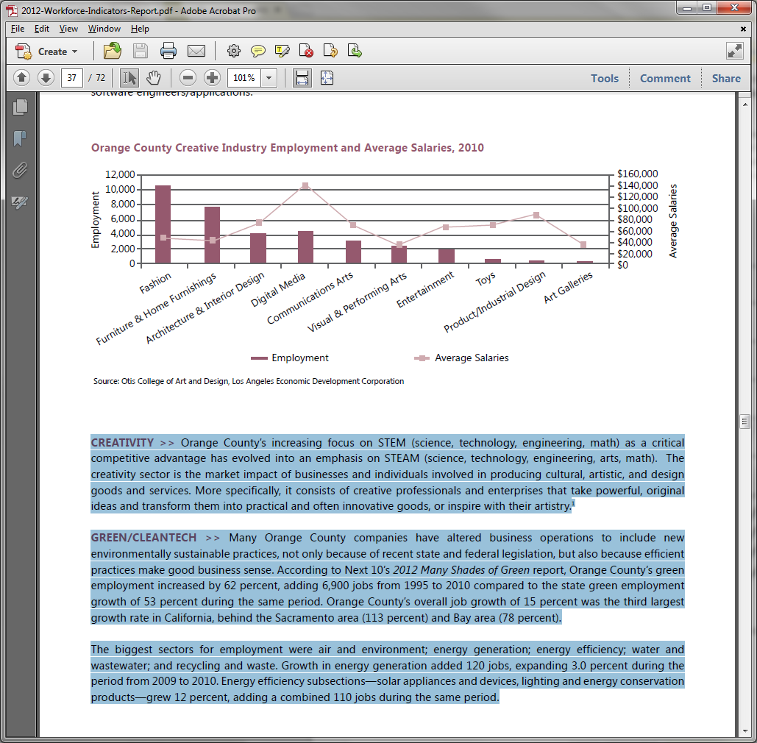

**GREEN/CLEANTECH >>** Many Orange County companies have altered business operations to include new environmentally sustainable practices, not only because of recent state and federal legislation, but also because efficient practices make good business sense. According to Next 10’s *2012 Many Shades of Green* report, Orange County’s green employment increased by 62 percent, adding 6,900 jobs from 1995 to 2010 compared to the state green employment growth of 53 percent during the same period. Orange County’s overall job growth of 15 percent was the third largest growth rate in California, behind the Sacramento area (113 percent) and Bay area (78 percent).

The biggest sectors for employment were air and environment; energy generation; energy efficiency; water and wastewater; and recycling and waste. Growth in energy generation added 120 jobs, expanding 3.0 percent during the period from 2009 to 2010. Energy efficiency subsections—solar appliances and devices, lighting and energy conservation products—grew 12 percent, adding a combined 110 jobs during the same period.

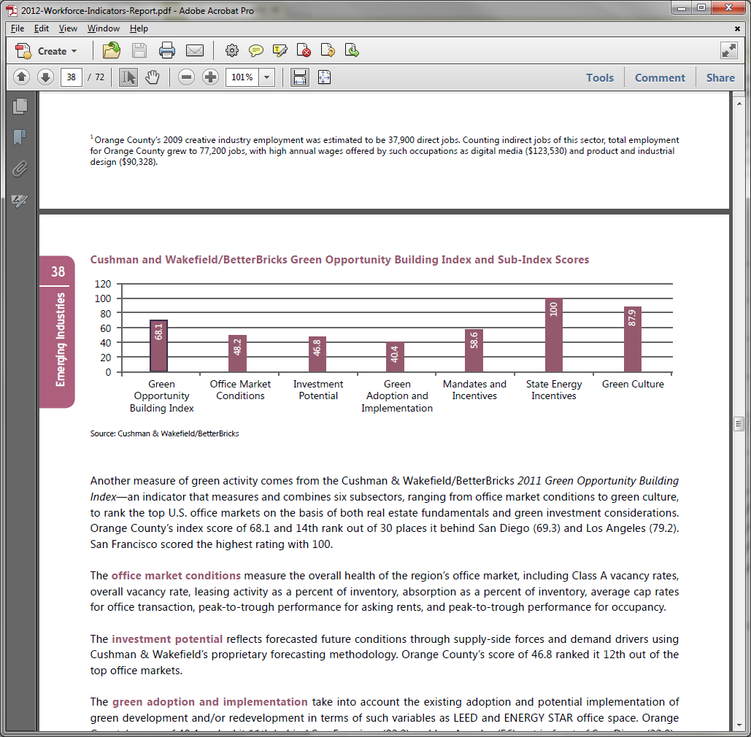

Another measure of green activity comes from the Cushman & Wakefield/BetterBricks *2011 Green Opportunity Building*

*Index*—an indicator that measures and combines six subsectors, ranging from office market conditions to green culture, to rank the top U.S. office markets on the basis of both real estate fundamentals and green investment considerations.

Orange County’s index score of 68.1 and 14th rank out of 30 places it behind San Diego (69.3) and Los Angeles (79.2).

San Francisco scored the highest rating with 100.

The **office market conditions** measure the overall health of the region’s office market, including Class A vacancy rates, overall vacancy rate, leasing activity as a percent of inventory, absorption as a percent of inventory, average cap rates for office transaction, peak-to-trough performance for asking rents, and peak-to-trough performance for occupancy.

The **investment potential** reflects forecasted future conditions through supply-side forces and demand drivers using

Cushman & Wakefield’s proprietary forecasting methodology. Orange County’s score of 46.8 ranked it 12th out of the top office markets.

The **green adoption and implementation** take into account the existing adoption and potential implementation of green development and/or redevelopment in terms of such variables as LEED and ENERGY STAR office space. Orange

County’s score of 40.4 ranked it 11th behind San Francisco (83.2) and Los Angeles (56), yet in front of San Diego (32.9).

The **mandates and incentives** assess a local market’s commitment to sustainable building practices through legislative mandates and incentives to build and refurbish green development, capital investments and retrofits. Orange County ranked 13th, along with San Diego but behind San Francisco and Los Angeles.

The **state energy incentives** measure utility and public benefit funds, efficiency programs and policies, building energy codes, appliance efficiency standards, financial and information incentives, and research and development. All cities located in California scored 100 on this measure.

The **green culture** measures the green economy, land use and planning measures, walkability and public transportation.

Orange County scored 87.9, behind San Francisco (100) and San Diego at (88.1), but in front of Los Angeles (85.4).

### Industry Sector Overview

In 2010, California’s Employment Development Department released its 2008— 2018 employment projections for Orange County. While there are still six years left in the projected time frame, current numbers propose a different story. Projections estimated that Orange County’s industry sector employment would grow by 8.4 percent, but since the beginning of 2008 industry employment has fallen by 6.8 percent. This gap between the current and projected employment growth is a result of the uncertainty and lasting impacts of the Great Recession.

When looking at the industries that California’s Employment Development Department projected to grow the fastest— both in terms of absolute and percentage growth—during the 2008 to 2018 period, there is a more diverse picture. While some are on track to meet or exceed the projections, others are far behind or have experienced employment loss since 2008. The professional, scientific and technical services industry was projected to increase the most in terms of absolute growth but instead lost 6,100 jobs. The administrative and support services followed with a 4,900 loss in employment.

In terms of percentage growth, hospitals (private) and warehousing and storage were projected to be among the top 10 fastest growing industries, yet experienced an 11.6 percent and 10.2 percent decrease, respectively. Other industries are on track to exceed EDD projections, such as ambulatory healthcare services and social assistance industries, which saw gains of 9,100 and 15.6 percent, respectively.

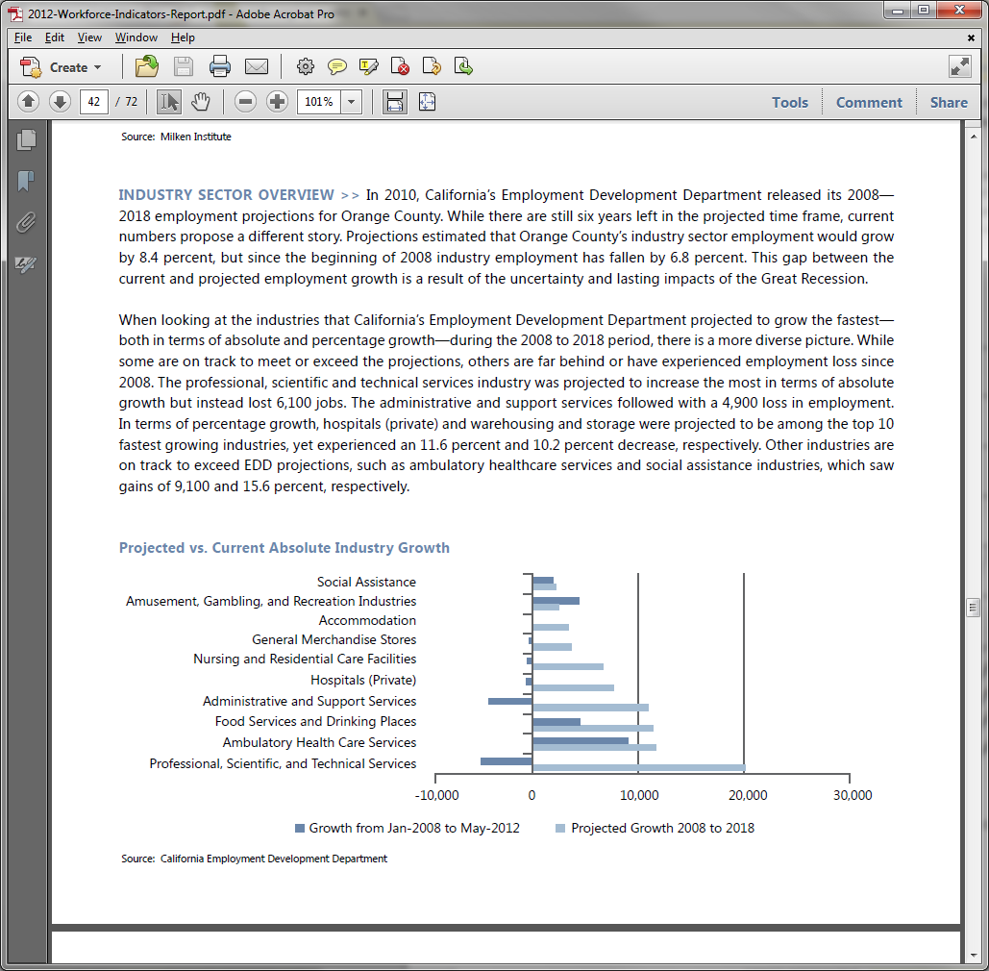

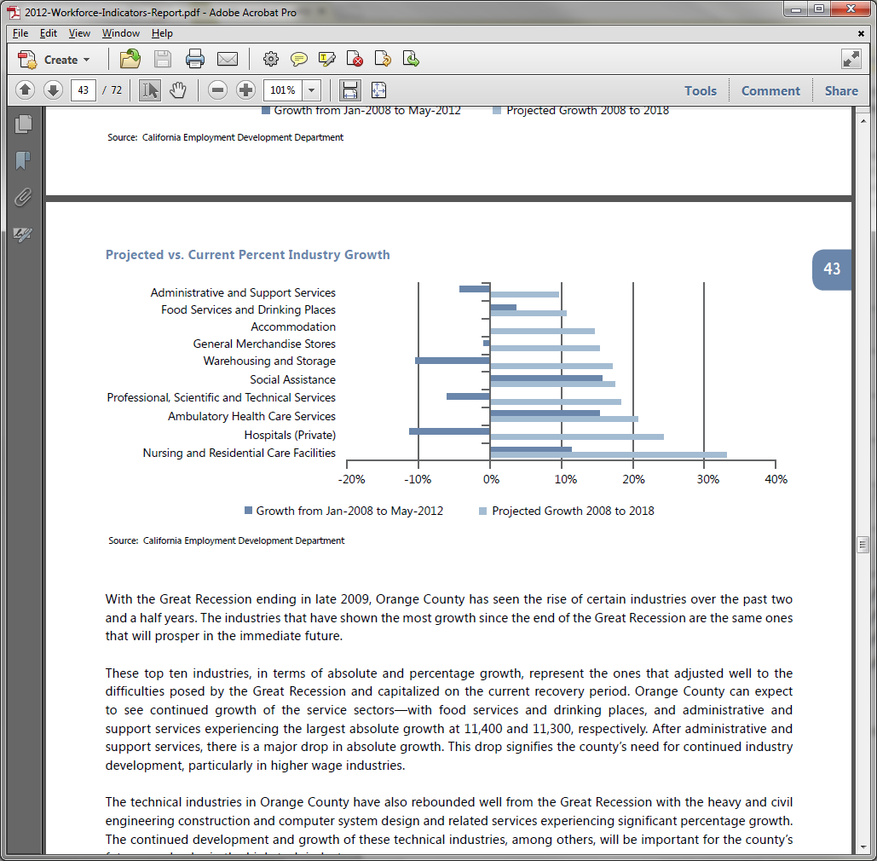

Orange County has seen the rise of certain industries over the past two and a half years. The industries that have shown the most growth since the end of the Great Recession are the same ones that will prosper in the immediate future.

These top ten industries, in terms of absolute and percentage growth, represent the ones that adjusted well to the difficulties posed by the Great Recession and capitalized on the current recovery period. Orange County can expect to see continued growth of the service sectors—with food services and drinking places, and administrative and support services experiencing the largest absolute growth at 11,400 and 11,300, respectively. After administrative and support services, there is a major drop in absolute growth. This drop signifies the county’s need for continued industry development, particularly in higher wage industries.

The technical industries in Orange County have also rebounded well from the Great Recession with the heavy and civil engineering construction and computer system design and related services experiencing significant percentage growth. The continued development and growth of these technical industries, among others, will be important for the county’s future as a leader in the high-tech industry.

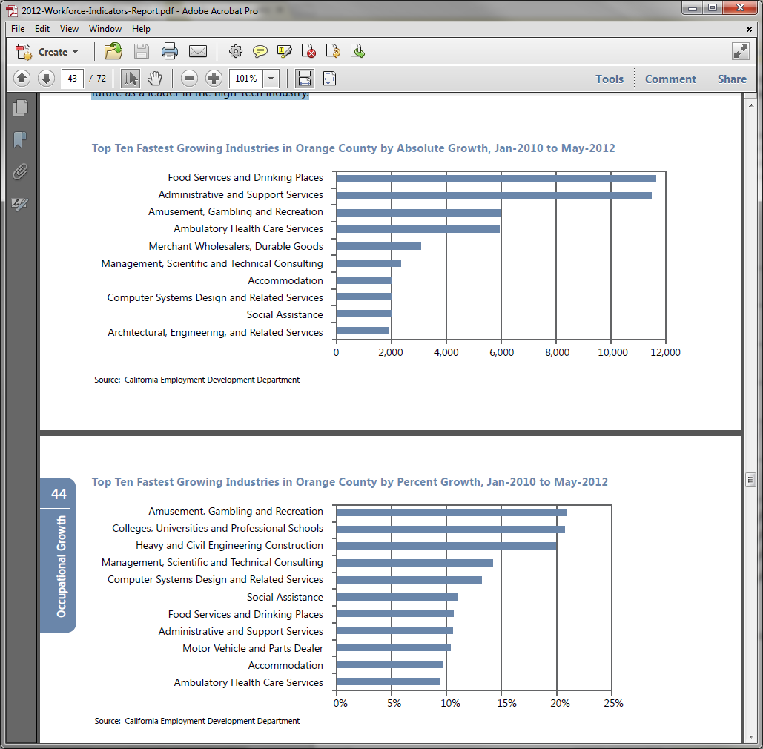



### Occupational Overview

During the 2008 to 2018 period, California’s Employment Development Department projected that Orange County would add 135,000 jobs by 2018. Although, estimates indicate that the county currently has 7,500 fewer jobs than 2008 levels. This decrease is the result of major losses during the Great Recession from 2008 to the end of 2009. Since 2010, relatively steady employment growth has added approximately 30,000 jobs to the Orange County economy. Occupations identified as the fastest growing in terms of absolute growth have kept pace with or exceeded the EDD projections. Only home health aides, medical secretaries and dental assistants experienced minor net declines since 2008. With the exception of those three, the healthcare industry continues to grow and be a strong presence in the county.

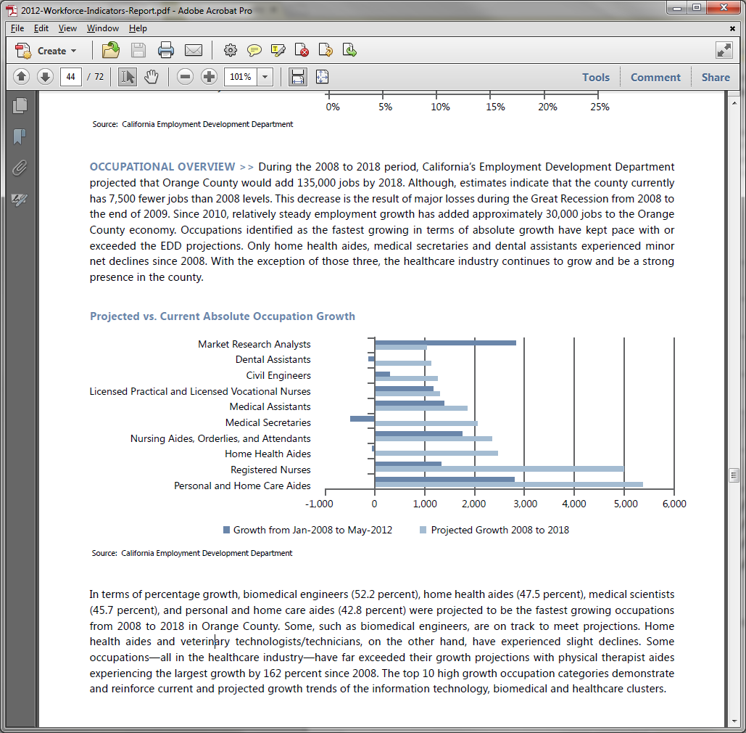

Five of the 10 high growth occupations have salaries above $50,000 and are split between the high-tech, management and administration, and healthcare clusters. Many fast growing occupations pay above average salaries, as often workforce demand exceeds the existing supply of skilled workers, leading to workforce shortages. Fast growing occupation categories are ripe areas to consider for targeted education and workforce programs.

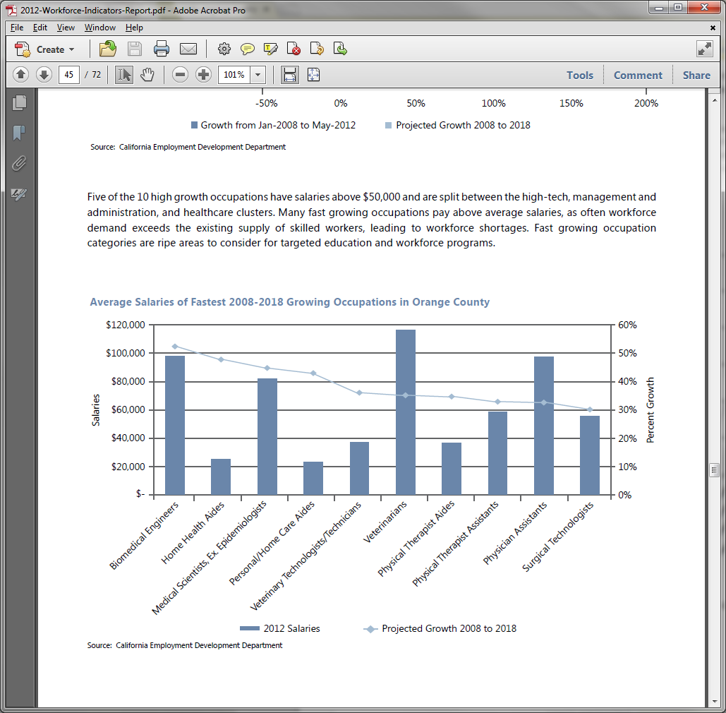

## Education and workforce training trends

### High School Graduate Trends in Orange County

Orange County high school graduation projections through 2021-22 are expected to be steady and oscillate between 35,000 and 38,000 students.

As of 2010—2011, approximately 43 percent of Orange County high school students were eligible for entry into the UC/CSU university systems. This rate shows a significant improvement with a seven percent increase in the past year.

However, this latest increase has only been the most recent upturn in a series of ups and downs in the eligibility rate since 2006.

While Asians continue to have the highest levels of eligibility, the issue arises in the eligibility of Orange County’s minority populations. Current efforts to address the low rates have clearly had an impact on the Latino population, which experienced an increase of over 10 percent in their eligibility rate over the past year. This increase was significant, but the

African American and Latino eligibility rates in Orange County continue to perform poorly compared to other ethnicities and remain below the state levels.

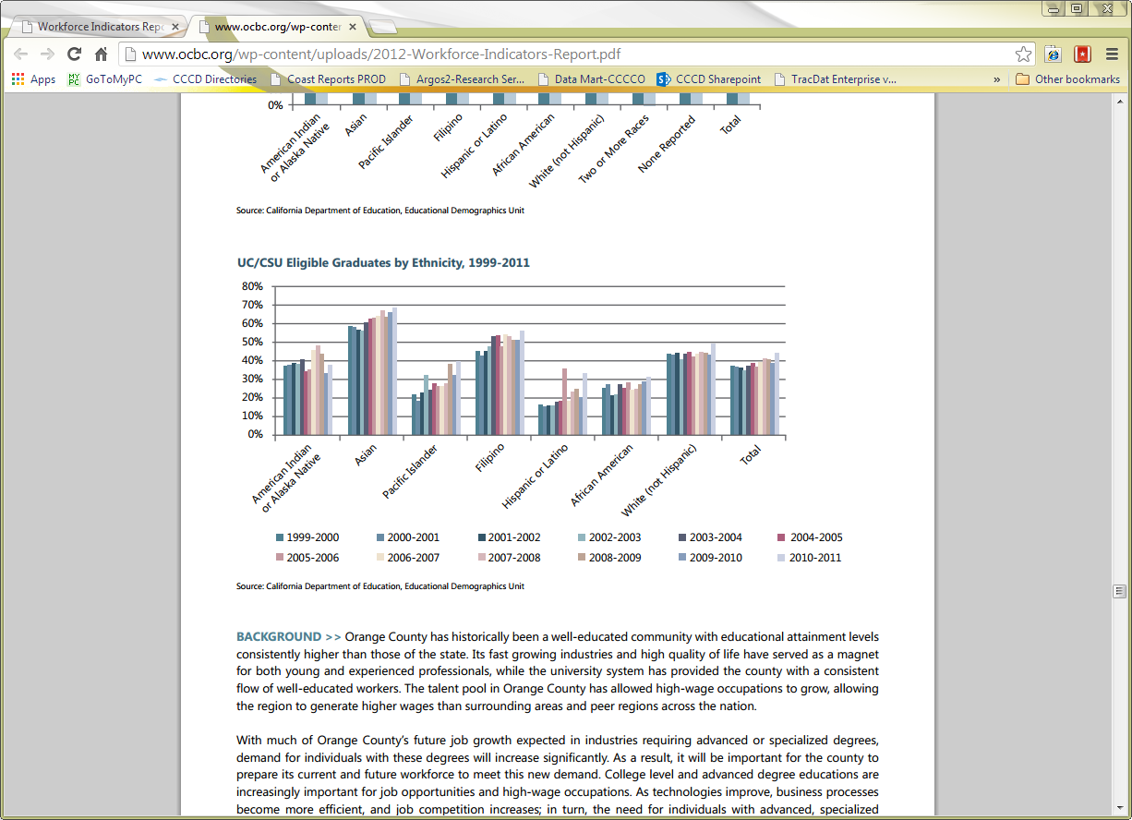

Orange County has historically been a well-educated community with educational attainment levels consistently higher than those of the state. Its fast growing industries and high quality of life have served as a magnet for both young and experienced professionals, while the university system has provided the county with a consistent flow of well-educated workers. The talent pool in Orange County has allowed high-wage occupations to grow, allowing the region to generate higher wages than surrounding areas and peer regions across the nation.

With much of Orange County’s future job growth expected in industries requiring advanced or specialized degrees, demand for individuals with these degrees will increase significantly. As a result, it will be important for the county to prepare its current and future workforce to meet this new demand. College level and advanced degree educations are increasingly important for job opportunities and high-wage occupations. As technologies improve, business processes become more efficient, and job competition increases; in turn, the need for individuals with advanced, specialized degrees increases dramatically

HIGH SCHOOL EXIT EXAM PERFORMANCE >> Orange County high school students are required to take the High School Exit Exam in order to graduate. Exit exams provide another tool in measuring cumulative student achievement.

As of 2012, Orange County high schools students had an exam pass rate of 88 percent for English language arts and 89 percent for mathematics. These are the highest rates experienced for both subjects, and exceed the state pass rates of

83% for English and 84% for mathematics.

Santa Ana Unified School District’s High School Exit Exam pass rates are the lowest in the county and lower than statewide rates. While pass rates for Santa Ana schools have experienced an absolute increase in recent years, they are still well below average county rates and those of neighboring school districts.

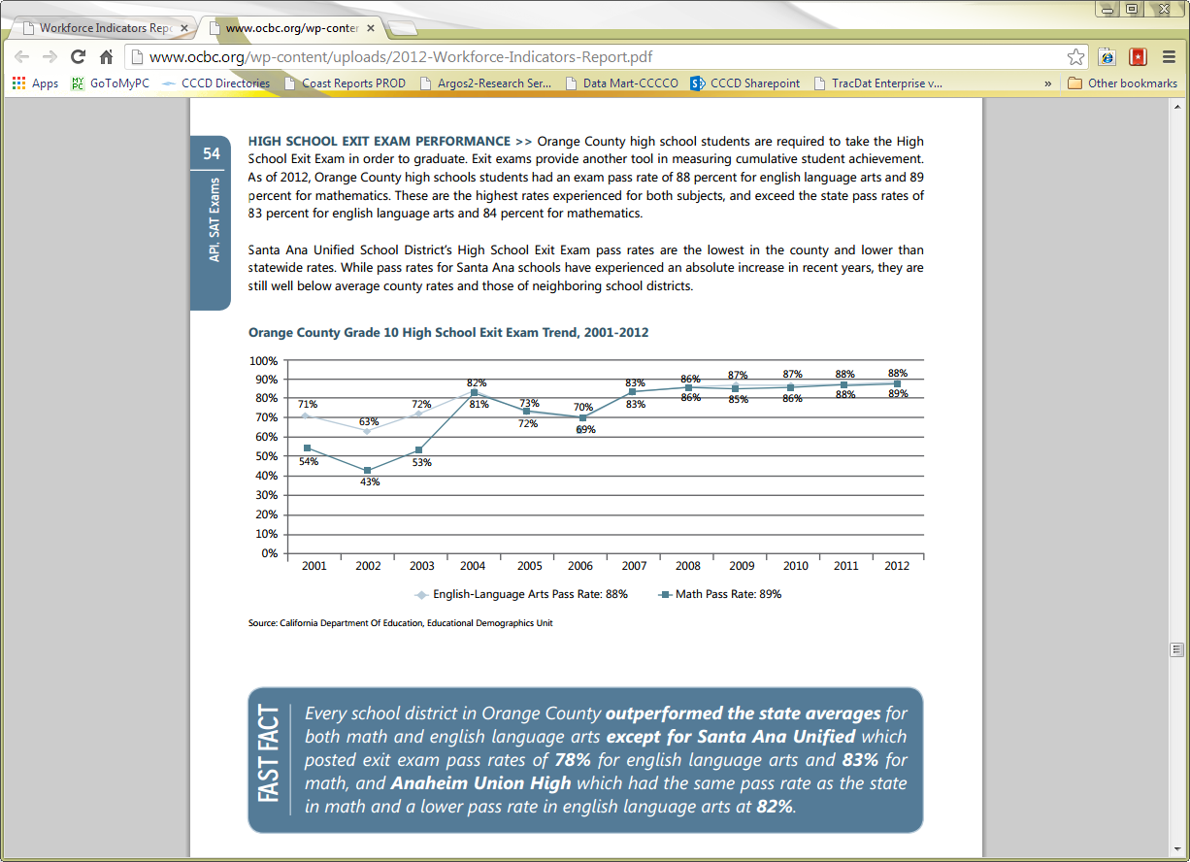

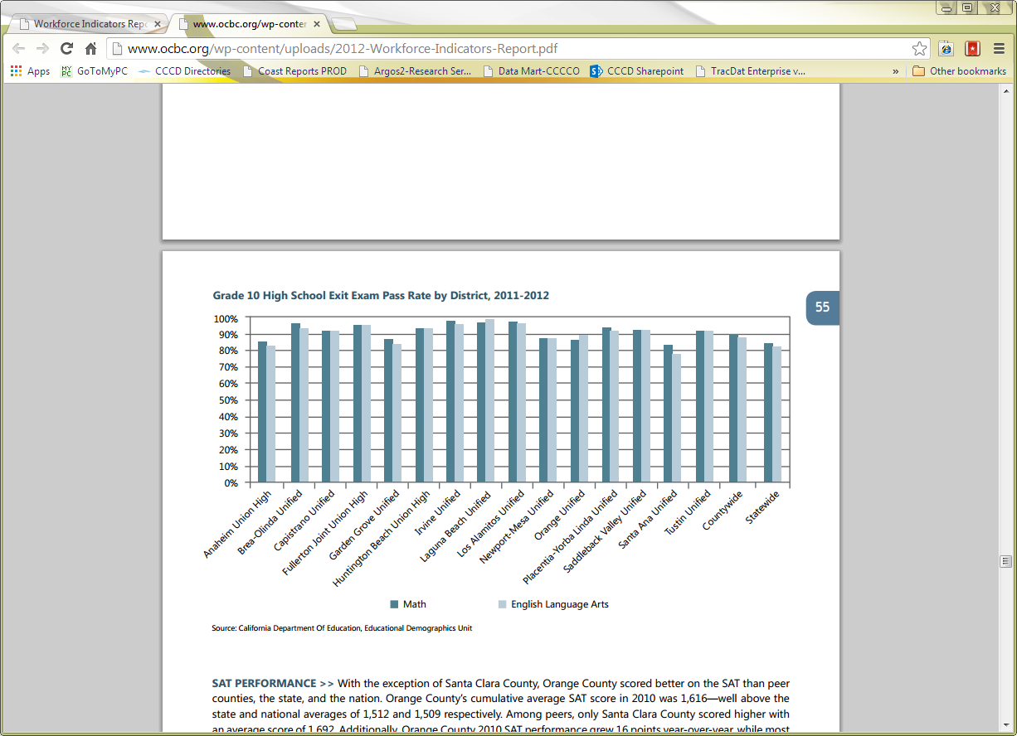

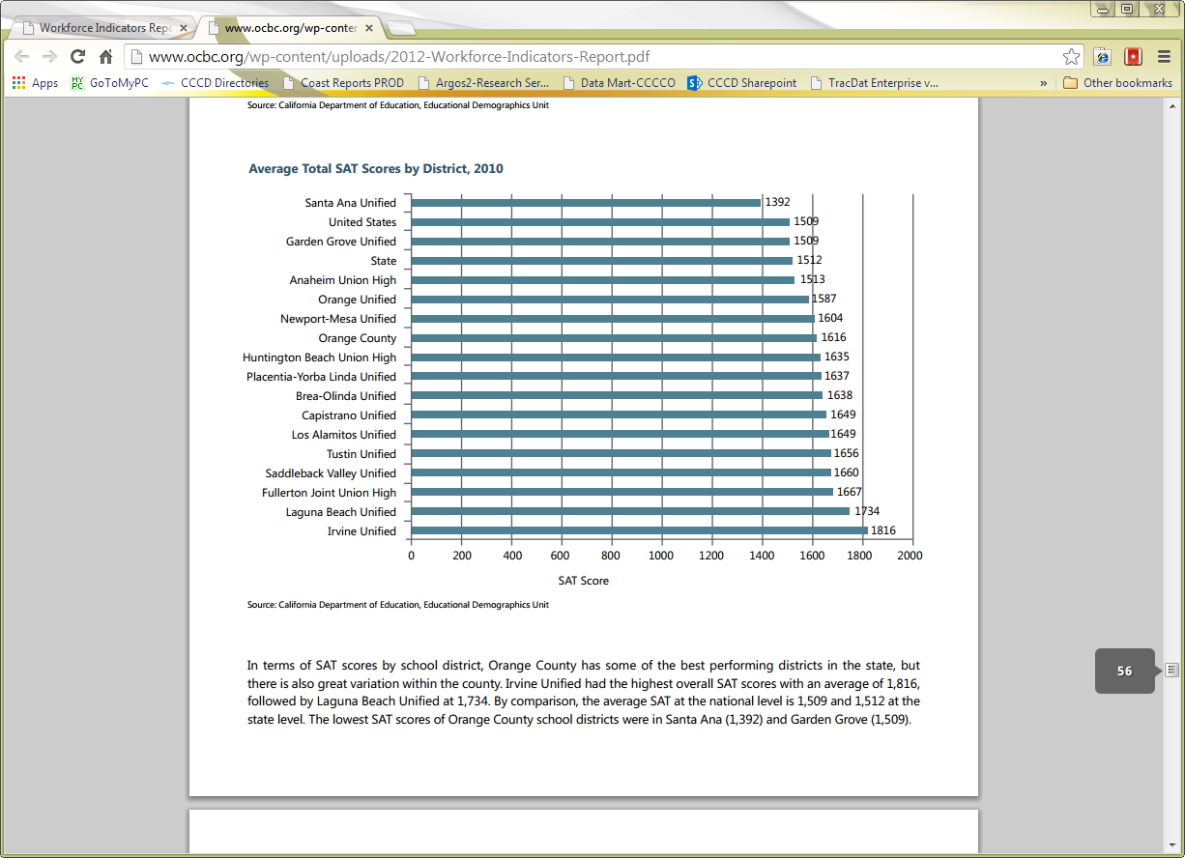

In terms of SAT scores by school district, Orange County has some of the best performing districts in the state, but there is also great variation within the county. Irvine Unified had the highest overall SAT scores with an average of 1,816, followed by Laguna Beach Unified at 1,734. By comparison, the average SAT at the national level is 1,509 and 1,512 at the state level. The lowest SAT scores of Orange County school districts were in Santa Ana (1,392) and Garden Grove (1,509).

### Educational Attainment for the Population 25 Years and Over

|  |  |  |  |  |  |  |  |  |  |  |  |  |  |  |  |  |  |  |
| --- | --- | --- | --- | --- | --- | --- | --- | --- | --- | --- | --- | --- | --- | --- | --- | --- | --- | --- |
| Cities Within the Coast District Service Area |  | |  | | |  | | |  | | | |  | | |  |  | |
|  | CM | | FV | | | GG | | | HB | | | | NPB | | | SB | West minster | |
| No schooling completed | 1,188 | 478 | | | 6,470 | | | 871 | | | | 197 | | | 247 | | 3,002 | |
| Nursery school | 0 | 0 | | | 2,435 | | | 43 | | | | 0 | | | 27 | | 65 | |
| Kindergarten | 0 | 0 | | | 0 | | | 53 | | | | 0 | | | 0 | | 38 | |
| 1st grade | 0 | 144 | | | 0 | | | 0 | | | | 0 | | | 0 | | 104 | |
| 2nd grade | 399 | 40 | | | 0 | | | 20 | | | | 0 | | | 26 | | 101 | |
| 3rd grade | 278 | 0 | | | 0 | | | 312 | | | | 62 | | | 0 | | 267 | |
| 4th grade | 131 | 43 | | | 0 | | | 135 | | | | 17 | | | 23 | | 305 | |
| 5th grade | 267 | 229 | | | 6,612 | | | 39 | | | | 95 | | | 48 | | 565 | |
| 6th grade | 2,989 | 444 | | | 0 | | | 983 | | | | 169 | | | 0 | | 1,931 | |
| 7th grade | 498 | 53 | | | 2,886 | | | 187 | | | | 20 | | | 21 | | 513 | |
| 8th grade | 1,209 | 192 | | | 0 | | | 787 | | | | 13 | | | 84 | | 585 | |
| 9th grade | 1,090 | 117 | | | 2,759 | | | 907 | | | | 240 | | | 0 | | 1,743 | |
| 10th grade | 1,167 | 614 | | | 1,999 | | | 452 | | | | 185 | | | 137 | | 1,721 | |
| 11th grade | 1,472 | 494 | | | 1,799 | | | 823 | | | | 187 | | | 207 | | 1,488 | |
| 12th grade, no diploma | 1,695 | 963 | | | 4,158 | | | 2,644 | | | | 292 | | | 217 | | 3,368 | |
| Regular hs diploma | 12,272 | 6,219 | | | 24,719 | | | 23,212 | | | | 5,683 | | | 3,039 | | 12,691 | |
| GED or alternative | 1,231 | 884 | | | 1,864 | | | 2,168 | | | | 497 | | | 207 | | 1,629 | |
| Some college, less than 1 year | 4,033 | 2,833 | | | 8,155 | | | 9,200 | | | | 1,802 | | | 1,400 | | 3,237 | |
| Some college, 1 or more years, no degree | 13,093 | 7,494 | | | 20,721 | | | 25,368 | | | | 9,873 | | | 3,679 | | 10,318 | |
| Associate's degree | 7,678 | 4,049 | | | 8,809 | | | 15,131 | | | | 4,133 | | | 1,819 | | 5,356 | |
| Bachelor's degree | 19,157 | 9,960 | | | 15,072 | | | 35,923 | | | | 23,867 | | | 4,826 | | 9,593 | |
| Master's degree | 5,510 | 3,367 | | | 4,082 | | | 12,592 | | | | 9,061 | | | 2,749 | | 2,064 | |
| Professional school degree | 1,883 | 1,036 | | | 1,312 | | | 4,583 | | | | 5,113 | | | 686 | | 586 | |
| Doctorate degree | 780 | 431 | | | 278 | | | 2,600 | | | | 2,113 | | | 464 | | 320 | |
| Total: | 78,020 | 40,084 | | 114,130 | | | 139,033 | | | | 63,619 | | | 19,906 | | | 61,590 | |
|  |  | |  | | |  | | | |  | | |  | | |  | |  |
| Source: US Census |  | |  | | |  | | | |  | | |  | | |  | |  |
| 2009-11 American Community Survey (ACS) |  | |  | | |  | | | |  | | |  | | |  | |  |
| <http://factfinder2.census.gov/> |  | |  | | |  | | | |  | | |  | | |  | |  |

### Demographic Estimates for Coast District Service Area Cities

Total population 728,199

|  |  |  |  |  |  |  |  |  |  |  |  |  |  |  |  |  |  |  |  |  |  |  |  |  |  |  |  |  |  |  |  |  |  |  |  |  |  |  |  |  |  |  |  |  |  |  |  |  |  |  |  |  |  |  |  |  |  |  |  |  |  |  |  |  |  |  |  |  |  |  |  |  |  |  |  |  |  |  |  |  |  |  |  |  |  |  |  |  |  |  |  |  |  |  |  |  |  |  |  |  |  |  |  |  |  |  |  |  |  |  |  |  |  |  |  |  |  |  |  |  |  |  |  |  |  |  |  |  |  |  |  |  |  |  |  |  |  |  |  |  |  |  |  |  |  |  |  |  |  |  |  |  |  |  |  |  |  |  |  |  |  |  |  |  |  |  |  |  |  |  |  |  |  |  |  |  |  |  |  |  |  |  |  |  |  |  |  |  |  |  |  |  |  |  |  |  |  |  |  |  |  |  |  |  |  |  |  |  |  |  |  |  |  |  |  |  |  |  |  |  |  |  |  |
| --- | --- | --- | --- | --- | --- | --- | --- | --- | --- | --- | --- | --- | --- | --- | --- | --- | --- | --- | --- | --- | --- | --- | --- | --- | --- | --- | --- | --- | --- | --- | --- | --- | --- | --- | --- | --- | --- | --- | --- | --- | --- | --- | --- | --- | --- | --- | --- | --- | --- | --- | --- | --- | --- | --- | --- | --- | --- | --- | --- | --- | --- | --- | --- | --- | --- | --- | --- | --- | --- | --- | --- | --- | --- | --- | --- | --- | --- | --- | --- | --- | --- | --- | --- | --- | --- | --- | --- | --- | --- | --- | --- | --- | --- | --- | --- | --- | --- | --- | --- | --- | --- | --- | --- | --- | --- | --- | --- | --- | --- | --- | --- | --- | --- | --- | --- | --- | --- | --- | --- | --- | --- | --- | --- | --- | --- | --- | --- | --- | --- | --- | --- | --- | --- | --- | --- | --- | --- | --- | --- | --- | --- | --- | --- | --- | --- | --- | --- | --- | --- | --- | --- | --- | --- | --- | --- | --- | --- | --- | --- | --- | --- | --- | --- | --- | --- | --- | --- | --- | --- | --- | --- | --- | --- | --- | --- | --- | --- | --- | --- | --- | --- | --- | --- | --- | --- | --- | --- | --- | --- | --- | --- | --- | --- | --- | --- | --- | --- | --- | --- | --- | --- | --- | --- | --- | --- | --- | --- | --- | --- | --- | --- | --- | --- | --- | --- | --- | --- | --- | --- | --- | --- | --- | --- |
| |  |  |  | | --- | --- | --- | | GENDER |  |  | | Male | 362,904 | 49.8% | | Female | 365,295 | 50.2% | |  |  |  | | AGE |  |  | | Under 5 years | 39,543 | 5.4% | | 5 to 9 years | 42,033 | 5.8% | | 10 to 14 years | 44,556 | 6.1% | | 15 to 19 years | 47,821 | 6.6% | | 20 to 24 years | 48,857 | 6.7% | | 25 to 34 years | 102,529 | 14.1% | | 35 to 44 years | 104,205 | 14.3% | | 45 to 54 years | 108,376 | 14.9% | | 55 to 59 years | 45,355 | 6.2% | | 60 to 64 years | 40,164 | 5.5% | | 65 to 74 years | 55,635 | 7.6% | | 75 to 84 years | 33,399 | 4.6% | | 85 years and over | 15,726 | 2.2% | |  |  |  | | Median age (years) |  |  | |  |  |  | | 18 years and over | 573,255 | 78.7% | | 21 years and over | 544,417 | 74.8% | | 62 years and over | 128,928 | 17.7% | | 65 years and over | 104,760 | 14.4% | |  |  |  | | 18 years and over | 573,255 | 78.7% | | Male | 282,419 | 38.8% | | Female | 290,836 | 39.9% | |  |  |  | | 65 years and over | 104,760 | 14.4% | | Male | 45,855 | 6.3% | | Female | 58,905 | 8.1% | | Race   |  |  |  | | --- | --- | --- | | Total population | 728,199 | 100.0% | | One race | 708,525 | 97.3% | | Two or more races | 19,674 | 2.7% | |  |  |  | | One race | 708,525 | 97.3% | | White | 458,694 | 63.0% | | Black or African American | 7,863 | 1.1% | | Am Indian and Alaska Native | 2,542 | 0.3% | | Asian | 165,202 | 22.7% | | Asian Indian | 5,296 | 0.7% | | Chinese | 16,059 | 2.2% | | Filipino | 9,419 | 1.3% | | Japanese | 8,904 | 1.2% | | Korean | 11,608 | 1.6% | | Vietnamese | 103,533 | 14.2% | | Other Asian | 10,383 | 1.4% | | Native Hawaiian and Other | 4,147 | 0.6% | | Native Hawaiian | 41 | 0.0% | | Guamanian or Chamorro | 44 | 0.0% | | Samoan | 786 | 0.1% | | Other Pacific Islander | 840 | 0.1% | | Some other race | 70,077 | 9.6% | | Two or more races | 19,674 | 2.7% | |  |  |  | | Some other race | 74,199 | 10.2% | |  |  |  | | HISPANIC OR LATINO AND RACE |  |  | | Total population | 728,199 | 100.0% | | Hispanic or Latino (of any race) | 176,646 | 24.3% | | Mexican | 146,977 | 20.2% | | Puerto Rican | 2,591 | 0.4% | | Cuban | 1,989 | 0.3% | | Other Hispanic or Latino | 25,089 | 3.4% | | Not Hispanic or Latino | 551,553 | 75.7% | | White alone | 359,402 | 49.4% | | Black or African American alone | 6,840 | 0.9% | | Am Indian and Ala Native alone | 1,462 | 0.2% | | Asian alone | 164,467 | 22.6% | | Nat Hawaiian and Othr Pac Isl | 3,583 | 0.5% | | Some other race alone | 1,441 | 0.2% | | Two or more races | 14,358 | 2.0% | |

Source: U.S. Census, 2009-11 American Community Survey 3-Year

# Internal Data

## Students Enrolled at Coast Colleges

### Students Enrolled (FTES) by College by Residency Status

|  |  |  |  |  |  |  |  |  |  |  |  |  |  |  |  |
| --- | --- | --- | --- | --- | --- | --- | --- | --- | --- | --- | --- | --- | --- | --- | --- |
| Academic Year | 2008-2009 | | | 2009-2010 | | | 2010-2011 | | | 2011-2012 | | | 2012-2013 | | |
| College | FTES Intl | FTES OOS | FTES Res | FTES Intl | FTES OOS | FTES Res | FTES Intl | FTES OOS | FTES Res | FTES Intl | FTES OOS | FTES Res | FTES Intl | FTES OOS | FTES Res |
| CCC | 172 | 268 | 6,593 | 107 | 283 | 5,810 | 75 | 163 | 5,737 | 71 | 113 | 5,700 | 65 | 94 | 5,213 |
| CCC M/CE | 0 | 456 | 5 | 0 | 390 | 5 | 0 | 0 | 0 | 0 | 0 | 0 | 0 | 0 | 0 |
| GWC | 310 | 111 | 10,480 | 318 | 115 | 10,677 | 276 | 129 | 10,601 | 240 | 117 | 10,102 | 203 | 99 | 9,172 |
| OCC | 863 | 411 | 20,022 | 859 | 423 | 19,526 | 803 | 401 | 18,732 | 761 | 334 | 17,850 | 718 | 274 | 15,907 |
| Total | 1,346 | 1,246 | 37,099 | 1,284 | 1,211 | 36,017 | 1,154 | 693 | 35,070 | 1,072 | 563 | 33,653 | 986 | 467 | 30,292 |

Source: CCCD Enrollment Productivity Data Cube (filtered out classes with an attendance accounting method of ‘Other FTES Exempt ‘ classes)

Intl-International Students, OOS-Out of State

### Students Enrolled (FTES) by College by Discipline by Residency Status

| Academic Year |  | 2008-2009 | | | 2009-2010 | | | 2010-2011 | | | 2011-2012 | | | 2012-2013 | | |
| --- | --- | --- | --- | --- | --- | --- | --- | --- | --- | --- | --- | --- | --- | --- | --- | --- |
| Subject | Site | FTES Intl | FTES OOS | FTES Res | FTES Intl | FTES OOS | FTES Res | FTES Intl | FTES OOS | FTES Res | FTES Intl | FTES OOS | FTES Res | FTES Intl | FTES OOS | FTES Res |
| Accounting | CCC | 2 | 1 | 132 | 3 | 2 | 181 | 2 | 5 | 199 | 3 | 2 | 188 | 3 | 2 | 175 |
|  | GWC | 16 | 2 | 292 | 18 | 3 | 263 | 17 | 3 | 241 | 13 | 2 | 207 | 11 | 2 | 199 |
|  | OCC | 27 | 7 | 448 | 35 | 10 | 483 | 32 | 12 | 463 | 28 | 9 | 478 | 34 | 7 | 397 |
| Airline Travel | OCC | 9 | 0 | 19 | 4 | 0 | 11 | 1 | 0 | 7 | 1 | 0 | 7 | 1 | 0 | 7 |
| Allied Health | OCC | 1 | 1 | 109 | 0 | 2 | 106 | 1 | 1 | 102 | 1 | 1 | 94 | 1 | 2 | 99 |
| Am Sign Lang | CCC | 0 | 0 | 5 | 0 | 0 | 4 | 0 | 0 | 5 | 0 | 0 | 0 | 0 | 0 | 0 |
|  | GWC | 1 | 1 | 116 | 1 | 1 | 138 | 1 | 0 | 133 | 1 | 0 | 116 | 1 | 1 | 99 |
| Amer Studies | OCC | 3 | 1 | 23 | 2 | 0 | 19 | 1 | 0 | 17 | 0 | 0 | 0 | 0 | 0 | 0 |
| Anthropology | CCC | 0 | 0 | 40 | 0 | 0 | 40 | 0 | 0 | 36 | 0 | 0 | 45 | 0 | 0 | 46 |
|  | GWC | 2 | 2 | 162 | 2 | 2 | 147 | 3 | 2 | 160 | 2 | 1 | 158 | 2 | 1 | 131 |
|  | OCC | 17 | 8 | 380 | 12 | 8 | 344 | 12 | 7 | 309 | 15 | 6 | 320 | 12 | 5 | 289 |
| Arabic | CCC | 0 | 0 | 8 | 0 | 0 | 8 | 0 | 0 | 8 | 0 | 0 | 3 | 0 | 0 | 0 |
| Architecture | GWC | 2 | 1 | 58 | 1 | 0 | 53 | 1 | 0 | 21 | 0 | 0 | 3 | 0 | 0 | 3 |
|  | OCC | 14 | 2 | 150 | 12 | 2 | 184 | 15 | 3 | 182 | 14 | 3 | 190 | 9 | 2 | 161 |
| Art | CCC | 5 | 5 | 330 | 4 | 7 | 328 | 3 | 2 | 248 | 2 | 1 | 205 | 1 | 1 | 212 |
|  | CCCM | 0 | 20 | 1 | 0 | 17 | 0 | 0 | 0 | 0 | 0 | 0 | 0 | 0 | 0 | 0 |
|  | GWC | 5 | 3 | 286 | 4 | 2 | 330 | 9 | 3 | 346 | 5 | 3 | 320 | 7 | 3 | 260 |
|  | OCC | 36 | 12 | 649 | 34 | 12 | 633 | 27 | 13 | 577 | 26 | 9 | 560 | 26 | 7 | 523 |
| Astronomy | CCC | 0 | 1 | 84 | 0 | 0 | 24 | 0 | 1 | 46 | 0 | 0 | 21 | 0 | 0 | 27 |
|  | CCCM | 0 | 23 | 0 | 0 | 19 | 0 | 0 | 0 | 0 | 0 | 0 | 0 | 0 | 0 | 0 |
|  | GWC | 2 | 1 | 59 | 1 | 1 | 60 | 1 | 1 | 65 | 1 | 0 | 60 | 1 | 0 | 54 |
|  | OCC | 3 | 1 | 118 | 2 | 1 | 73 | 1 | 1 | 59 | 1 | 1 | 41 | 2 | 2 | 96 |
| Auto Collision | GWC | 0 | 0 | 79 | 0 | 0 | 0 | 0 | 0 | 0 | 0 | 0 | 0 | 0 | 0 | 0 |
| Automotive Technology | GWC | 1 | 1 | 106 | 1 | 1 | 162 | 1 | 0 | 225 | 2 | 2 | 213 | 3 | 0 | 169 |
| Aviation Maint Tech | OCC | 0 | 0 | 99 | 0 | 0 | 109 | 5 | 1 | 119 | 8 | 0 | 111 | 7 | 1 | 107 |
| Pilot Train | OCC | 1 | 0 | 35 | 0 | 1 | 54 | 1 | 1 | 49 | 1 | 1 | 60 | 1 | 2 | 54 |
| Biology | CCC | 5 | 5 | 474 | 4 | 3 | 417 | 6 | 4 | 454 | 3 | 2 | 488 | 5 | 2 | 456 |
|  | CCCM | 0 | 51 | 1 | 0 | 39 | 0 | 0 | 0 | 0 | 0 | 0 | 0 | 0 | 0 | 0 |
|  | GWC | 32 | 8 | 1,000 | 32 | 6 | 1,052 | 26 | 9 | 1,009 | 21 | 10 | 1,006 | 21 | 7 | 820 |
|  | OCC | 32 | 18 | 933 | 30 | 16 | 901 | 31 | 11 | 845 | 24 | 12 | 827 | 27 | 11 | 770 |
| Broadcast & Vid Prod | GWC | 1 | 0 | 32 | 0 | 0 | 39 | 0 | 0 | 1 | 0 | 0 | 0 | 0 | 0 | 0 |
| Broadcasting | OCC | 0 | 0 | 4 | 0 | 0 | 3 | 0 | 0 | 4 | 0 | 0 | 5 | 0 | 0 | 3 |
| Building Codes Tech | CCC | 0 | 0 | 34 | 0 | 0 | 39 | 0 | 0 | 42 | 0 | 0 | 39 | 0 | 0 | 25 |
| Building Tech | CCC | 0 | 0 | 5 | 0 | 0 | 0 | 0 | 0 | 0 | 0 | 0 | 0 | 0 | 0 | 0 |
| Business | CCC | 1 | 1 | 512 | 1 | 1 | 307 | 1 | 2 | 281 | 1 | 2 | 266 | 1 | 1 | 290 |
|  | CCCM | 0 | 16 | 0 | 0 | 15 | 0 | 0 | 0 | 0 | 0 | 0 | 0 | 0 | 0 | 0 |
|  | GWC | 7 | 3 | 193 | 10 | 2 | 184 | 8 | 3 | 162 | 6 | 2 | 174 | 6 | 2 | 164 |
|  | OCC | 16 | 12 | 443 | 17 | 12 | 436 | 17 | 12 | 392 | 15 | 11 | 363 | 14 | 5 | 283 |
| Bus Comp | CCC | 0 | 1 | 92 | 0 | 2 | 162 | 1 | 1 | 149 | 1 | 0 | 135 | 0 | 0 | 90 |
| CardioTech | OCC | 2 | 0 | 86 | 0 | 0 | 77 | 0 | 0 | 71 | 0 | 0 | 70 | 0 | 0 | 70 |
| Chemistry | CCC | 1 | 2 | 149 | 3 | 1 | 139 | 1 | 1 | 134 | 1 | 0 | 110 | 0 | 1 | 141 |
|  | GWC | 17 | 4 | 342 | 19 | 5 | 365 | 19 | 5 | 365 | 19 | 4 | 353 | 14 | 3 | 344 |
|  | OCC | 27 | 9 | 534 | 28 | 6 | 552 | 26 | 6 | 523 | 27 | 7 | 498 | 20 | 5 | 462 |
| Chinese | CCC | 0 | 0 | 11 | 0 | 0 | 15 | 1 | 0 | 17 | 0 | 0 | 11 | 1 | 0 | 11 |
|  | GWC | 2 | 0 | 13 | 2 | 0 | 14 | 1 | 0 | 16 | 0 | 0 | 0 | 0 | 0 | 0 |
| Coll Success | GWC | 4 | 2 | 113 | 5 | 1 | 105 | 6 | 1 | 99 | 3 | 0 | 92 | 4 | 1 | 78 |
| Comm Studies | CCC | 0 | 1 | 131 | 0 | 1 | 83 | 0 | 1 | 88 | 0 | 0 | 49 | 1 | 1 | 67 |
|  | CCCM | 0 | 41 | 1 | 0 | 27 | 0 | 0 | 0 | 0 | 0 | 0 | 0 | 0 | 0 | 0 |
|  | GWC | 12 | 4 | 292 | 10 | 2 | 280 | 9 | 3 | 284 | 8 | 2 | 251 | 6 | 2 | 219 |
|  | OCC | 0 | 0 | 0 | 0 | 0 | 0 | 0 | 0 | 0 | 16 | 10 | 557 | 20 | 9 | 502 |
| Computer & High Tech | OCC | 1 | 0 | 5 | 0 | 0 | 9 | 0 | 0 | 11 | 0 | 0 | 11 | 0 | 0 | 8 |
| Comp Bus A | GWC | 3 | 0 | 81 | 2 | 1 | 90 | 2 | 1 | 97 | 2 | 1 | 85 | 1 | 0 | 59 |
| CIS | CCC | 0 | 0 | 13 | 0 | 1 | 21 | 1 | 0 | 27 | 0 | 0 | 29 | 0 | 0 | 31 |
|  | CCCM | 0 | 3 | 0 | 0 | 4 | 0 | 0 | 0 | 0 | 0 | 0 | 0 | 0 | 0 | 0 |
|  | OCC | 16 | 5 | 370 | 18 | 6 | 380 | 10 | 4 | 326 | 10 | 3 | 311 | 15 | 3 | 296 |
| Computer Sci | CCCM | 0 | 1 | 0 | 0 | 0 | 0 | 0 | 0 | 0 | 0 | 0 | 0 | 0 | 0 | 0 |
|  | GWC | 9 | 1 | 152 | 11 | 2 | 169 | 12 | 1 | 182 | 10 | 1 | 200 | 9 | 1 | 193 |
|  | OCC | 10 | 1 | 118 | 9 | 1 | 126 | 7 | 3 | 128 | 7 | 1 | 145 | 7 | 2 | 143 |
| Computer Services Tech | CCC | 0 | 0 | 118 | 0 | 0 | 145 | 1 | 1 | 139 | 2 | 1 | 151 | 0 | 1 | 126 |
| Constr Tech | OCC | 1 | 2 | 162 | 0 | 1 | 174 | 0 | 2 | 178 | 0 | 1 | 151 | 0 | 0 | 130 |
| Coop Work Experience | GWC | 0 | 0 | 0 | 0 | 0 | 0 | 0 | 0 | 3 | 0 | 0 | 14 | 0 | 0 | 12 |
| Cosmetology | GWC | 8 | 2 | 485 | 15 | 3 | 468 | 8 | 6 | 478 | 5 | 3 | 418 | 2 | 4 | 435 |
| Counseling | CCC | 2 | 0 | 278 | 2 | 1 | 128 | 1 | 1 | 129 | 1 | 1 | 140 | 1 | 0 | 112 |
|  | GWC | 1 | 1 | 82 | 2 | 1 | 82 | 1 | 1 | 85 | 1 | 1 | 72 | 0 | 0 | 63 |
|  | OCC | 3 | 3 | 142 | 3 | 3 | 139 | 4 | 3 | 143 | 3 | 2 | 135 | 4 | 2 | 131 |
| Crim Justice | GWC | 0 | 2 | 433 | 0 | 4 | 372 | 0 | 2 | 390 | 0 | 1 | 354 | 0 | 2 | 304 |
| Culinary Arts | OCC | 2 | 1 | 129 | 4 | 1 | 122 | 3 | 1 | 118 | 1 | 1 | 114 | 1 | 1 | 104 |
| Dance | CCC | 1 | 0 | 28 | 0 | 0 | 29 | 0 | 0 | 25 | 0 | 0 | 25 | 0 | 0 | 0 |
|  | GWC | 1 | 1 | 65 | 2 | 0 | 73 | 1 | 0 | 59 | 1 | 0 | 41 | 1 | 0 | 32 |
|  | OCC | 10 | 4 | 228 | 7 | 3 | 230 | 5 | 2 | 209 | 4 | 2 | 187 | 6 | 2 | 177 |
| Dental Assist | OCC | 0 | 0 | 44 | 0 | 0 | 44 | 0 | 1 | 40 | 0 | 0 | 42 | 0 | 0 | 39 |
| Design | GWC | 1 | 0 | 25 | 1 | 0 | 33 | 0 | 0 | 35 | 0 | 1 | 41 | 0 | 0 | 44 |
|  | OCC | 0 | 0 | 1 | 0 | 0 | 0 | 0 | 0 | 0 | 0 | 0 | 0 | 0 | 0 | 0 |
| Diagn Med Sonography | OCC | 4 | 4 | 99 | 0 | 0 | 92 | 0 | 0 | 86 | 0 | 0 | 93 | 0 | 0 | 89 |
| Diesel Technology | GWC | 0 | 0 | 27 | 0 | 0 | 0 | 0 | 0 | 0 | 0 | 0 | 0 | 0 | 0 | 0 |
| Digital Arts | GWC | 1 | 1 | 147 | 2 | 2 | 146 | 1 | 2 | 142 | 1 | 1 | 121 | 1 | 0 | 115 |
| Digital Graphic Appl | CCC | 0 | 0 | 29 | 0 | 0 | 44 | 0 | 0 | 56 | 0 | 0 | 61 | 0 | 0 | 56 |
| Digital Media | GWC | 0 | 0 | 0 | 0 | 0 | 0 | 0 | 0 | 61 | 1 | 0 | 62 | 1 | 0 | 61 |
| Digital Media Arts & Design | OCC | 18 | 4 | 182 | 19 | 2 | 177 | 13 | 5 | 196 | 9 | 3 | 183 | 9 | 2 | 178 |
| Display & Visual Pres | OCC | 1 | 0 | 3 | 0 | 0 | 2 | 0 | 0 | 3 | 0 | 0 | 3 | 0 | 0 | 3 |
| Drafting | GWC | 0 | 0 | 33 | 0 | 0 | 33 | 0 | 0 | 27 | 0 | 0 | 24 | 0 | 0 | 27 |
|  | OCC | 3 | 2 | 100 | 1 | 1 | 65 | 1 | 0 | 23 | 0 | 0 | 4 | 0 | 0 | 0 |
| Early Childh | OCC | 1 | 0 | 78 | 1 | 0 | 67 | 1 | 1 | 63 | 1 | 0 | 61 | 1 | 0 | 71 |
| Ecology | CCC | 0 | 0 | 36 | 0 | 0 | 20 | 0 | 0 | 14 | 0 | 0 | 11 | 0 | 0 | 0 |
|  | CCCM | 0 | 3 | 0 | 0 | 3 | 0 | 0 | 0 | 0 | 0 | 0 | 0 | 0 | 0 | 0 |
|  | GWC | 0 | 0 | 7 | 0 | 0 | 8 | 0 | 0 | 8 | 0 | 0 | 8 | 0 | 0 | 8 |
|  | OCC | 2 | 1 | 38 | 3 | 0 | 35 | 2 | 1 | 33 | 2 | 1 | 32 | 1 | 0 | 18 |
| Economics | CCC | 2 | 1 | 65 | 1 | 1 | 59 | 2 | 1 | 59 | 1 | 0 | 59 | 1 | 1 | 61 |
|  | GWC | 5 | 1 | 85 | 9 | 1 | 78 | 8 | 1 | 65 | 8 | 1 | 100 | 6 | 1 | 94 |
|  | OCC | 20 | 12 | 370 | 22 | 11 | 324 | 19 | 8 | 282 | 20 | 5 | 255 | 18 | 4 | 194 |
| Education | CCC | 0 | 0 | 23 | 0 | 0 | 23 | 0 | 0 | 16 | 0 | 0 | 17 | 0 | 0 | 16 |
|  | GWC | 0 | 0 | 16 | 0 | 0 | 17 | 0 | 0 | 14 | 0 | 0 | 14 | 0 | 0 | 9 |
|  | OCC | 0 | 0 | 21 | 0 | 0 | 17 | 0 | 0 | 14 | 0 | 0 | 0 | 0 | 0 | 0 |
| Electr Tech | OCC | 0 | 1 | 51 | 2 | 1 | 52 | 0 | 0 | 49 | 0 | 1 | 51 | 0 | 1 | 51 |
| Emerg Mgmt | CCC | 0 | 0 | 7 | 0 | 0 | 20 | 0 | 0 | 28 | 0 | 0 | 44 | 0 | 0 | 38 |
| Emerg Med Services | OCC | 0 | 0 | 0 | 0 | 0 | 0 | 0 | 0 | 0 | 0 | 0 | 0 | 0 | 0 | 30 |
| Emergency Medical Tech | OCC | 1 | 0 | 52 | 0 | 1 | 49 | 1 | 1 | 72 | 0 | 1 | 33 | 0 | 0 | 1 |
| Engineering | OCC | 1 | 0 | 13 | 0 | 0 | 12 | 1 | 0 | 12 | 1 | 0 | 8 | 1 | 0 | 8 |
| Engineer Tech | GWC | 0 | 0 | 13 | 0 | 0 | 19 | 0 | 0 | 7 | 0 | 0 | 5 | 0 | 0 | 6 |
| English | CCC | 4 | 2 | 238 | 4 | 2 | 281 | 4 | 3 | 260 | 3 | 3 | 289 | 4 | 2 | 293 |
|  | GWC | 25 | 9 | 768 | 28 | 11 | 736 | 21 | 8 | 727 | 21 | 9 | 730 | 15 | 5 | 683 |
|  | OCC | 43 | 30 | 1,527 | 44 | 30 | 1,411 | 42 | 31 | 1,404 | 39 | 25 | 1,416 | 41 | 19 | 1,259 |
| Writing Center | GWC | 4 | 0 | 50 | 6 | 1 | 58 | 4 | 1 | 53 | 4 | 1 | 54 | 3 | 1 | 41 |
| ESL | CCC | 125 | 204 | 373 | 61 | 225 | 540 | 30 | 118 | 631 | 38 | 80 | 634 | 33 | 60 | 502 |
|  | GWC | 23 | 5 | 230 | 21 | 4 | 247 | 12 | 7 | 230 | 10 | 5 | 223 | 9 | 5 | 202 |
|  | OCC | 137 | 13 | 313 | 128 | 16 | 312 | 119 | 11 | 295 | 107 | 14 | 283 | 92 | 11 | 204 |
| Envir Studies | GWC | 1 | 0 | 22 | 0 | 1 | 30 | 0 | 0 | 34 | 1 | 1 | 64 | 1 | 1 | 27 |
| Ethnic Studies | OCC | 1 | 1 | 59 | 1 | 1 | 66 | 1 | 2 | 67 | 2 | 1 | 62 | 1 | 1 | 53 |
| Family & Consumer Sci | OCC | 0 | 0 | 6 | 0 | 0 | 7 | 0 | 0 | 5 | 0 | 0 | 0 | 0 | 0 | 0 |
| Farsi | GWC | 0 | 0 | 3 | 0 | 0 | 0 | 0 | 0 | 0 | 0 | 0 | 0 | 0 | 0 | 0 |
| Fashion | OCC | 8 | 4 | 145 | 6 | 3 | 125 | 8 | 3 | 126 | 8 | 2 | 121 | 3 | 1 | 101 |
| Film & Video | OCC | 18 | 7 | 342 | 16 | 8 | 326 | 15 | 8 | 289 | 13 | 5 | 226 | 11 | 5 | 224 |
| Floral Design | GWC | 1 | 0 | 43 | 2 | 0 | 44 | 0 | 0 | 39 | 0 | 0 | 39 | 0 | 0 | 36 |
| Food Service Management | OCC | 5 | 0 | 98 | 5 | 2 | 99 | 5 | 1 | 111 | 3 | 1 | 105 | 2 | 1 | 105 |
| Foods & Nutr | CCC | 0 | 1 | 124 | 0 | 1 | 70 | 0 | 1 | 85 | 0 | 1 | 100 | 0 | 1 | 71 |
|  | OCC | 4 | 3 | 87 | 2 | 1 | 95 | 4 | 1 | 96 | 3 | 1 | 76 | 2 | 0 | 67 |
| French | CCC | 1 | 0 | 26 | 1 | 0 | 27 | 0 | 0 | 21 | 0 | 0 | 16 | 0 | 0 | 19 |
|  | GWC | 1 | 0 | 28 | 1 | 0 | 33 | 1 | 0 | 33 | 0 | 0 | 0 | 0 | 0 | 0 |
|  | OCC | 3 | 1 | 92 | 2 | 2 | 81 | 3 | 3 | 76 | 4 | 2 | 79 | 3 | 1 | 61 |
| Gend Studies | OCC | 1 | 0 | 27 | 0 | 1 | 31 | 0 | 1 | 42 | 1 | 1 | 32 | 0 | 0 | 27 |
| Geography | CCC | 1 | 1 | 19 | 1 | 1 | 19 | 1 | 0 | 5 | 0 | 0 | 4 | 0 | 0 | 4 |
|  | GWC | 2 | 1 | 74 | 2 | 1 | 105 | 2 | 1 | 102 | 2 | 2 | 101 | 1 | 1 | 106 |
|  | OCC | 9 | 6 | 276 | 13 | 6 | 260 | 14 | 7 | 254 | 11 | 7 | 265 | 14 | 4 | 226 |
| Geology | CCC | 0 | 1 | 138 | 0 | 1 | 99 | 0 | 0 | 86 | 0 | 1 | 93 | 0 | 0 | 99 |
|  | CCCM | 0 | 17 | 0 | 0 | 15 | 0 | 0 | 0 | 0 | 0 | 0 | 0 | 0 | 0 | 0 |
|  | GWC | 1 | 1 | 63 | 1 | 1 | 73 | 1 | 1 | 51 | 1 | 0 | 51 | 1 | 0 | 48 |
|  | OCC | 8 | 4 | 177 | 9 | 2 | 142 | 5 | 3 | 145 | 6 | 4 | 155 | 7 | 2 | 139 |
| German | OCC | 1 | 1 | 36 | 0 | 0 | 38 | 0 | 1 | 31 | 0 | 0 | 0 | 0 | 0 | 0 |
| Gerontology | CCC | 0 | 0 | 11 | 0 | 0 | 12 | 0 | 0 | 10 | 0 | 0 | 13 | 0 | 0 | 12 |
| Health | CCC | 1 | 0 | 184 | 0 | 1 | 106 | 0 | 1 | 99 | 0 | 0 | 117 | 0 | 1 | 103 |
| Health Ed | GWC | 1 | 1 | 77 | 1 | 1 | 94 | 1 | 2 | 103 | 2 | 2 | 116 | 2 | 1 | 108 |
|  | OCC | 2 | 2 | 65 | 3 | 3 | 67 | 2 | 3 | 80 | 3 | 1 | 73 | 2 | 2 | 61 |
| HVAC | OCC | 0 | 0 | 51 | 0 | 0 | 77 | 0 | 0 | 85 | 0 | 0 | 71 | 0 | 0 | 76 |
| History | CCC | 2 | 2 | 249 | 2 | 2 | 169 | 2 | 3 | 201 | 1 | 2 | 214 | 1 | 2 | 191 |
|  | CCCM | 0 | 49 | 1 | 0 | 49 | 1 | 0 | 0 | 0 | 0 | 0 | 0 | 0 | 0 | 0 |
|  | GWC | 11 | 4 | 377 | 12 | 3 | 363 | 10 | 6 | 379 | 9 | 4 | 405 | 7 | 4 | 383 |
|  | OCC | 20 | 12 | 561 | 18 | 12 | 546 | 18 | 12 | 492 | 15 | 9 | 469 | 17 | 7 | 408 |
| Hospitality, Travel & Tour | OCC | 9 | 0 | 36 | 19 | 3 | 73 | 21 | 3 | 79 | 18 | 1 | 86 | 16 | 1 | 78 |
| Hotel Mgmt | OCC | 2 | 0 | 14 | 1 | 0 | 6 | 1 | 0 | 5 | 1 | 0 | 5 | 1 | 0 | 4 |
| Human Devel | OCC | 2 | 1 | 120 | 1 | 1 | 106 | 1 | 1 | 98 | 2 | 1 | 87 | 1 | 1 | 74 |
| Human Srvs | CCC | 0 | 0 | 24 | 0 | 0 | 28 | 0 | 0 | 38 | 0 | 0 | 32 | 0 | 0 | 30 |
| Humanities | CCC | 0 | 1 | 106 | 0 | 1 | 80 | 1 | 0 | 75 | 1 | 1 | 89 | 0 | 1 | 70 |
|  | CCCM | 0 | 32 | 0 | 0 | 28 | 0 | 0 | 0 | 0 | 0 | 0 | 0 | 0 | 0 | 0 |
|  | GWC | 1 | 1 | 100 | 1 | 2 | 119 | 2 | 3 | 141 | 2 | 3 | 120 | 1 | 3 | 112 |
|  | OCC | 3 | 2 | 88 | 2 | 3 | 96 | 1 | 2 | 84 | 1 | 1 | 50 | 2 | 1 | 61 |
| Informatics | CCC | 0 | 0 | 0 | 0 | 0 | 0 | 0 | 0 | 0 | 0 | 0 | 1 | 0 | 0 | 0 |
| Intercoll Athl | OCC | 0 | 0 | 0 | 0 | 0 | 0 | 0 | 0 | 0 | 0 | 0 | 0 | 3 | 18 | 324 |
| Interior Desgn | OCC | 5 | 1 | 90 | 4 | 0 | 89 | 5 | 1 | 88 | 5 | 0 | 89 | 5 | 0 | 77 |
| Intern | OCC | 1 | 0 | 7 | 2 | 0 | 34 | 1 | 0 | 30 | 0 | 1 | 31 | 0 | 0 | 28 |
| Interpreting | GWC | 0 | 0 | 31 | 0 | 0 | 30 | 0 | 0 | 34 | 0 | 0 | 29 | 0 | 0 | 21 |
| Italian | CCC | 0 | 0 | 12 | 0 | 0 | 15 | 0 | 0 | 18 | 0 | 0 | 13 | 0 | 0 | 0 |
|  | OCC | 1 | 1 | 60 | 1 | 1 | 54 | 1 | 1 | 40 | 1 | 1 | 38 | 0 | 0 | 24 |
| Japanese | OCC | 10 | 2 | 83 | 7 | 2 | 82 | 6 | 1 | 75 | 8 | 1 | 62 | 5 | 1 | 51 |
| Journalism | GWC | 0 | 1 | 16 | 1 | 0 | 20 | 0 | 0 | 26 | 0 | 0 | 35 | 1 | 1 | 45 |
|  | OCC | 0 | 1 | 45 | 1 | 2 | 44 | 0 | 1 | 38 | 1 | 1 | 28 | 0 | 1 | 28 |
| Kinesiology | GWC | 0 | 0 | 0 | 0 | 0 | 0 | 0 | 0 | 0 | 0 | 0 | 0 | 0 | 1 | 43 |
|  | OCC | 0 | 0 | 0 | 0 | 0 | 0 | 0 | 0 | 0 | 0 | 0 | 0 | 13 | 10 | 426 |
| Law | CCC | 0 | 0 | 62 | 0 | 1 | 92 | 0 | 1 | 95 | 0 | 1 | 97 | 1 | 1 | 88 |
| Leadership | CCC | 0 | 0 | 1 | 0 | 0 | 0 | 0 | 0 | 0 | 0 | 0 | 0 | 0 | 0 | 0 |
|  | OCC | 0 | 0 | 9 | 1 | 1 | 19 | 1 | 1 | 18 | 0 | 0 | 18 | 1 | 1 | 26 |
| Learning | OCC | 0 | 1 | 49 | 0 | 0 | 45 | 0 | 1 | 42 | 0 | 0 | 43 | 0 | 0 | 45 |
| Learning Skills | CCC | 0 | 0 | 0 | 0 | 0 | 0 | 0 | 0 | 0 | 0 | 0 | 1 | 0 | 0 | 1 |
|  | GWC | 1 | 0 | 15 | 1 | 0 | 16 | 1 | 0 | 16 | 1 | 0 | 16 | 1 | 0 | 15 |
| Library | CCC | 0 | 0 | 0 | 0 | 0 | 0 | 0 | 0 | 0 | 0 | 0 | 0 | 0 | 0 | 2 |
|  | GWC | 0 | 0 | 3 | 0 | 0 | 4 | 0 | 0 | 4 | 0 | 0 | 4 | 0 | 0 | 3 |
|  | OCC | 0 | 0 | 0 | 0 | 0 | 3 | 0 | 0 | 2 | 0 | 0 | 6 | 0 | 0 | 4 |
| Machine Tech | OCC | 0 | 1 | 68 | 0 | 1 | 66 | 0 | 2 | 68 | 1 | 1 | 84 | 0 | 1 | 91 |
| Management | GWC | 2 | 0 | 32 | 1 | 1 | 36 | 1 | 1 | 32 | 1 | 0 | 30 | 1 | 0 | 33 |
|  | OCC | 1 | 1 | 37 | 2 | 2 | 43 | 1 | 1 | 40 | 1 | 1 | 36 | 0 | 1 | 35 |
| Mgmt & Super | CCC | 0 | 0 | 38 | 0 | 1 | 59 | 0 | 0 | 59 | 0 | 1 | 71 | 0 | 1 | 80 |
|  | CCCM | 0 | 4 | 0 | 0 | 4 | 0 | 0 | 0 | 0 | 0 | 0 | 0 | 0 | 0 | 0 |
| Marine Act | OCC | 0 | 0 | 30 | 1 | 2 | 30 | 0 | 0 | 27 | 0 | 0 | 23 | 0 | 0 | 27 |
| Marine Sci | CCC | 0 | 0 | 50 | 0 | 0 | 29 | 1 | 0 | 33 | 0 | 0 | 29 | 0 | 0 | 31 |
|  | CCCM | 0 | 12 | 0 | 0 | 9 | 0 | 0 | 0 | 0 | 0 | 0 | 0 | 0 | 0 | 0 |
|  | OCC | 5 | 5 | 255 | 8 | 7 | 248 | 6 | 6 | 236 | 9 | 6 | 237 | 9 | 4 | 204 |
| Marketing | GWC | 0 | 0 | 15 | 0 | 0 | 18 | 1 | 0 | 12 | 1 | 0 | 8 | 0 | 0 | 13 |
|  | OCC | 8 | 5 | 108 | 7 | 6 | 117 | 7 | 5 | 121 | 7 | 3 | 110 | 4 | 3 | 101 |
| Mass Comm | CCC | 0 | 0 | 0 | 0 | 0 | 0 | 0 | 0 | 0 | 0 | 0 | 22 | 0 | 1 | 81 |
|  | OCC | 3 | 4 | 101 | 4 | 3 | 103 | 3 | 2 | 81 | 0 | 0 | 0 | 0 | 0 | 0 |
| Mathematics | CCC | 3 | 4 | 538 | 5 | 4 | 512 | 4 | 4 | 520 | 3 | 2 | 442 | 4 | 2 | 426 |
|  | CCCM | 0 | 35 | 1 | 0 | 32 | 1 | 0 | 0 | 0 | 0 | 0 | 0 | 0 | 0 | 0 |
|  | GWC | 35 | 10 | 924 | 26 | 11 | 969 | 24 | 13 | 996 | 22 | 12 | 999 | 17 | 9 | 941 |
|  | OCC | 85 | 43 | 2,127 | 80 | 45 | 2,058 | 75 | 44 | 2,084 | 77 | 38 | 2,068 | 74 | 31 | 1,714 |
| Medical Asst | OCC | 0 | 0 | 27 | 0 | 0 | 27 | 2 | 0 | 34 | 1 | 1 | 24 | 0 | 0 | 18 |
| Medical Trans | OCC | 0 | 0 | 2 | 0 | 0 | 2 | 0 | 0 | 2 | 0 | 0 | 0 | 0 | 0 | 0 |
| Music | CCC | 1 | 11 | 54 | 1 | 7 | 47 | 0 | 0 | 51 | 0 | 0 | 43 | 0 | 0 | 32 |
|  | GWC | 4 | 3 | 201 | 3 | 1 | 225 | 5 | 2 | 204 | 6 | 3 | 168 | 5 | 2 | 171 |
|  | OCC | 25 | 9 | 568 | 25 | 13 | 545 | 21 | 10 | 481 | 25 | 9 | 492 | 20 | 8 | 434 |
| Natural Sci | OCC | 0 | 0 | 41 | 0 | 0 | 8 | 0 | 0 | 0 | 0 | 0 | 0 | 0 | 0 | 0 |
| Neurodiag Tech | OCC | 0 | 0 | 27 | 1 | 0 | 49 | 0 | 0 | 20 | 0 | 0 | 40 | 0 | 0 | 28 |
| Nursing | GWC | 15 | 2 | 440 | 13 | 1 | 383 | 2 | 1 | 358 | 1 | 0 | 321 | 2 | 0 | 281 |
| Nutrition Care | OCC | 2 | 0 | 14 | 1 | 0 | 9 | 0 | 1 | 12 | 1 | 0 | 10 | 1 | 0 | 16 |
| Ornam Hort | OCC | 1 | 0 | 45 | 2 | 1 | 65 | 2 | 1 | 62 | 1 | 0 | 56 | 0 | 0 | 57 |
| Peace Studies | GWC | 0 | 0 | 8 | 0 | 0 | 16 | 0 | 0 | 19 | 0 | 0 | 18 | 0 | 0 | 23 |
| Philosophy | CCC | 1 | 2 | 262 | 1 | 2 | 201 | 1 | 1 | 174 | 1 | 2 | 202 | 1 | 2 | 196 |
|  | CCCM | 0 | 37 | 0 | 0 | 34 | 0 | 0 | 0 | 0 | 0 | 0 | 0 | 0 | 0 | 0 |
|  | GWC | 7 | 2 | 182 | 6 | 3 | 191 | 7 | 3 | 196 | 6 | 3 | 212 | 4 | 2 | 200 |
|  | OCC | 8 | 8 | 337 | 7 | 7 | 342 | 11 | 9 | 340 | 9 | 7 | 340 | 11 | 8 | 306 |
| Photography | CCC | 0 | 0 | 3 | 0 | 0 | 1 | 0 | 0 | 2 | 0 | 0 | 1 | 0 | 0 | 1 |
|  | GWC | 1 | 1 | 79 | 1 | 1 | 84 | 2 | 0 | 69 | 1 | 1 | 57 | 0 | 0 | 25 |
|  | OCC | 9 | 7 | 322 | 10 | 6 | 290 | 8 | 5 | 320 | 8 | 3 | 245 | 7 | 2 | 213 |
| Physical Ed | CCC | 4 | 9 | 166 | 1 | 5 | 119 | 0 | 0 | 25 | 0 | 0 | 28 | 0 | 0 | 15 |
|  | GWC | 8 | 11 | 465 | 7 | 14 | 521 | 8 | 14 | 482 | 6 | 17 | 391 | 7 | 19 | 352 |
|  | OCC | 28 | 45 | 1,358 | 34 | 48 | 1,232 | 24 | 33 | 1,006 | 21 | 28 | 871 | 0 | 0 | 10 |
| Physical Sci | GWC | 0 | 0 | 17 | 0 | 0 | 24 | 0 | 0 | 29 | 0 | 0 | 12 | 0 | 0 | 12 |
| Physics | CCC | 0 | 0 | 20 | 0 | 1 | 36 | 0 | 0 | 34 | 0 | 0 | 41 | 0 | 0 | 35 |
|  | GWC | 7 | 1 | 93 | 6 | 1 | 87 | 8 | 2 | 85 | 9 | 2 | 89 | 6 | 1 | 67 |
|  | OCC | 15 | 4 | 189 | 16 | 3 | 181 | 15 | 3 | 181 | 16 | 2 | 167 | 9 | 2 | 142 |
| Political Sci | CCC | 1 | 1 | 127 | 2 | 1 | 102 | 2 | 3 | 136 | 1 | 1 | 119 | 1 | 2 | 126 |
|  | CCCM | 0 | 11 | 0 | 0 | 6 | 0 | 0 | 0 | 0 | 0 | 0 | 0 | 0 | 0 | 0 |
|  | GWC | 8 | 3 | 199 | 7 | 1 | 191 | 7 | 3 | 219 | 6 | 2 | 203 | 6 | 3 | 208 |
|  | OCC | 16 | 12 | 492 | 19 | 12 | 516 | 19 | 13 | 472 | 18 | 13 | 462 | 16 | 10 | 412 |
| Polysomphy | OCC | 1 | 0 | 15 | 0 | 0 | 2 | 0 | 0 | 18 | 0 | 0 | 3 | 0 | 0 | 25 |
| Process Tech | CCC | 0 | 1 | 14 | 0 | 2 | 42 | 0 | 0 | 23 | 0 | 0 | 21 | 0 | 0 | 25 |
| Prof PE | GWC | 0 | 1 | 11 | 0 | 1 | 13 | 0 | 1 | 22 | 0 | 1 | 17 | 0 | 0 | 0 |
| Psychology | CCC | 2 | 1 | 374 | 2 | 1 | 265 | 1 | 1 | 246 | 2 | 2 | 243 | 1 | 1 | 224 |
|  | CCCM | 0 | 78 | 0 | 0 | 67 | 0 | 0 | 0 | 0 | 0 | 0 | 0 | 0 | 0 | 0 |
|  | GWC | 6 | 5 | 456 | 8 | 5 | 508 | 8 | 5 | 502 | 7 | 6 | 539 | 6 | 4 | 469 |
|  | OCC | 27 | 21 | 932 | 31 | 22 | 943 | 28 | 17 | 911 | 27 | 17 | 950 | 33 | 16 | 863 |
| Radiol Tech | OCC | 0 | 0 | 141 | 0 | 0 | 139 | 0 | 0 | 126 | 0 | 0 | 119 | 0 | 0 | 115 |
| Real Estate | CCC | 0 | 0 | 31 | 0 | 0 | 54 | 0 | 0 | 40 | 0 | 0 | 33 | 0 | 0 | 31 |
|  | GWC | 0 | 0 | 42 | 0 | 0 | 27 | 0 | 0 | 21 | 0 | 0 | 0 | 0 | 0 | 0 |
|  | OCC | 1 | 2 | 98 | 1 | 1 | 73 | 1 | 1 | 57 | 0 | 1 | 43 | 1 | 1 | 45 |
| Relig Studies | OCC | 1 | 2 | 81 | 1 | 3 | 88 | 2 | 1 | 74 | 2 | 1 | 68 | 2 | 1 | 60 |
| Respi Care | OCC | 0 | 0 | 117 | 0 | 0 | 117 | 0 | 0 | 97 | 0 | 0 | 102 | 0 | 0 | 72 |
| Schl Hlth Asst | OCC | 0 | 0 | 2 | 0 | 0 | 0 | 0 | 0 | 0 | 0 | 0 | 0 | 0 | 0 | 0 |
| Social Sci | CCC | 0 | 1 | 13 | 0 | 1 | 12 | 0 | 0 | 0 | 0 | 0 | 0 | 0 | 0 | 0 |
|  | GWC | 0 | 0 | 4 | 0 | 0 | 5 | 0 | 0 | 6 | 0 | 0 | 6 | 0 | 0 | 6 |
| Sociology | CCC | 0 | 1 | 169 | 0 | 0 | 109 | 0 | 1 | 112 | 0 | 0 | 130 | 0 | 1 | 114 |
|  | CCCM | 0 | 8 | 0 | 0 | 10 | 0 | 0 | 0 | 0 | 0 | 0 | 0 | 0 | 0 | 0 |
|  | GWC | 4 | 4 | 261 | 4 | 3 | 256 | 3 | 4 | 239 | 3 | 3 | 239 | 5 | 2 | 221 |
|  | OCC | 15 | 9 | 438 | 13 | 8 | 417 | 11 | 11 | 402 | 9 | 9 | 336 | 11 | 7 | 324 |
| Spanish | CCC | 1 | 1 | 252 | 1 | 0 | 164 | 4 | 1 | 168 | 1 | 0 | 158 | 1 | 1 | 136 |
|  | CCCM | 0 | 15 | 0 | 0 | 12 | 0 | 0 | 0 | 0 | 0 | 0 | 0 | 0 | 0 | 0 |
|  | GWC | 4 | 2 | 200 | 2 | 2 | 198 | 3 | 3 | 171 | 3 | 1 | 146 | 1 | 2 | 145 |
|  | OCC | 6 | 6 | 310 | 8 | 7 | 300 | 7 | 8 | 289 | 7 | 4 | 244 | 8 | 5 | 217 |
| Special Ed | CCC | 3 | 5 | 203 | 1 | 3 | 166 | 2 | 2 | 154 | 2 | 3 | 175 | 1 | 5 | 153 |
|  | GWC | 0 | 0 | 12 | 0 | 0 | 14 | 0 | 0 | 15 | 0 | 0 | 10 | 0 | 0 | 4 |
| Special Topics | GWC | 0 | 0 | 1 | 0 | 0 | 3 | 0 | 0 | 7 | 0 | 0 | 0 | 0 | 0 | 0 |
| Speech | CCC | 1 | 0 | 47 | 2 | 1 | 49 | 3 | 1 | 62 | 1 | 1 | 62 | 0 | 0 | 3 |
| Speech Comm | OCC | 15 | 11 | 562 | 18 | 13 | 566 | 17 | 10 | 539 | 1 | 0 | 12 | 0 | 0 | 0 |
| Spch Path Asst | OCC | 1 | 0 | 41 | 0 | 0 | 42 | 0 | 0 | 45 | 0 | 0 | 38 | 0 | 0 | 35 |
| Technology | OCC | 0 | 0 | 26 | 0 | 1 | 21 | 0 | 0 | 7 | 0 | 0 | 7 | 0 | 0 | 3 |
| Theater Arts | CCC | 1 | 0 | 8 | 0 | 0 | 0 | 0 | 0 | 6 | 0 | 0 | 4 | 0 | 0 | 0 |
|  | GWC | 3 | 1 | 89 | 3 | 1 | 104 | 2 | 1 | 103 | 2 | 1 | 89 | 2 | 1 | 80 |
|  | OCC | 6 | 4 | 170 | 6 | 5 | 157 | 6 | 3 | 157 | 7 | 5 | 153 | 4 | 3 | 122 |
| Tutoring | GWC | 0 | 0 | 0 | 0 | 0 | 1 | 0 | 0 | 1 | 0 | 0 | 1 | 0 | 0 | 1 |
|  | OCC | 9 | 2 | 84 | 14 | 4 | 144 | 25 | 10 | 386 | 30 | 9 | 430 | 26 | 7 | 347 |
| Vietnamese | CCC | 1 | 0 | 55 | 2 | 0 | 65 | 1 | 0 | 67 | 0 | 0 | 68 | 0 | 0 | 39 |
|  | GWC | 2 | 0 | 54 | 1 | 1 | 57 | 1 | 1 | 65 | 1 | 1 | 48 | 0 | 0 | 44 |
|  | OCC | 1 | 0 | 36 | 1 | 0 | 31 | 0 | 0 | 12 | 0 | 0 | 0 | 0 | 0 | 0 |
| Welding Tech | OCC | 0 | 1 | 124 | 0 | 3 | 116 | 0 | 2 | 127 | 0 | 2 | 109 | 0 | 2 | 117 |
| Total |  | 1,346 | 1,246 | 37,099 | 1,284 | 1,211 | 36,017 | 1,154 | 693 | 35,070 | 1,072 | 563 | 33,653 | 986 | 467 | 30,292 |

Source: CCCD Enrollment Productivity Data Cube (filtered out classes with an attendance accounting method of ‘Other FTES Exempt ‘ classes)

Intl-International Students, OOS-Out of State

### Enrollments (Fall 2013 Census) in 200 Level Classes

(sorted highest to lowest enrollments)

As an indirect estimate measure of student demand for a major, the table below aggregates the census enrollments of all 200 level courses for the Fall 2013. The estimate for major demand will improve the next couple of years as Degree Works use by students increases.

| Banner Subject Title | CCC | GWC | OCC | District Total |
| --- | --- | --- | --- | --- |
| Biology | 462 | 819 | 674 | 1,955 |
| Psychology | 155 | 267 | 899 | 1,321 |
| Physical Education (Includes teams) | 0 | 418 | 455 | 873 |
| Business | 307 | 0 | 252 | 559 |
| Kinesiology | 0 | 39 | 455 | 494 |
| Chemistry | 67 | 88 | 293 | 448 |
| Mathematics | 31 | 56 | 261 | 348 |
| Hospitality, Travel & Tourism | 0 | 0 | 281 | 281 |
| Music | 0 | 63 | 218 | 281 |
| Computer Services Technology | 247 | 0 | 0 | 247 |
| Accounting | 0 | 133 | 83 | 216 |
| Food Service Management | 0 | 0 | 213 | 213 |
| Communication Studies | 0 | 187 | 0 | 187 |
| Communication Studies | 0 | 0 | 174 | 174 |
| English | 46 | 46 | 70 | 162 |
| Art | 35 | 23 | 96 | 154 |
| Nursing | 0 | 142 | 0 | 142 |
| Computer Science | 0 | 15 | 121 | 136 |
| Construction Technology | 0 | 0 | 132 | 132 |
| Respiratory Care | 0 | 0 | 129 | 129 |
| Architecture | 0 | 0 | 127 | 127 |
| Film & Video | 0 | 0 | 127 | 127 |
| Culinary Arts | 0 | 0 | 113 | 113 |
| Neuro diagnostic Technology | 0 | 0 | 105 | 105 |
| Welding Technology | 0 | 0 | 102 | 102 |
| Physics | 0 | 33 | 67 | 100 |
| Cardiovascular Technology | 0 | 0 | 96 | 96 |
| American Sign Language | 0 | 96 | 0 | 96 |
| Dance | 0 | 27 | 66 | 93 |
| Early Childhood | 0 | 0 | 88 | 88 |
| Photography | 0 | 0 | 88 | 88 |
| Interior Design | 0 | 0 | 81 | 81 |
| Radiologic Technology | 0 | 0 | 69 | 69 |
| Computer Information Systems | 0 | 0 | 67 | 67 |
| Leadership | 0 | 0 | 66 | 66 |
| Diagnostic Medical Sonography | 0 | 0 | 60 | 60 |
| Education | 18 | 38 | 0 | 56 |
| Spanish | 0 | 19 | 36 | 55 |
| Health Education | 0 | 0 | 52 | 52 |
| Banner Subject Title | CCC | GWC | OCC | District Total |
| Criminal Justice | 0 | 50 | 0 | 50 |
| Fashion | 0 | 0 | 50 | 50 |
| Digital Media Arts & Design | 0 | 0 | 47 | 47 |
| Theater Arts | 0 | 8 | 38 | 46 |
| Human Development | 0 | 0 | 41 | 41 |
| Anthropology | 0 | 0 | 39 | 39 |
| French | 0 | 0 | 33 | 33 |
| Marketing | 0 | 0 | 32 | 32 |
| Building Codes Technology | 26 | 0 | 0 | 26 |
| Gerontology | 26 | 0 | 0 | 26 |
| Nutrition Care | 0 | 0 | 22 | 22 |
| Japanese | 0 | 0 | 21 | 21 |
| Vietnamese | 0 | 19 | 0 | 19 |
| Philosophy | 0 | 0 | 18 | 18 |
| Management | 0 | 0 | 16 | 16 |
| Digital Arts | 0 | 14 | 0 | 14 |
| Journalism | 0 | 10 | 2 | 12 |
| Sociology | 0 | 0 | 11 | 11 |
| Hotel Management | 0 | 0 | 9 | 9 |
| Marine Science | 0 | 0 | 7 | 7 |
| Peace Studies | 0 | 5 | 0 | 5 |
| Law | 4 | 0 | 0 | 4 |
| Business Computing | 2 | 0 | 0 | 2 |
| Aviation Pilot Training | 0 | 0 | 1 | 1 |

Source: CCCD Enrollment Productivity Cube

## Faculty

### Faculty (FTEF) by College by Status (FT/PT)

|  |  |  |  |  |  |  |  |  |  |
| --- | --- | --- | --- | --- | --- | --- | --- | --- | --- |
| Term Year | | Fall 2010 | | Fall 2011 | | Fall 2012 | | Fall 2013 | |
| Site |  | FTEF | | FTEF | | FTEF | | FTEF | |
|  |  | Value | % by c group | Value | % by c group | Value | % by c group | Value | % by c group |
| CCC | Full-Time | 41.6 | 46.5% | 41.6 | 45.9% | 38.6 | 46.6% | 40.6 | 43.1% |
|  | Part-Time | 47.8 | 53.5% | 49.0 | 54.1% | 44.2 | 53.4% | 53.5 | 56.9% |
|  | **Total CCC** | **89.3** | **13.7%** | **90.5** | **14.3%** | **82.8** | **14.0%** | **94.1** | **15.6%** |
| GWC | Full-Time | 130.0 | 67.0% | 122.5 | 64.3% | 124.2 | 69.1% | 123.6 | 67.2% |
|  | Part-Time | 64.0 | 33.0% | 68.1 | 35.7% | 55.6 | 30.9% | 60.4 | 32.8% |
|  | **Total GWC** | **194.0** | **29.7%** | **190.6** | **30.1%** | **179.8** | **30.5%** | **184.0** | **30.6%** |
| OCC | Full-Time | 253.9 | 68.8% | 246.4 | 70.0% | 245.7 | 75.1% | 240.3 | 74.3% |
|  | Part-Time | 115.2 | 31.2% | 105.7 | 30.0% | 81.3 | 24.9% | 83.1 | 25.7% |
|  | **Total OCC** | **369.1** | **56.6%** | **352.1** | **55.6%** | **327.0** | **55.5%** | **323.4** | **53.8%** |
| Total by COLUMNS | | 652.3 | 100.0 | 633.2 | 100.0 | 589.5 | 100.0 | 601.5 | 100.0 |

Source: CCCD Employee Profile Cube (Includes full-time and part-time instructional faculty plus counselors and librarians)

### Faculty (FTEF) by College by Discipline (6 Digit TOP Code) by Status (FT/PT)

| Term Year | | | Fall 2010 | | Fall 2011 | | Fall 2012 | | Fall 2013 | |
| --- | --- | --- | --- | --- | --- | --- | --- | --- | --- | --- |
| Program Description | Site | FT_PT | FTEF | | FTEF | | FTEF | | FTEF | |
| Value | % by c group | Value | % by c group | Value | % by c group | Value | % by c group |
| A S Coll Barg | CCC | Full-Time | 1.6 | 100% | 2.1 | 100% | .7 | 100% | 1.7 | 100% |
|  |  | Part-Time | .0 | 0% | .0 | 0% | .0 | 0% | .0 | 0% |
|  |  | Total CCC | 1.6 | 24% | 2.1 | 29% | .7 | 11% | 1.7 | 23% |
|  | GWC | Full-Time | 3.5 | 100% | 3.2 | 100% | 3.3 | 100% | 3.1 | 100% |
|  | OCC | Full-Time | 1.4 | 100% | 2.1 | 100% | 2.8 | 100% | 2.5 | 100% |
|  | Total A S Coll Barg |  | 6.5 | 1% | 7.3 | 1% | 6.9 | 1% | 7.3 | 1% |
| Academic Administration | CCC | Full-Time | 2.5 | 97% | 1.5 | 88% | 2.2 | 100% | 1.9 | 90% |
|  |  | Part-Time | .1 | 3% | .2 | 12% | .0 | 0% | .2 | 10% |
|  |  | Total CCC | 2.5 | 34% | 1.7 | 25% | 2.2 | 35% | 2.1 | 33% |
|  | GWC | Full-Time | 1.4 | 100% | 1.6 | 100% | 1.7 | 100% | 2.1 | 100% |
|  | OCC | Full-Time | 3.6 | 100% | 3.4 | 100% | 2.4 | 100% | 2.1 | 100% |
|  | Total Academic Administration |  | 7.6 | 1% | 6.7 | 1% | 6.4 | 1% | 6.3 | 1% |
| Academic Guidance | GWC | Full-Time | 1.4 | 78% | 1.6 | 80% | 1.0 | 63% | 1.2 | 67% |
|  |  | Part-Time | .4 | 22% | .4 | 20% | .6 | 37% | .6 | 33% |
|  |  | Total GWC | 1.8 | 100% | 2.0 | 100% | 1.6 | 100% | 1.8 | 100% |
| Accounting | CCC | Full-Time | .0 | 0% | .0 | 0% | .0 | 0% | 1.0 | 32% |
|  |  | Part-Time | 1.6 | 100% | 2.2 | 100% | 1.2 | 100% | 2.2 | 68% |
|  |  | Total CCC | 1.6 | 13% | 2.2 | 18% | 1.2 | 11% | 3.2 | 26% |
|  | GWC | Full-Time | 2.0 | 48% | 2.0 | 53% | 2.0 | 58% | 2.0 | 49% |
|  |  | Part-Time | 2.2 | 52% | 1.7 | 47% | 1.5 | 42% | 2.1 | 51% |
|  |  | Total GWC | 4.2 | 35% | 3.7 | 31% | 3.5 | 32% | 4.1 | 33% |
|  | OCC | Full-Time | 3.0 | 49% | 3.0 | 48% | 3.8 | 63% | 4.0 | 79% |
|  |  | Part-Time | 3.2 | 51% | 3.3 | 52% | 2.2 | 37% | 1.1 | 21% |
|  |  | Total OCC | 6.2 | 52% | 6.3 | 51% | 6.0 | 56% | 5.1 | 41% |
|  | Total Accounting |  | 11.9 | 2% | 12.2 | 2% | 10.7 | 2% | 12.3 | 2% |
| Adapted Physical Education | CCC | Part-Time | .0 | 0% | .0 | 0% | .0 | 0% | .2 | 100% |
|  | OCC | Full-Time | .9 | 100% | .9 | 100% | .8 | 100% | .6 | 65% |
|  |  | Part-Time | .0 | 0% | .0 | 0% | .0 | 0% | .3 | 35% |
|  |  | Total OCC | .9 | 100% | .9 | 100% | .8 | 100% | .9 | 82% |
|  | Total Adapted Physical Education |  | .9 | 0% | .9 | 0% | .8 | 0% | 1.1 | 0% |
| Admin Medical Assisting | OCC | Full-Time | .2 | 100% | .0 | 0% | .0 | 0% | .0 | 0% |
| Administration of Justice | GWC | Full-Time | 1.0 | 83% | 2.0 | 91% | 1.6 | 89% | 2.1 | 100% |
|  |  | Part-Time | .2 | 17% | .2 | 9% | .2 | 11% | .0 | 0% |
|  |  | Total GWC | 1.2 | 100% | 2.2 | 100% | 1.8 | 100% | 2.1 | 100% |
| Advertising | OCC | Full-Time | .2 | 53% | .2 | 53% | .2 | 53% | .2 | 53% |
|  |  | Part-Time | .2 | 47% | .2 | 47% | .2 | 47% | .2 | 47% |
|  |  | Total OCC | .4 | 100% | .4 | 100% | .4 | 100% | .4 | 100% |
| Aeronautical and Aviation Tech | OCC | Full-Time | .9 | 100% | .2 | 100% | .4 | 65% | .4 | 100% |
|  |  | Part-Time | .0 | 0% | .0 | 0% | .2 | 35% | .0 | 0% |
|  |  | Total OCC | .9 | 100% | .2 | 100% | .6 | 100% | .4 | 100% |
| Aircraft Electronics Avionics | OCC | Full-Time | .3 | 100% | .5 | 59% | .3 | 43% | .5 | 79% |
|  |  | Part-Time | .0 | 0% | .4 | 41% | .4 | 57% | .1 | 21% |
|  |  | Total OCC | .3 | 100% | .9 | 100% | .6 | 100% | .6 | 100% |
| Anatomy Physiology | CCC | Part-Time | 1.2 | 100% | .4 | 100% | 1.9 | 100% | 2.4 | 100% |
|  | GWC | Full-Time | 2.0 | 65% | 1.8 | 45% | .5 | 21% | 2.0 | 65% |
|  |  | Part-Time | 1.1 | 35% | 2.2 | 55% | 1.9 | 79% | 1.1 | 35% |
|  |  | Total GWC | 3.1 | 38% | 4.0 | 54% | 2.4 | 35% | 3.1 | 38% |
|  | OCC | Full-Time | 3.0 | 77% | 2.0 | 69% | 2.0 | 77% | 2.0 | 77% |
|  |  | Part-Time | .9 | 23% | .9 | 31% | .6 | 23% | .6 | 23% |
|  |  | Total OCC | 3.9 | 48% | 2.9 | 40% | 2.6 | 38% | 2.6 | 32% |
|  | Total Anatomy Physiology |  | 8.1 | 1% | 7.3 | 1% | 6.9 | 1% | 8.1 | 1% |
| Animation | CCC | Part-Time | .0 | 0% | .3 | 100% | .0 | 0% | .0 | 0% |
|  | GWC | Part-Time | .0 | 0% | .0 | 0% | .0 | 0% | .1 | 100% |
|  | OCC | Part-Time | .5 | 100% | .5 | 100% | .5 | 100% | .0 | 0% |
|  | Total Animation |  | .5 | 0% | .7 | 0% | .5 | 0% | .1 | 0% |
| Anthroplogy | CCC | Part-Time | .4 | 100% | .2 | 100% | .2 | 100% | .2 | 100% |
|  | GWC | Full-Time | 1.0 | 100% | .0 | 0% | .0 | 0% | .0 | 0% |
|  |  | Part-Time | .0 | 0% | 1.3 | 100% | 1.4 | 100% | 1.4 | 100% |
|  |  | Total GWC | 1.0 | 18% | 1.3 | 23% | 1.4 | 26% | 1.4 | 25% |
|  | OCC | Full-Time | 2.0 | 48% | 2.0 | 49% | 2.0 | 54% | 2.0 | 51% |
|  |  | Part-Time | 2.2 | 52% | 2.1 | 51% | 1.7 | 46% | 2.0 | 49% |
|  |  | Total OCC | 4.2 | 75% | 4.1 | 73% | 3.7 | 70% | 4.0 | 71% |
|  | Total Anthroplogy |  | 5.6 | 1% | 5.6 | 1% | 5.3 | 1% | 5.6 | 1% |
| Applied Design | CCC | Part-Time | .7 | 100% | .0 | 0% | .0 | 0% | .0 | 0% |
|  | OCC | Part-Time | .0 | 0% | .0 | 0% | .4 | 100% | .3 | 100% |
|  | Total Applied Design |  | .7 | 0% | .0 | 0% | .4 | 0% | .3 | 0% |
| Applied Photography | OCC | Full-Time | 5.3 | 91% | 5.3 | 89% | 4.5 | 91% | 4.6 | 92% |
|  |  | Part-Time | .5 | 9% | .7 | 11% | .4 | 9% | .4 | 8% |
|  |  | Total OCC | 5.8 | 100% | 6.0 | 100% | 5.0 | 100% | 5.0 | 100% |
| Arabic | CCC | Part-Time | .2 | 100% | .2 | 100% | .0 | 0% | .0 | 0% |
| Architectural Drafting | OCC | Part-Time | .4 | 100% | .0 | 0% | .0 | 0% | .0 | 0% |
| Architecture and Architectural Tech | GWC | Full-Time | .0 | 0% | .0 | 0% | .1 | 100% | .2 | 100% |
|  |  | Part-Time | .3 | 100% | .0 | 0% | .0 | 0% | .0 | 0% |
|  |  | Total GWC | .3 | 6% | .0 | 0% | .1 | 3% | .2 | 5% |
|  | OCC | Full-Time | 2.0 | 46% | 2.0 | 48% | 3.2 | 63% | 3.0 | 66% |
|  |  | Part-Time | 2.4 | 54% | 2.2 | 52% | 1.8 | 37% | 1.6 | 34% |
|  |  | Total OCC | 4.4 | 94% | 4.2 | 100% | 5.0 | 97% | 4.6 | 95% |
|  | Total Architecture and Architectural Tech |  | 4.6 | 1% | 4.2 | 1% | 5.2 | 1% | 4.8 | 1% |
| Art | CCC | Full-Time | 2.5 | 63% | 2.5 | 71% | 1.5 | 81% | 2.0 | 100% |
|  |  | Part-Time | 1.5 | 37% | 1.0 | 29% | .4 | 19% | .0 | 0% |
|  |  | Total CCC | 4.0 | 46% | 3.5 | 50% | 1.9 | 32% | 2.0 | 30% |
|  | GWC | Full-Time | .7 | 40% | .4 | 35% | .0 | 0% | .0 | 0% |
|  |  | Part-Time | 1.0 | 60% | .7 | 65% | 1.1 | 100% | 1.5 | 100% |
|  |  | Total GWC | 1.7 | 19% | 1.1 | 15% | 1.1 | 20% | 1.5 | 23% |
|  | OCC | Full-Time | 1.7 | 54% | 1.3 | 56% | 1.3 | 49% | 1.3 | 43% |
|  |  | Part-Time | 1.4 | 46% | 1.1 | 44% | 1.4 | 51% | 1.7 | 57% |
|  |  | Total OCC | 3.1 | 35% | 2.4 | 34% | 2.7 | 48% | 3.1 | 47% |
|  | Total Art |  | 8.7 | 1% | 7.0 | 1% | 5.7 | 1% | 6.6 | 1% |
| Asian Excluding Chinese Japanese | CCC | Part-Time | 1.0 | 100% | .0 | 0% | .0 | 0% | .3 | 100% |
| Astronomy | CCC | Part-Time | .3 | 100% | .3 | 100% | .0 | 0% | .0 | 0% |
|  | GWC | Full-Time | .6 | 100% | .0 | 0% | .0 | 0% | .0 | 0% |
|  |  | Part-Time | .0 | 0% | .6 | 100% | .6 | 100% | .6 | 100% |
|  |  | Total GWC | .6 | 33% | .6 | 36% | .6 | 23% | .6 | 38% |
|  | OCC | Full-Time | 1.0 | 100% | .6 | 80% | 2.0 | 100% | 1.0 | 100% |
|  |  | Part-Time | .0 | 0% | .2 | 20% | .0 | 0% | .0 | 0% |
|  |  | Total OCC | 1.0 | 51% | .8 | 45% | 2.0 | 77% | 1.0 | 63% |
|  | Total Astronomy |  | 1.9 | 0% | 1.7 | 0% | 2.6 | 0% | 1.6 | 0% |
| Automotive Technology | GWC | Full-Time | 1.0 | 27% | .8 | 22% | 3.0 | 74% | 3.0 | 88% |
|  |  | Part-Time | 2.7 | 73% | 2.7 | 78% | 1.0 | 26% | .4 | 12% |
|  |  | Total GWC | 3.7 | 100% | 3.5 | 100% | 4.0 | 100% | 3.4 | 100% |
| Aviation Airframe Mechanics | OCC | Full-Time | .2 | 100% | .8 | 100% | .0 | 0% | .7 | 100% |
| Aviation Airport Mgmt Svs | OCC | Full-Time | .1 | 100% | .1 | 100% | .0 | 0% | .1 | 100% |
| Aviation Powerplant Mechanics | OCC | Full-Time | .6 | 76% | .6 | 74% | 1.4 | 100% | .4 | 41% |
|  |  | Part-Time | .2 | 24% | .2 | 26% | .0 | 0% | .6 | 59% |
|  |  | Total OCC | .8 | 100% | .8 | 100% | 1.4 | 100% | 1.0 | 100% |
| Banking and Finance | GWC | Part-Time | .2 | 100% | .2 | 100% | .0 | 0% | .0 | 0% |
| Biology General | CCC | Full-Time | 1.8 | 51% | 1.9 | 38% | 2.1 | 72% | 2.1 | 63% |
|  |  | Part-Time | 1.7 | 49% | 3.0 | 62% | .8 | 28% | 1.3 | 37% |
|  |  | Total CCC | 3.4 | 21% | 4.9 | 28% | 2.9 | 19% | 3.4 | 22% |
|  | GWC | Full-Time | 2.0 | 52% | 2.3 | 57% | 3.3 | 68% | 2.1 | 50% |
|  |  | Part-Time | 1.9 | 48% | 1.8 | 43% | 1.6 | 32% | 2.1 | 50% |
|  |  | Total GWC | 3.9 | 24% | 4.1 | 23% | 4.9 | 32% | 4.2 | 27% |
|  | OCC | Full-Time | 6.5 | 73% | 5.7 | 66% | 6.5 | 88% | 6.6 | 81% |
|  |  | Part-Time | 2.4 | 27% | 3.0 | 34% | .9 | 12% | 1.5 | 19% |
|  |  | Total OCC | 8.9 | 55% | 8.7 | 49% | 7.4 | 49% | 8.1 | 52% |
|  | Total Biology General |  | 16.2 | 2% | 17.6 | 3% | 15.2 | 3% | 15.7 | 3% |
| Botany General | GWC | Part-Time | .0 | 0% | .2 | 100% | .2 | 100% | .0 | 0% |
|  | OCC | Part-Time | .2 | 100% | .2 | 100% | .2 | 100% | .2 | 100% |
|  | Total Botany General |  | .2 | 0% | .4 | 0% | .4 | 0% | .2 | 0% |
| Broadcast Journalism | OCC | Full-Time | .2 | 100% | .2 | 100% | .0 | 0% | .2 | 100% |
| Business Administration | CCC | Part-Time | 1.1 | 100% | .6 | 100% | .2 | 100% | .3 | 100% |
|  | GWC | Full-Time | 1.2 | 100% | .6 | 75% | .4 | 67% | .8 | 80% |
|  |  | Part-Time | .0 | 0% | .2 | 25% | .2 | 33% | .2 | 20% |
|  |  | Total GWC | 1.2 | 53% | .8 | 57% | .6 | 75% | 1.0 | 75% |
|  | Total Business Administration |  | 2.3 | 0% | 1.4 | 0% | .8 | 0% | 1.3 | 0% |
| Business Management | GWC | Full-Time | .2 | 50% | .2 | 100% | .4 | 75% | .2 | 50% |
|  |  | Part-Time | .2 | 50% | .0 | 0% | .1 | 25% | .2 | 50% |
|  |  | Total GWC | .4 | 37% | .2 | 37% | .5 | 47% | .4 | 44% |
|  | OCC | Full-Time | .5 | 70% | .3 | 100% | .4 | 67% | .3 | 61% |
|  |  | Part-Time | .2 | 30% | .0 | 0% | .2 | 33% | .2 | 39% |
|  |  | Total OCC | .7 | 63% | .3 | 63% | .6 | 53% | .5 | 56% |
|  | Total Business Management |  | 1.1 | 0% | .5 | 0% | 1.1 | 0% | .9 | 0% |
| Business and Commerce General | CCC | Full-Time | 1.0 | 77% | 1.0 | 71% | 1.0 | 56% | 1.0 | 42% |
|  |  | Part-Time | .3 | 23% | .4 | 29% | .8 | 44% | 1.4 | 58% |
|  |  | Total CCC | 1.3 | 21% | 1.4 | 17% | 1.8 | 25% | 2.4 | 35% |
|  | GWC | Full-Time | .8 | 100% | .8 | 62% | 1.0 | 83% | .8 | 80% |
|  |  | Part-Time | .0 | 0% | .5 | 38% | .2 | 17% | .2 | 20% |
|  |  | Total GWC | .8 | 13% | 1.3 | 16% | 1.2 | 17% | 1.0 | 15% |
|  | OCC | Full-Time | 1.8 | 45% | 2.7 | 50% | 2.3 | 57% | 2.4 | 68% |
|  |  | Part-Time | 2.2 | 55% | 2.8 | 50% | 1.8 | 43% | 1.1 | 32% |
|  |  | Total OCC | 4.0 | 66% | 5.5 | 67% | 4.1 | 58% | 3.5 | 50% |
|  | Total Business and Commerce General |  | 6.1 | 1% | 8.2 | 1% | 7.1 | 1% | 6.9 | 1% |
| CW Opp and Rspons to Kids(CalWORKS) | GWC | Part-Time | .0 | 0% | .0 | 0% | .0 | 0% | .0 | 0% |
| Cardiovascular Technician CVT | OCC | Full-Time | .5 | 69% | .5 | 68% | .4 | 61% | .6 | 80% |
|  |  | Part-Time | .2 | 31% | .2 | 32% | .2 | 39% | .2 | 20% |
|  |  | Total OCC | .7 | 100% | .7 | 100% | .6 | 100% | .8 | 100% |
| Ceramics | GWC | Full-Time | .8 | 100% | .8 | 100% | .8 | 100% | .8 | 100% |
|  | OCC | Full-Time | 1.0 | 59% | 1.0 | 74% | 1.0 | 100% | 1.0 | 100% |
|  |  | Part-Time | .7 | 41% | .4 | 26% | .0 | 0% | .0 | 0% |
|  |  | Total OCC | 1.7 | 68% | 1.4 | 63% | 1.0 | 56% | 1.0 | 56% |
|  | Total Ceramics |  | 2.5 | 0% | 2.2 | 0% | 1.8 | 0% | 1.8 | 0% |
| Chemistry General | CCC | Full-Time | 1.0 | 51% | 1.0 | 51% | 1.0 | 51% | 1.0 | 33% |
|  |  | Part-Time | 1.0 | 49% | 1.0 | 49% | 1.0 | 49% | 2.1 | 67% |
|  |  | Total CCC | 2.0 | 11% | 2.0 | 11% | 2.0 | 11% | 3.1 | 17% |
|  | GWC | Full-Time | 4.0 | 62% | 4.0 | 60% | 4.0 | 57% | 4.0 | 58% |
|  |  | Part-Time | 2.4 | 38% | 2.7 | 40% | 3.0 | 43% | 2.9 | 42% |
|  |  | Total GWC | 6.4 | 37% | 6.7 | 38% | 7.0 | 39% | 6.9 | 39% |
|  | OCC | Full-Time | 8.0 | 90% | 8.0 | 91% | 8.0 | 90% | 8.0 | 100% |
|  |  | Part-Time | .9 | 10% | .8 | 9% | .9 | 10% | .0 | 0% |
|  |  | Total OCC | 8.9 | 52% | 8.8 | 51% | 8.9 | 50% | 8.0 | 44% |
|  | Total Chemistry General |  | 17.3 | 3% | 17.4 | 3% | 17.8 | 3% | 18.0 | 3% |
| Child Dev Admin and Mgmt | OCC | Full-Time | .0 | 0% | .0 | 0% | .2 | 100% | .0 | 0% |
| Child Dvlpmt Early Care Education | CCC | Full-Time | .9 | 100% | 1.0 | 100% | .0 | 0% | .0 | 0% |
|  | OCC | Full-Time | 2.9 | 77% | 2.9 | 78% | 2.7 | 87% | 2.9 | 88% |
|  |  | Part-Time | .9 | 23% | .8 | 22% | .4 | 13% | .4 | 12% |
|  |  | Total OCC | 3.8 | 80% | 3.7 | 79% | 3.1 | 100% | 3.3 | 100% |
|  | Total Child Dvlpmt Early Care Education |  | 4.7 | 1% | 4.7 | 1% | 3.1 | 1% | 3.3 | 1% |
| Chinese | CCC | Part-Time | .3 | 100% | .3 | 100% | .0 | 0% | .0 | 0% |
|  | GWC | Part-Time | .3 | 100% | .0 | 0% | .0 | 0% | .0 | 0% |
|  | Total Chinese |  | .7 | 0% | .3 | 0% | .0 | 0% | .0 | 0% |
| Citizenship | CCC | Part-Time | .0 | 0% | .0 | 0% | .5 | 100% | .0 | 0% |
| Civil and Constr Mgmt Technology | OCC | Full-Time | .2 | 100% | .2 | 100% | .2 | 100% | .2 | 100% |
| Clinical Medical Assisting | OCC | Full-Time | .5 | 100% | .0 | 0% | .5 | 100% | .3 | 100% |
| Coaching | OCC | Full-Time | .3 | 100% | .4 | 100% | .0 | 0% | .0 | 0% |
| Commercial Art | OCC | Full-Time | 1.6 | 82% | 1.6 | 58% | 1.1 | 47% | .8 | 68% |
|  |  | Part-Time | .4 | 18% | 1.2 | 42% | 1.2 | 53% | .3 | 32% |
|  |  | Total OCC | 2.0 | 100% | 2.8 | 100% | 2.3 | 100% | 1.1 | 100% |
| Commercial Dance | OCC | Full-Time | .1 | 100% | .1 | 100% | .1 | 100% | .1 | 100% |
| Commercial Music | GWC | Full-Time | 1.2 | 69% | .6 | 69% | .6 | 84% | .2 | 100% |
|  |  | Part-Time | .5 | 31% | .3 | 31% | .1 | 16% | .0 | 0% |
|  |  | Total GWC | 1.7 | 81% | .8 | 64% | .7 | 67% | .2 | 31% |
|  | OCC | Full-Time | .0 | 12% | .0 | 0% | .2 | 62% | .2 | 52% |
|  |  | Part-Time | .4 | 88% | .5 | 100% | .1 | 38% | .2 | 48% |
|  |  | Total OCC | .4 | 19% | .5 | 36% | .4 | 33% | .3 | 69% |
|  | Total Commercial Music |  | 2.1 | 0% | 1.3 | 0% | 1.1 | 0% | .5 | 0% |
| Communication Skills | OCC | Full-Time | 2.0 | 100% | .0 | 0% | .9 | 100% | .0 | 0% |
| Comparative Literature | CCC | Part-Time | .0 | 0% | .0 | 0% | .0 | 0% | .2 | 100% |
|  | OCC | Full-Time | 1.5 | 100% | 1.4 | 100% | 1.4 | 100% | 1.4 | 100% |
|  | Total Comparative Literature |  | 1.5 | 0% | 1.4 | 0% | 1.4 | 0% | 1.6 | 0% |
| Computational Skills | OCC | Part-Time | .7 | 100% | .0 | 0% | .0 | 0% | .0 | 0% |
| Computer Electronics | OCC | Full-Time | .2 | 100% | .2 | 100% | .0 | 0% | .2 | 100% |
| Computer Graphics Digital Imagery | CCC | Part-Time | .0 | 0% | .8 | 100% | .8 | 100% | .5 | 100% |
|  | GWC | Full-Time | .5 | 66% | .2 | 100% | .6 | 100% | .0 | 0% |
|  |  | Part-Time | .3 | 34% | .0 | 0% | .0 | 0% | .5 | 100% |
|  |  | Total GWC | .8 | 68% | .2 | 18% | .6 | 38% | .5 | 37% |
|  | OCC | Full-Time | .1 | 29% | .1 | 27% | .1 | 45% | .1 | 29% |
|  |  | Part-Time | .3 | 71% | .3 | 73% | .1 | 55% | .3 | 71% |
|  |  | Total OCC | .4 | 32% | .4 | 27% | .2 | 15% | .4 | 27% |
|  | Total Computer Graphics Digital Imagery |  | 1.2 | 0% | 1.4 | 0% | 1.6 | 0% | 1.4 | 0% |
| Computer Information Systems | OCC | Full-Time | .4 | 42% | .5 | 44% | .3 | 46% | .4 | 100% |
|  |  | Part-Time | .6 | 58% | .6 | 56% | .4 | 54% | .0 | 0% |
|  |  | Total OCC | 1.0 | 100% | 1.1 | 100% | .7 | 100% | .4 | 100% |
| Computer Infrastructure and Support | CCC | Part-Time | .0 | 0% | .0 | 100% | .0 | 0% | .0 | 0% |
| Computer Networking | CCC | Part-Time | .0 | 0% | .5 | 100% | .8 | 100% | .8 | 100% |
|  | OCC | Full-Time | .8 | 76% | .8 | 60% | .7 | 75% | 1.0 | 79% |
|  |  | Part-Time | .2 | 24% | .5 | 40% | .2 | 25% | .3 | 21% |
|  |  | Total OCC | 1.0 | 100% | 1.3 | 72% | 1.0 | 55% | 1.3 | 61% |
|  | Total Computer Networking |  | 1.0 | 0% | 1.8 | 0% | 1.7 | 0% | 2.1 | 0% |
| Computer Programming | GWC | Full-Time | .0 | 2% | .0 | 2% | .8 | 40% | 1.8 | 75% |
|  |  | Part-Time | 1.5 | 98% | 1.7 | 98% | 1.2 | 60% | .6 | 25% |
|  |  | Total GWC | 1.6 | 42% | 1.7 | 41% | 1.9 | 42% | 2.4 | 50% |
|  | OCC | Full-Time | 1.8 | 84% | 1.8 | 74% | 2.3 | 87% | 2.0 | 86% |
|  |  | Part-Time | .3 | 16% | .6 | 26% | .3 | 13% | .3 | 14% |
|  |  | Total OCC | 2.1 | 58% | 2.5 | 59% | 2.6 | 58% | 2.3 | 50% |
|  | Total Computer Programming |  | 3.7 | 1% | 4.2 | 1% | 4.5 | 1% | 4.7 | 1% |
| Computer Software Development | GWC | Full-Time | .0 | 0% | .0 | 100% | .0 | 0% | .0 | 0% |
|  |  | Part-Time | .0 | 0% | .0 | 0% | .0 | 0% | .2 | 100% |
|  |  | Total GWC | .0 | 0% | .0 | 100% | .0 | 0% | .2 | 100% |
| Computer Support | CCC | Part-Time | .0 | 0% | .3 | 100% | .3 | 100% | .3 | 100% |
| Construction Crafts Technology | OCC | Full-Time | 1.7 | 66% | 1.9 | 77% | 1.6 | 75% | 1.6 | 89% |
|  |  | Part-Time | .9 | 34% | .6 | 23% | .5 | 25% | .2 | 11% |
|  |  | Total OCC | 2.6 | 100% | 2.4 | 100% | 2.1 | 100% | 1.8 | 100% |
| Construction Inspection | CCC | Part-Time | .8 | 100% | .8 | 100% | .4 | 100% | .6 | 100% |
|  | OCC | Part-Time | .2 | 100% | .2 | 100% | .2 | 100% | .2 | 100% |
|  | Total Construction Inspection |  | 1.0 | 0% | 1.0 | 0% | .6 | 0% | .8 | 0% |
| Consumer Services | OCC | Part-Time | .4 | 100% | .0 | 0% | .0 | 0% | .0 | 0% |
| Contract Education | CCC | Full-Time | 1.0 | 100% | 1.0 | 100% | 1.0 | 100% | 1.0 | 100% |
|  |  | Part-Time | .0 | 0% | .0 | 0% | .0 | 0% | .0 | 0% |
|  |  | Total CCC | 1.0 | 100% | 1.0 | 100% | 1.0 | 100% | 1.0 | 100% |
| Cosmetology and Barbering | GWC | Full-Time | 6.0 | 82% | 6.8 | 85% | 7.0 | 100% | 7.0 | 86% |
|  |  | Part-Time | 1.3 | 18% | 1.2 | 15% | .0 | 0% | 1.1 | 14% |
|  |  | Total GWC | 7.3 | 100% | 8.0 | 100% | 7.0 | 100% | 8.1 | 100% |
| Counseling and Guidance | CCC | Full-Time | 6.0 | 100% | 5.4 | 100% | 4.6 | 100% | 5.6 | 100% |
|  |  | Part-Time | .0 | 0% | .0 | 0% | .0 | 0% | .0 | 0% |
|  |  | Total CCC | 6.0 | 22% | 5.4 | 21% | 4.6 | 17% | 5.6 | 20% |
|  | GWC | Full-Time | 7.0 | 100% | 7.5 | 100% | 7.1 | 100% | 7.1 | 100% |
|  |  | Part-Time | .0 | 0% | .0 | 0% | .0 | 0% | .0 | 0% |
|  |  | Total GWC | 7.0 | 26% | 7.5 | 29% | 7.1 | 27% | 7.1 | 26% |
|  | OCC | Full-Time | 13.7 | 100% | 13.3 | 100% | 14.9 | 100% | 15.2 | 100% |
|  | Total Counseling and Guidance |  | 26.7 | 4% | 26.2 | 4% | 26.5 | 5% | 27.8 | 5% |
| Course and Curriculum Development | CCC | Part-Time | .0 | 0% | .0 | 0% | .0 | 0% | .0 | 0% |
|  | GWC | Full-Time | .0 | 0% | .0 | 0% | .3 | 100% | .3 | 100% |
|  |  | Part-Time | .0 | 0% | .0 | 0% | .0 | 0% | .0 | 0% |
|  |  | Total GWC | .0 | 0% | .0 | 0% | .3 | 50% | .3 | 100% |
|  | OCC | Full-Time | .0 | 0% | .3 | 100% | .3 | 100% | .0 | 0% |
|  |  | Part-Time | .0 | 0% | .0 | 0% | .0 | 0% | .0 | 0% |
|  |  | Total OCC | .0 | 0% | .3 | 100% | .3 | 50% | .0 | 0% |
|  | Total Course and Curriculum Development |  | .0 | 0% | .3 | 0% | .5 | 0% | .3 | 0% |
| Creative Writing | GWC | Full-Time | .2 | 100% | .2 | 100% | .0 | 0% | .0 | 0% |
|  | OCC | Full-Time | 1.0 | 100% | 1.0 | 100% | 1.0 | 100% | 1.0 | 92% |
|  |  | Part-Time | .0 | 0% | .0 | 0% | .0 | 0% | .1 | 8% |
|  |  | Total OCC | 1.0 | 83% | 1.0 | 83% | 1.0 | 100% | 1.1 | 100% |
|  | Total Creative Writing |  | 1.2 | 0% | 1.2 | 0% | 1.0 | 0% | 1.1 | 0% |
| Culinary Arts | OCC | Full-Time | 2.0 | 90% | 2.9 | 93% | 2.9 | 95% | 2.9 | 93% |
|  |  | Part-Time | .2 | 10% | .2 | 7% | .2 | 5% | .2 | 7% |
|  |  | Total OCC | 2.2 | 100% | 3.1 | 100% | 3.1 | 100% | 3.1 | 100% |
| Dance | CCC | Part-Time | .2 | 100% | .2 | 100% | .0 | 0% | .0 | 0% |
|  | GWC | Full-Time | 1.0 | 84% | 1.0 | 96% | 1.0 | 100% | 1.0 | 100% |
|  |  | Part-Time | .2 | 16% | .0 | 4% | .0 | 0% | .0 | 0% |
|  |  | Total GWC | 1.2 | 19% | 1.0 | 17% | 1.0 | 18% | 1.0 | 17% |
|  | OCC | Full-Time | 2.9 | 60% | 2.9 | 60% | 2.9 | 62% | 3.0 | 59% |
|  |  | Part-Time | 2.0 | 40% | 1.9 | 40% | 1.8 | 38% | 2.1 | 41% |
|  |  | Total OCC | 4.8 | 77% | 4.8 | 79% | 4.7 | 82% | 5.0 | 83% |
|  | Total Dance |  | 6.3 | 1% | 6.1 | 1% | 5.7 | 1% | 6.0 | 1% |
| Database Design and Administration | OCC | Full-Time | .5 | 63% | .6 | 100% | .2 | 55% | .6 | 67% |
|  |  | Part-Time | .3 | 37% | .0 | 0% | .2 | 45% | .3 | 33% |
|  |  | Total OCC | .8 | 100% | .6 | 100% | .4 | 100% | .8 | 100% |
| Dental Assistant | OCC | Full-Time | 1.0 | 78% | .9 | 76% | .9 | 76% | .9 | 84% |
|  |  | Part-Time | .3 | 22% | .3 | 24% | .3 | 24% | .2 | 16% |
|  |  | Total OCC | 1.3 | 100% | 1.2 | 100% | 1.2 | 100% | 1.1 | 100% |
| Desktop Publisher | GWC | Part-Time | .1 | 100% | .0 | 0% | .0 | 0% | .1 | 100% |
| Diagnostic Medical Sonography | OCC | Full-Time | 1.1 | 60% | 1.1 | 59% | 1.1 | 60% | .9 | 62% |
|  |  | Part-Time | .7 | 40% | .8 | 41% | .8 | 40% | .6 | 38% |
|  |  | Total OCC | 1.8 | 100% | 1.8 | 100% | 1.9 | 100% | 1.4 | 100% |
| Dietetic Technology | OCC | Full-Time | .6 | 100% | .0 | 0% | .4 | 100% | .3 | 100% |
| Dietetics Srvs and Mgmt | OCC | Full-Time | .9 | 69% | .4 | 52% | .2 | 35% | .2 | 42% |
|  |  | Part-Time | .4 | 31% | .4 | 48% | .4 | 65% | .2 | 58% |
|  |  | Total OCC | 1.3 | 100% | .8 | 100% | .6 | 100% | .4 | 100% |
| Digital Media | GWC | Full-Time | .8 | 66% | .9 | 77% | .7 | 78% | .7 | 58% |
|  |  | Part-Time | .4 | 34% | .3 | 23% | .2 | 22% | .5 | 42% |
|  |  | Total GWC | 1.2 | 30% | 1.1 | 39% | .9 | 43% | 1.3 | 37% |
|  | OCC | Full-Time | 1.9 | 67% | 1.8 | 100% | .7 | 57% | .7 | 33% |
|  |  | Part-Time | .9 | 33% | .0 | 0% | .5 | 43% | 1.4 | 67% |
|  |  | Total OCC | 2.8 | 70% | 1.8 | 61% | 1.2 | 57% | 2.1 | 63% |
|  | Total Digital Media |  | 4.0 | 1% | 2.9 | 0% | 2.2 | 0% | 3.4 | 1% |
| Disabled Student Prgm and Svs DSPS | CCC | Full-Time | 2.0 | 100% | 1.2 | 100% | .5 | 100% | 1.1 | 100% |
|  |  | Part-Time | .0 | 0% | .0 | 0% | .0 | 0% | .0 | 0% |
|  |  | Total CCC | 2.0 | 58% | 1.2 | 44% | .5 | 27% | 1.1 | 53% |
|  | GWC | Full-Time | 1.0 | 100% | 1.0 | 100% | 1.0 | 100% | .0 | 0% |
|  |  | Part-Time | .0 | 0% | .0 | 0% | .0 | 0% | .0 | 0% |
|  |  | Total GWC | 1.0 | 29% | 1.0 | 38% | 1.0 | 50% | .0 | 0% |
|  | OCC | Full-Time | .5 | 100% | .5 | 100% | .5 | 100% | 1.0 | 100% |
|  | Total Disabled Student Prgm and Svs DSPS |  | 3.5 | 1% | 2.6 | 0% | 2.0 | 0% | 2.1 | 0% |
| Display | OCC | Part-Time | .3 | 100% | .0 | 0% | .0 | 0% | .0 | 0% |
| Drafting Technology | GWC | Full-Time | 2.0 | 100% | 2.0 | 100% | 1.9 | 100% | 1.8 | 100% |
|  |  | Part-Time | .0 | 0% | .0 | 0% | .0 | 0% | .0 | 0% |
|  |  | Total GWC | 2.0 | 90% | 2.0 | 85% | 1.9 | 100% | 1.8 | 100% |
|  | OCC | Part-Time | .2 | 100% | .4 | 100% | .0 | 0% | .0 | 0% |
|  | Total Drafting Technology |  | 2.2 | 0% | 2.4 | 0% | 1.9 | 0% | 1.8 | 0% |
| Dramatic Arts | CCC | Part-Time | .0 | 0% | .0 | 0% | .0 | 0% | .0 | 0% |
|  | GWC | Full-Time | 3.3 | 88% | 3.1 | 90% | 2.1 | 83% | 2.1 | 74% |
|  |  | Part-Time | .5 | 12% | .4 | 10% | .4 | 17% | .7 | 26% |
|  |  | Total GWC | 3.8 | 54% | 3.4 | 50% | 2.5 | 43% | 2.8 | 50% |
|  | OCC | Full-Time | 2.5 | 78% | 2.8 | 80% | 2.8 | 86% | 1.8 | 65% |
|  |  | Part-Time | .7 | 22% | .7 | 20% | .5 | 14% | .9 | 35% |
|  |  | Total OCC | 3.2 | 46% | 3.5 | 50% | 3.3 | 57% | 2.7 | 50% |
|  | Total Dramatic Arts |  | 6.9 | 1% | 6.9 | 1% | 5.7 | 1% | 5.5 | 1% |
| E Commerce Business Emphasis | CCC | Part-Time | .0 | 0% | .2 | 100% | .0 | 0% | .0 | 0% |
|  | GWC | Part-Time | .0 | 0% | .0 | 0% | .0 | 0% | .2 | 100% |
|  | Total E Commerce Business Emphasis |  | .0 | 0% | .2 | 0% | .0 | 0% | .2 | 0% |
| ESL Intermediate | CCC | Full-Time | 1.5 | 100% | 1.5 | 100% | 1.0 | 56% | .5 | 100% |
|  |  | Part-Time | .0 | 0% | .0 | 0% | .8 | 44% | .0 | 0% |
|  |  | Total CCC | 1.5 | 88% | 1.5 | 100% | 1.8 | 100% | .5 | 100% |
|  | GWC | Part-Time | .2 | 100% | .0 | 0% | .0 | 0% | .0 | 0% |
|  | Total ESL Intermediate |  | 1.7 | 0% | 1.5 | 0% | 1.8 | 0% | .5 | 0% |
| ESL Reading | CCC | Full-Time | .5 | 21% | .5 | 28% | .5 | 15% | .5 | 14% |
|  |  | Part-Time | 1.7 | 79% | 1.2 | 72% | 2.7 | 85% | 2.9 | 86% |
|  |  | Total CCC | 2.2 | 62% | 1.7 | 80% | 3.1 | 81% | 3.4 | 82% |
|  | GWC | Full-Time | 1.3 | 100% | .4 | 100% | .4 | 47% | .6 | 73% |
|  |  | Part-Time | .0 | 0% | .0 | 0% | .4 | 53% | .2 | 27% |
|  |  | Total GWC | 1.3 | 38% | .4 | 20% | .8 | 19% | .8 | 18% |
|  | Total ESL Reading |  | 3.5 | 1% | 2.1 | 0% | 3.9 | 1% | 4.2 | 1% |
| ESL Speaking/Listening | CCC | Part-Time | 2.3 | 100% | 1.7 | 100% | 1.5 | 100% | 2.7 | 100% |
|  | GWC | Full-Time | 1.0 | 56% | .5 | 48% | .6 | 51% | .8 | 67% |
|  |  | Part-Time | .8 | 44% | .6 | 52% | .6 | 49% | .4 | 33% |
|  |  | Total GWC | 1.8 | 28% | 1.1 | 21% | 1.2 | 14% | 1.2 | 11% |
|  | OCC | Full-Time | 1.7 | 77% | 2.5 | 100% | 5.8 | 96% | 5.8 | 82% |
|  |  | Part-Time | .5 | 23% | .0 | 0% | .3 | 4% | 1.3 | 18% |
|  |  | Total OCC | 2.3 | 35% | 2.5 | 46% | 6.1 | 69% | 7.1 | 65% |
|  | Total ESL Speaking/Listening |  | 6.4 | 1% | 5.4 | 1% | 8.8 | 1% | 10.9 | 2% |
| ESL Writing | CCC | Full-Time | .5 | 15% | .5 | 14% | .5 | 9% | .5 | 9% |
|  |  | Part-Time | 3.1 | 85% | 3.2 | 86% | 5.3 | 91% | 5.6 | 91% |
|  |  | Total CCC | 3.6 | 22% | 3.7 | 26% | 5.8 | 61% | 6.1 | 60% |
|  | GWC | Full-Time | 1.4 | 49% | 1.6 | 62% | 1.6 | 71% | 1.4 | 50% |
|  |  | Part-Time | 1.4 | 51% | 1.0 | 38% | .6 | 29% | 1.4 | 50% |
|  |  | Total GWC | 2.8 | 18% | 2.6 | 19% | 2.2 | 23% | 2.8 | 28% |
|  | OCC | Full-Time | 7.3 | 75% | 5.5 | 70% | 1.2 | 77% | 1.2 | 100% |
|  |  | Part-Time | 2.4 | 25% | 2.4 | 30% | .4 | 23% | .0 | 0% |
|  |  | Total OCC | 9.7 | 60% | 7.8 | 55% | 1.6 | 16% | 1.2 | 12% |
|  | Total ESL Writing |  | 16.1 | 2% | 14.2 | 2% | 9.6 | 2% | 10.1 | 2% |
| Economics | CCC | Part-Time | .5 | 100% | .5 | 100% | .5 | 100% | .6 | 100% |
|  | GWC | Full-Time | .0 | 0% | .0 | 0% | .0 | 0% | 1.0 | 77% |
|  |  | Part-Time | .6 | 100% | 1.1 | 100% | .6 | 100% | .3 | 23% |
|  |  | Total GWC | .6 | 13% | 1.1 | 22% | .6 | 14% | 1.3 | 27% |
|  | OCC | Full-Time | 2.0 | 54% | 2.0 | 59% | 2.0 | 63% | 2.0 | 69% |
|  |  | Part-Time | 1.7 | 46% | 1.4 | 41% | 1.2 | 38% | .9 | 31% |
|  |  | Total OCC | 3.7 | 77% | 3.4 | 68% | 3.2 | 74% | 2.9 | 60% |
|  | Total Economics |  | 4.8 | 1% | 5.0 | 1% | 4.3 | 1% | 4.8 | 1% |
| Education Gen Pre Prof Transfer | CCC | Part-Time | .2 | 100% | .2 | 100% | .0 | 0% | .0 | 0% |
|  | GWC | Full-Time | .0 | 0% | .1 | 41% | .1 | 61% | .1 | 43% |
|  |  | Part-Time | .1 | 100% | .1 | 59% | .1 | 39% | .1 | 57% |
|  |  | Total GWC | .1 | 15% | .2 | 53% | .2 | 100% | .1 | 100% |
|  | OCC | Full-Time | .4 | 100% | .0 | 0% | .0 | 0% | .0 | 0% |
|  | Total Education Gen Pre Prof Transfer |  | .7 | 0% | .4 | 0% | .2 | 0% | .1 | 0% |
| Electrical | OCC | Full-Time | .5 | 100% | .4 | 100% | .5 | 100% | .5 | 100% |
| Electro Mechanical Technology | OCC | Full-Time | .0 | 0% | .0 | 0% | .3 | 100% | .0 | 0% |
| Electrocardiography ECD | OCC | Full-Time | .3 | 100% | .2 | 100% | .3 | 100% | .3 | 100% |
| Electronic Game Design | GWC | Part-Time | .0 | 0% | .0 | 0% | .0 | 0% | .2 | 100% |
| Electronics and Electric Technology | OCC | Full-Time | .8 | 100% | .8 | 100% | .8 | 100% | .8 | 100% |
|  |  | Part-Time | .0 | 0% | .0 | 0% | .0 | 0% | .0 | 0% |
|  |  | Total OCC | .8 | 100% | .8 | 100% | .8 | 100% | .8 | 100% |
| Emergency Management | CCC | Part-Time | .0 | 0% | .0 | 0% | .2 | 100% | .2 | 100% |
| Emergency Medical Services | OCC | Full-Time | 1.3 | 71% | .9 | 100% | .9 | 100% | .7 | 70% |
|  |  | Part-Time | .5 | 29% | .0 | 0% | .0 | 0% | .3 | 30% |
|  |  | Total OCC | 1.8 | 100% | .9 | 100% | .9 | 100% | 1.0 | 100% |
| Engineering General | OCC | Full-Time | .1 | 100% | .1 | 100% | .3 | 100% | .3 | 100% |
| English | CCC | Full-Time | 1.6 | 63% | 1.6 | 45% | 2.4 | 59% | 1.8 | 38% |
|  |  | Part-Time | 1.0 | 37% | 2.0 | 55% | 1.6 | 41% | 3.0 | 62% |
|  |  | Total CCC | 2.6 | 5% | 3.6 | 7% | 4.0 | 9% | 4.8 | 10% |
|  | GWC | Full-Time | 10.4 | 59% | 9.1 | 53% | 8.0 | 52% | 7.8 | 47% |
|  |  | Part-Time | 7.4 | 41% | 8.2 | 47% | 7.3 | 48% | 8.8 | 53% |
|  |  | Total GWC | 17.8 | 36% | 17.3 | 33% | 15.2 | 33% | 16.6 | 34% |
|  | OCC | Full-Time | 15.5 | 54% | 16.2 | 52% | 17.2 | 62% | 16.6 | 59% |
|  |  | Part-Time | 13.1 | 46% | 14.9 | 48% | 10.4 | 38% | 11.5 | 41% |
|  |  | Total OCC | 28.5 | 58% | 31.0 | 60% | 27.6 | 59% | 28.1 | 57% |
|  | Total English |  | 48.9 | 8% | 51.9 | 8% | 46.8 | 8% | 49.5 | 8% |
| Environmental Control Tech HVAC | OCC | Full-Time | 1.0 | 79% | 1.0 | 79% | 1.0 | 79% | 1.0 | 65% |
|  |  | Part-Time | .3 | 21% | .3 | 21% | .3 | 21% | .5 | 35% |
|  |  | Total OCC | 1.3 | 100% | 1.3 | 100% | 1.3 | 100% | 1.5 | 100% |
| Environmental Science | GWC | Full-Time | .2 | 100% | .2 | 100% | .3 | 100% | .3 | 100% |
|  | OCC | Full-Time | .0 | 0% | .0 | 0% | .2 | 100% | .2 | 100% |
|  |  | Part-Time | .3 | 100% | .3 | 100% | .0 | 0% | .0 | 0% |
|  |  | Total OCC | .3 | 60% | .3 | 60% | .2 | 38% | .2 | 38% |
|  | Total Environmental Science |  | .5 | 0% | .5 | 0% | .5 | 0% | .5 | 0% |
| Environmental Studies | CCC | Full-Time | .1 | 100% | .1 | 41% | .1 | 100% | .1 | 100% |
|  |  | Part-Time | .0 | 0% | .2 | 59% | .0 | 0% | .0 | 0% |
|  |  | Total CCC | .1 | 100% | .3 | 100% | .1 | 100% | .1 | 100% |
| Environmental Technolgy | GWC | Full-Time | .0 | 0% | .0 | 0% | 1.0 | 71% | .7 | 100% |
|  |  | Part-Time | .0 | 0% | .8 | 100% | .4 | 29% | .0 | 0% |
|  |  | Total GWC | .0 | 0% | .8 | 100% | 1.4 | 100% | .7 | 100% |
| Ethnic Studies | OCC | Full-Time | 1.3 | 100% | 1.1 | 100% | 1.0 | 100% | .6 | 100% |
| Extended Opport Prgms and Svs EOPS | CCC | Part-Time | .0 | 0% | .0 | 0% | .0 | 0% | .0 | 0% |
|  | GWC | Full-Time | 3.9 | 100% | 3.9 | 100% | 3.9 | 100% | 3.9 | 100% |
|  | OCC | Full-Time | 3.0 | 100% | 2.9 | 100% | 2.6 | 100% | 2.6 | 100% |
|  |  | Part-Time | .0 | 0% | .0 | 0% | .0 | 0% | .0 | 0% |
|  |  | Total OCC | 3.0 | 43% | 2.9 | 42% | 2.6 | 40% | 2.6 | 40% |
|  | Total Extended Opport Prgms and Svs EOPS |  | 6.9 | 1% | 6.8 | 1% | 6.5 | 1% | 6.5 | 1% |
| Family and Consumer Sciences Gen | OCC | Part-Time | .2 | 100% | .0 | 0% | .0 | 0% | .0 | 0% |
| Fashion | OCC | Full-Time | 1.5 | 70% | 1.2 | 65% | 1.4 | 75% | 1.4 | 69% |
|  |  | Part-Time | .7 | 30% | .6 | 35% | .5 | 25% | .6 | 31% |
|  |  | Total OCC | 2.2 | 100% | 1.8 | 100% | 1.8 | 100% | 2.0 | 100% |
| Fashion Design | OCC | Part-Time | .3 | 100% | .6 | 100% | .3 | 100% | .3 | 100% |
| Fashion Merchandising | OCC | Full-Time | .2 | 50% | .3 | 59% | .3 | 73% | .3 | 100% |
|  |  | Part-Time | .2 | 50% | .2 | 41% | .1 | 27% | .0 | 0% |
|  |  | Total OCC | .4 | 100% | .5 | 100% | .4 | 100% | .3 | 100% |
| Film History and Criticism | OCC | Full-Time | .8 | 65% | .8 | 52% | .8 | 52% | .7 | 52% |
|  |  | Part-Time | .4 | 35% | .7 | 48% | .7 | 48% | .6 | 48% |
|  |  | Total OCC | 1.2 | 100% | 1.5 | 100% | 1.5 | 100% | 1.3 | 100% |
| Film Production | OCC | Full-Time | 1.1 | 49% | 1.1 | 48% | 1.2 | 46% | 1.2 | 51% |
|  |  | Part-Time | 1.1 | 51% | 1.2 | 52% | 1.5 | 54% | 1.2 | 49% |
|  |  | Total OCC | 2.2 | 100% | 2.2 | 100% | 2.7 | 100% | 2.4 | 100% |
| Fine Arts General | CCC | Full-Time | .0 | 0% | .0 | 0% | .0 | 0% | 1.0 | 58% |
|  |  | Part-Time | .0 | 0% | .2 | 100% | .0 | 0% | .7 | 42% |
|  |  | Total CCC | .0 | 0% | .2 | 11% | .0 | 0% | 1.7 | 56% |
|  | OCC | Full-Time | 1.0 | 77% | 1.0 | 63% | 1.0 | 77% | 1.0 | 77% |
|  |  | Part-Time | .3 | 23% | .6 | 38% | .3 | 23% | .3 | 23% |
|  |  | Total OCC | 1.3 | 100% | 1.6 | 89% | 1.3 | 100% | 1.3 | 44% |
|  | Total Fine Arts General |  | 1.3 | 0% | 1.8 | 0% | 1.3 | 0% | 3.0 | 0% |
| Fitness Trainer | OCC | Full-Time | .3 | 41% | .7 | 78% | .4 | 67% | .7 | 77% |
|  |  | Part-Time | .4 | 59% | .2 | 22% | .2 | 33% | .2 | 23% |
|  |  | Total OCC | .7 | 100% | .9 | 100% | .6 | 100% | .9 | 100% |
| Flight Attendant | OCC | Full-Time | .2 | 38% | .2 | 67% | .3 | 100% | .3 | 100% |
|  |  | Part-Time | .3 | 62% | .1 | 33% | .0 | 0% | .0 | 0% |
|  |  | Total OCC | .5 | 100% | .3 | 100% | .3 | 100% | .3 | 100% |
| Floriculture Floristry | GWC | Full-Time | 1.0 | 91% | 1.0 | 91% | 1.0 | 91% | 1.0 | 91% |
|  |  | Part-Time | .1 | 9% | .1 | 9% | .1 | 9% | .1 | 9% |
|  |  | Total GWC | 1.1 | 100% | 1.1 | 100% | 1.1 | 100% | 1.1 | 100% |
| French | CCC | Part-Time | .0 | 0% | .3 | 100% | .0 | 0% | .5 | 100% |
|  | GWC | Part-Time | .2 | 100% | .0 | 0% | .0 | 0% | .0 | 0% |
|  | OCC | Full-Time | 1.0 | 75% | 1.0 | 75% | 1.0 | 100% | 1.0 | 100% |
|  |  | Part-Time | .3 | 25% | .3 | 25% | .0 | 0% | .0 | 0% |
|  |  | Total OCC | 1.3 | 87% | 1.3 | 80% | 1.0 | 100% | 1.0 | 67% |
|  | Total French |  | 1.5 | 0% | 1.7 | 0% | 1.0 | 0% | 1.5 | 0% |
| Gender Studies | OCC | Full-Time | .0 | 0% | .0 | 0% | .4 | 100% | .7 | 77% |
|  |  | Part-Time | .0 | 0% | .0 | 0% | .0 | 0% | .2 | 23% |
|  |  | Total OCC | .0 | 0% | .0 | 0% | .4 | 100% | .9 | 100% |
| Geography | CCC | Part-Time | .0 | 0% | .2 | 100% | .2 | 100% | .2 | 100% |
|  | GWC | Full-Time | 1.0 | 83% | .0 | 0% | .0 | 0% | .0 | 0% |
|  |  | Part-Time | .2 | 17% | 1.7 | 100% | 1.5 | 100% | 1.5 | 100% |
|  |  | Total GWC | 1.2 | 26% | 1.7 | 35% | 1.5 | 28% | 1.5 | 26% |
|  | OCC | Full-Time | 1.7 | 49% | 1.6 | 53% | 2.8 | 78% | 2.6 | 65% |
|  |  | Part-Time | 1.8 | 51% | 1.4 | 47% | .8 | 22% | 1.4 | 35% |
|  |  | Total OCC | 3.4 | 74% | 3.0 | 61% | 3.6 | 68% | 4.0 | 70% |
|  | Total Geography |  | 4.6 | 1% | 4.9 | 1% | 5.3 | 1% | 5.7 | 1% |
| Geology | CCC | Full-Time | .4 | 34% | .4 | 44% | .0 | 0% | .0 | 0% |
|  |  | Part-Time | .8 | 66% | .5 | 56% | .7 | 100% | .7 | 100% |
|  |  | Total CCC | 1.2 | 39% | .9 | 30% | .7 | 28% | .7 | 26% |
|  | GWC | Part-Time | .2 | 100% | .7 | 100% | .7 | 100% | .7 | 100% |
|  | OCC | Full-Time | 1.0 | 61% | 1.0 | 69% | 1.0 | 87% | 1.0 | 77% |
|  |  | Part-Time | .7 | 39% | .5 | 31% | .2 | 13% | .3 | 23% |
|  |  | Total OCC | 1.7 | 55% | 1.5 | 48% | 1.2 | 45% | 1.3 | 48% |
|  | Total Geology |  | 3.0 | 0% | 3.1 | 0% | 2.6 | 0% | 2.7 | 0% |
| German | OCC | Part-Time | 1.0 | 100% | .0 | 0% | .0 | 0% | .0 | 0% |
| Graphic Art and Design | GWC | Full-Time | .3 | 51% | .3 | 18% | .2 | 15% | .2 | 25% |
|  |  | Part-Time | .3 | 49% | 1.2 | 82% | 1.3 | 85% | .7 | 75% |
|  |  | Total GWC | .5 | 43% | 1.4 | 67% | 1.5 | 69% | 1.0 | 58% |
|  | OCC | Part-Time | .7 | 100% | .7 | 100% | .7 | 100% | .7 | 100% |
|  | Total Graphic Art and Design |  | 1.2 | 0% | 2.1 | 0% | 2.2 | 0% | 1.7 | 0% |
| Guidance | CCC | Part-Time | .8 | 100% | .6 | 100% | .0 | 0% | .2 | 100% |
|  | GWC | Full-Time | 1.0 | 83% | 1.0 | 91% | 1.0 | 91% | 1.0 | 83% |
|  |  | Part-Time | .2 | 17% | .1 | 9% | .1 | 9% | .2 | 17% |
|  |  | Total GWC | 1.2 | 25% | 1.1 | 24% | 1.1 | 26% | 1.2 | 26% |
|  | OCC | Full-Time | 2.5 | 93% | 2.5 | 86% | 3.2 | 100% | 3.1 | 100% |
|  |  | Part-Time | .2 | 7% | .4 | 14% | .0 | 0% | .0 | 0% |
|  |  | Total OCC | 2.7 | 58% | 2.9 | 63% | 3.2 | 74% | 3.1 | 69% |
|  | Total Guidance |  | 4.7 | 1% | 4.6 | 1% | 4.3 | 1% | 4.5 | 1% |
| Health Education | CCC | Full-Time | .4 | 37% | .4 | 32% | 1.0 | 60% | 1.0 | 79% |
|  |  | Part-Time | .7 | 63% | .9 | 68% | .7 | 40% | .3 | 21% |
|  |  | Total CCC | 1.1 | 26% | 1.3 | 27% | 1.7 | 38% | 1.3 | 30% |
|  | GWC | Full-Time | 1.0 | 100% | 1.4 | 100% | 1.3 | 100% | 1.3 | 100% |
|  |  | Part-Time | .0 | 0% | .0 | 0% | .0 | 0% | .0 | 0% |
|  |  | Total GWC | 1.0 | 24% | 1.4 | 29% | 1.3 | 30% | 1.3 | 31% |
|  | OCC | Full-Time | 2.1 | 100% | 2.1 | 100% | 1.2 | 85% | 1.2 | 75% |
|  |  | Part-Time | .0 | 0% | .0 | 0% | .2 | 15% | .4 | 25% |
|  |  | Total OCC | 2.1 | 50% | 2.1 | 45% | 1.4 | 33% | 1.6 | 38% |
|  | Total Health Education |  | 4.1 | 1% | 4.8 | 1% | 4.4 | 1% | 4.2 | 1% |
| Health Occupations General | OCC | Full-Time | .8 | 72% | .6 | 55% | 1.1 | 75% | .9 | 92% |
|  |  | Part-Time | .3 | 28% | .5 | 45% | .4 | 25% | .1 | 8% |
|  |  | Total OCC | 1.1 | 100% | 1.2 | 100% | 1.4 | 100% | 1.0 | 100% |
| History | CCC | Full-Time | 1.0 | 43% | 1.0 | 48% | 1.0 | 48% | .8 | 39% |
|  |  | Part-Time | 1.3 | 57% | 1.1 | 52% | 1.1 | 52% | 1.3 | 61% |
|  |  | Total CCC | 2.3 | 17% | 2.1 | 16% | 2.1 | 18% | 2.1 | 17% |
|  | GWC | Full-Time | 1.0 | 28% | 1.0 | 26% | 2.0 | 49% | 2.0 | 56% |
|  |  | Part-Time | 2.6 | 72% | 2.9 | 74% | 2.1 | 51% | 1.6 | 44% |
|  |  | Total GWC | 3.6 | 26% | 3.9 | 29% | 4.1 | 34% | 3.6 | 30% |
|  | OCC | Full-Time | 5.5 | 72% | 5.7 | 78% | 3.7 | 63% | 4.1 | 64% |
|  |  | Part-Time | 2.2 | 28% | 1.6 | 22% | 2.1 | 37% | 2.3 | 36% |
|  |  | Total OCC | 7.7 | 57% | 7.3 | 55% | 5.8 | 48% | 6.4 | 53% |
|  | Total History |  | 13.6 | 2% | 13.3 | 2% | 12.0 | 2% | 12.0 | 2% |
| Horticulture | OCC | Full-Time | .7 | 92% | .8 | 100% | .6 | 100% | .8 | 79% |
|  |  | Part-Time | .1 | 8% | .0 | 0% | .0 | 0% | .2 | 21% |
|  |  | Total OCC | .8 | 100% | .8 | 100% | .6 | 100% | 1.0 | 100% |
| Hospitality | OCC | Full-Time | .4 | 100% | .3 | 100% | .3 | 100% | .4 | 100% |
| Human Services | CCC | Part-Time | .0 | 0% | .2 | 100% | .2 | 100% | .2 | 100% |
|  | GWC | Full-Time | .0 | 0% | .0 | 0% | .4 | 100% | .2 | 100% |
|  | Total Human Services |  | .0 | 0% | .2 | 0% | .6 | 0% | .4 | 0% |
| Humanities | CCC | Part-Time | .2 | 100% | .5 | 100% | .0 | 0% | .0 | 0% |
|  | OCC | Full-Time | .8 | 73% | .7 | 69% | 1.0 | 100% | 1.0 | 100% |
|  |  | Part-Time | .3 | 27% | .3 | 31% | .0 | 0% | .0 | 0% |
|  |  | Total OCC | 1.1 | 85% | 1.0 | 66% | 1.0 | 100% | 1.0 | 100% |
|  | Total Humanities |  | 1.3 | 0% | 1.5 | 0% | 1.0 | 0% | 1.0 | 0% |
| Infants and Toddlers | OCC | Part-Time | .0 | 0% | .0 | 0% | .0 | 0% | .0 | 0% |
| Information Technolgy Gen | CCC | Part-Time | .0 | 0% | .4 | 100% | .5 | 100% | .3 | 100% |
|  | GWC | Full-Time | .4 | 50% | .5 | 100% | .4 | 100% | .0 | 0% |
|  |  | Part-Time | .4 | 50% | .0 | 0% | .0 | 0% | .5 | 100% |
|  |  | Total GWC | .7 | 19% | .5 | 16% | .4 | 11% | .5 | 15% |
|  | OCC | Full-Time | 2.5 | 83% | 2.3 | 100% | 2.6 | 100% | 2.4 | 91% |
|  |  | Part-Time | .5 | 17% | .0 | 0% | .0 | 0% | .3 | 9% |
|  |  | Total OCC | 3.0 | 81% | 2.3 | 71% | 2.6 | 74% | 2.6 | 77% |
|  | Total Information Technolgy Gen |  | 3.7 | 1% | 3.3 | 1% | 3.5 | 1% | 3.4 | 1% |
| Institutional Research | CCC | Full-Time | .0 | 0% | .4 | 100% | .4 | 100% | .4 | 100% |
| Intercollegiate Athletics | GWC | Full-Time | 2.7 | 59% | 2.3 | 45% | 2.3 | 48% | 2.2 | 43% |
|  |  | Part-Time | 1.9 | 41% | 2.8 | 55% | 2.5 | 52% | 2.9 | 57% |
|  |  | Total GWC | 4.6 | 30% | 5.0 | 30% | 4.8 | 28% | 5.0 | 35% |
|  | OCC | Full-Time | 4.7 | 44% | 4.2 | 37% | 4.9 | 40% | 4.7 | 51% |
|  |  | Part-Time | 5.9 | 56% | 7.3 | 63% | 7.4 | 60% | 4.6 | 49% |
|  |  | Total OCC | 10.5 | 70% | 11.5 | 70% | 12.4 | 72% | 9.3 | 65% |
|  | Total Intercollegiate Athletics |  | 15.1 | 2% | 16.5 | 3% | 17.1 | 3% | 14.3 | 2% |
| Interior Design and Merchandising | OCC | Full-Time | 1.9 | 53% | 1.9 | 66% | 1.9 | 68% | 1.9 | 60% |
|  |  | Part-Time | 1.7 | 47% | 1.0 | 34% | .9 | 32% | 1.2 | 40% |
|  |  | Total OCC | 3.6 | 100% | 2.9 | 100% | 2.8 | 100% | 3.1 | 100% |
| International Business and Trade | GWC | Part-Time | .2 | 100% | .0 | 0% | .0 | 0% | .0 | 0% |
|  | OCC | Full-Time | .1 | 100% | .1 | 100% | .1 | 100% | .2 | 100% |
|  | Total International Business and Trade |  | .3 | 0% | .1 | 0% | .1 | 0% | .2 | 0% |
| Italian | CCC | Part-Time | .3 | 100% | .3 | 100% | .0 | 0% | .0 | 0% |
|  | OCC | Part-Time | 1.3 | 100% | 1.0 | 100% | .7 | 100% | .7 | 100% |
|  | Total Italian |  | 1.6 | 0% | 1.3 | 0% | .7 | 0% | .7 | 0% |
| Japanese | OCC | Full-Time | 1.0 | 50% | 1.0 | 60% | 1.0 | 75% | 1.0 | 75% |
|  |  | Part-Time | 1.0 | 50% | .7 | 40% | .3 | 25% | .3 | 25% |
|  |  | Total OCC | 2.0 | 100% | 1.7 | 100% | 1.3 | 100% | 1.3 | 100% |
| Jewelry | GWC | Part-Time | .1 | 100% | .0 | 0% | .0 | 0% | .0 | 0% |
| Job Seeking Changing Skills | OCC | Part-Time | .0 | 100% | .0 | 0% | .0 | 0% | .0 | 0% |
| Journalism | GWC | Full-Time | .6 | 100% | .6 | 100% | .5 | 100% | .5 | 100% |
|  | OCC | Full-Time | 1.0 | 59% | 1.0 | 100% | 1.0 | 100% | 1.0 | 58% |
|  |  | Part-Time | .7 | 41% | .0 | 0% | .0 | 0% | .7 | 42% |
|  |  | Total OCC | 1.7 | 75% | 1.0 | 64% | 1.0 | 65% | 1.7 | 76% |
|  | Total Journalism |  | 2.2 | 0% | 1.6 | 0% | 1.5 | 0% | 2.3 | 0% |
| Landscape Design Maintenance | OCC | Full-Time | .3 | 100% | .2 | 100% | .4 | 100% | .2 | 100% |
| Learning Resource Center | CCC | Full-Time | .0 | 0% | 1.0 | 100% | 1.0 | 100% | 1.0 | 100% |
|  |  | Part-Time | .0 | 0% | .0 | 0% | .0 | 0% | .0 | 0% |
|  |  | Total CCC | .0 | 0% | 1.0 | 65% | 1.0 | 94% | 1.0 | 73% |
|  | GWC | Full-Time | .6 | 100% | .6 | 100% | .1 | 100% | .1 | 18% |
|  |  | Part-Time | .0 | 0% | .0 | 0% | .0 | 0% | .3 | 82% |
|  |  | Total GWC | .6 | 100% | .6 | 35% | .1 | 6% | .4 | 27% |
|  | Total Learning Resource Center |  | .6 | 0% | 1.6 | 0% | 1.1 | 0% | 1.4 | 0% |
| Learning Skills Handicapped | CCC | Full-Time | 3.4 | 49% | 4.9 | 62% | 4.3 | 65% | 4.1 | 66% |
|  |  | Part-Time | 3.5 | 51% | 2.9 | 38% | 2.3 | 35% | 2.1 | 34% |
|  |  | Total CCC | 6.9 | 100% | 7.8 | 100% | 6.6 | 100% | 6.2 | 100% |
| Learning Skills Learning Disabled | GWC | Full-Time | .0 | 0% | .0 | 0% | .0 | 0% | .1 | 100% |
|  | OCC | Part-Time | .5 | 100% | .2 | 100% | .0 | 0% | .0 | 0% |
|  | Total Learning Skills Learning Disabled |  | .5 | 0% | .2 | 0% | .0 | 0% | .1 | 0% |
| Library | CCC | Full-Time | .9 | 100% | 1.0 | 100% | 1.0 | 100% | 1.0 | 100% |
|  | GWC | Full-Time | 5.0 | 89% | 4.0 | 94% | 4.0 | 75% | 4.0 | 79% |
|  |  | Part-Time | .6 | 11% | .3 | 6% | 1.3 | 25% | 1.1 | 21% |
|  |  | Total GWC | 5.6 | 49% | 4.3 | 40% | 5.3 | 47% | 5.1 | 46% |
|  | OCC | Full-Time | 5.0 | 100% | 5.3 | 100% | 4.9 | 100% | 4.9 | 100% |
|  |  | Part-Time | .0 | 0% | .0 | 0% | .0 | 0% | .0 | 0% |
|  |  | Total OCC | 5.0 | 43% | 5.3 | 50% | 4.9 | 44% | 4.9 | 44% |
|  | Total Library |  | 11.5 | 2% | 10.5 | 2% | 11.2 | 2% | 11.0 | 2% |
| Library Science Other | OCC | Full-Time | .0 | 0% | .1 | 100% | .1 | 100% | .1 | 100% |
| Lodging Management | OCC | Full-Time | .8 | 49% | .7 | 43% | .6 | 48% | .6 | 75% |
|  |  | Part-Time | .8 | 51% | .9 | 57% | .6 | 52% | .2 | 25% |
|  |  | Total OCC | 1.6 | 100% | 1.6 | 100% | 1.2 | 100% | .8 | 100% |
| Machining and Machining Tools | OCC | Full-Time | 1.0 | 28% | .0 | 0% | 1.0 | 44% | 1.0 | 42% |
|  |  | Part-Time | 2.6 | 72% | 2.2 | 100% | 1.3 | 56% | 1.4 | 58% |
|  |  | Total OCC | 3.6 | 100% | 2.2 | 100% | 2.3 | 100% | 2.4 | 100% |
| Marketing and Distribution | CCC | Part-Time | .2 | 100% | .2 | 100% | .0 | 0% | .0 | 0% |
|  | GWC | Part-Time | .2 | 100% | .2 | 100% | .2 | 100% | .2 | 100% |
|  | OCC | Full-Time | .7 | 63% | .5 | 100% | .6 | 100% | .9 | 100% |
|  |  | Part-Time | .4 | 37% | .0 | 0% | .0 | 0% | .0 | 0% |
|  |  | Total OCC | 1.1 | 73% | .5 | 57% | .6 | 76% | .9 | 81% |
|  | Total Marketing and Distribution |  | 1.5 | 0% | .9 | 0% | .8 | 0% | 1.1 | 0% |
| Masonry Tile Cement Lath Plaster | OCC | Full-Time | .2 | 100% | .2 | 100% | .4 | 100% | .4 | 100% |
| Mass Communication | CCC | Part-Time | .0 | 0% | .0 | 0% | .6 | 100% | .4 | 100% |
|  | GWC | Full-Time | .4 | 100% | .4 | 100% | .4 | 100% | .4 | 100% |
|  | Total Mass Communication |  | .4 | 0% | .4 | 0% | 1.0 | 0% | .8 | 0% |
| Mathematics Skills | CCC | Part-Time | .0 | 0% | .2 | 100% | .2 | 100% | .2 | 100% |
| Mathematics general | CCC | Full-Time | 2.9 | 46% | 3.0 | 48% | 3.0 | 48% | 3.0 | 46% |
|  |  | Part-Time | 3.4 | 54% | 3.3 | 52% | 3.3 | 52% | 3.6 | 54% |
|  |  | Total CCC | 6.4 | 13% | 6.3 | 12% | 6.3 | 14% | 6.6 | 14% |
|  | GWC | Full-Time | 6.0 | 56% | 6.0 | 46% | 7.0 | 64% | 7.0 | 53% |
|  |  | Part-Time | 4.8 | 44% | 6.9 | 54% | 4.0 | 36% | 6.1 | 47% |
|  |  | Total GWC | 10.8 | 22% | 12.9 | 25% | 11.0 | 25% | 13.1 | 28% |
|  | OCC | Full-Time | 20.7 | 63% | 21.7 | 65% | 18.4 | 67% | 18.6 | 67% |
|  |  | Part-Time | 12.2 | 37% | 11.8 | 35% | 8.9 | 33% | 9.2 | 33% |
|  |  | Total OCC | 32.9 | 66% | 33.5 | 64% | 27.3 | 61% | 27.8 | 59% |
|  | Total Mathematics general |  | 50.0 | 8% | 52.7 | 8% | 44.6 | 8% | 47.5 | 8% |
| Matriculation and Student Assessmnt | GWC | Full-Time | .0 | 0% | .0 | 0% | .2 | 100% | .2 | 100% |
|  |  | Part-Time | .0 | 0% | .0 | 0% | .0 | 0% | .0 | 0% |
|  |  | Total GWC | .0 | 0% | .0 | 0% | .2 | 100% | .2 | 100% |
| Media and Communications Gen | CCC | Part-Time | .0 | 0% | .0 | 0% | .0 | 0% | .3 | 100% |
|  | OCC | Full-Time | .5 | 55% | .6 | 74% | .6 | 59% | .8 | 50% |
|  |  | Part-Time | .4 | 45% | .2 | 26% | .4 | 41% | .8 | 50% |
|  |  | Total OCC | .9 | 100% | .8 | 100% | 1.0 | 100% | 1.6 | 84% |
|  | Total Media and Communications Gen |  | .9 | 0% | .8 | 0% | 1.0 | 0% | 1.9 | 0% |
| Medical Assisting | OCC | Full-Time | .0 | 0% | .6 | 100% | .2 | 100% | .3 | 100% |
| Mgmt Development and Supervision | CCC | Part-Time | .4 | 100% | .4 | 100% | .4 | 100% | .4 | 100% |
|  | GWC | Full-Time | .4 | 67% | .2 | 50% | .0 | 0% | .2 | 50% |
|  |  | Part-Time | .2 | 33% | .2 | 50% | .2 | 100% | .2 | 50% |
|  |  | Total GWC | .6 | 47% | .4 | 31% | .2 | 22% | .4 | 36% |
|  | OCC | Full-Time | .3 | 100% | .5 | 100% | .3 | 100% | .3 | 100% |
|  | Total Mgmt Development and Supervision |  | 1.3 | 0% | 1.3 | 0% | .9 | 0% | 1.1 | 0% |
| Microbiology | CCC | Part-Time | .0 | 0% | .5 | 100% | 1.5 | 100% | 2.0 | 100% |
|  | GWC | Full-Time | 2.0 | 69% | 1.7 | 65% | 1.7 | 85% | 1.9 | 100% |
|  |  | Part-Time | .9 | 31% | .9 | 35% | .3 | 15% | .0 | 0% |
|  |  | Total GWC | 2.9 | 66% | 2.6 | 59% | 2.0 | 42% | 1.9 | 37% |
|  | OCC | Full-Time | 1.0 | 67% | 1.0 | 77% | 1.0 | 77% | 1.0 | 77% |
|  |  | Part-Time | .5 | 33% | .3 | 23% | .3 | 23% | .3 | 23% |
|  |  | Total OCC | 1.5 | 34% | 1.3 | 30% | 1.3 | 27% | 1.3 | 25% |
|  | Total Microbiology |  | 4.4 | 1% | 4.4 | 1% | 4.8 | 1% | 5.2 | 1% |
| Mill and Cabinet Work | OCC | Full-Time | 1.0 | 95% | 1.0 | 92% | .8 | 96% | 1.0 | 100% |
|  |  | Part-Time | .1 | 5% | .1 | 8% | .0 | 4% | .0 | 0% |
|  |  | Total OCC | 1.1 | 100% | 1.1 | 100% | .8 | 100% | 1.0 | 100% |
| Misc Student Services | GWC | Full-Time | .1 | 100% | .1 | 100% | .1 | 100% | .1 | 100% |
|  | OCC | Full-Time | .0 | 0% | .1 | 100% | .1 | 100% | .1 | 100% |
|  | Total Misc Student Services |  | .1 | 0% | .2 | 0% | .2 | 0% | .2 | 0% |
| Multi Media | GWC | Part-Time | .1 | 100% | .0 | 0% | .0 | 0% | .1 | 100% |
|  | OCC | Full-Time | .4 | 100% | .5 | 100% | .4 | 100% | .4 | 100% |
|  | Total Multi Media |  | .6 | 0% | .5 | 0% | .4 | 0% | .6 | 0% |
| Music | CCC | Part-Time | 1.2 | 100% | .9 | 100% | .7 | 100% | .6 | 100% |
|  | GWC | Full-Time | 3.6 | 84% | 4.4 | 90% | 3.4 | 89% | 2.8 | 77% |
|  |  | Part-Time | .7 | 16% | .5 | 10% | .4 | 11% | .8 | 23% |
|  |  | Total GWC | 4.3 | 37% | 4.9 | 42% | 3.8 | 37% | 3.7 | 36% |
|  | OCC | Full-Time | 5.0 | 79% | 5.0 | 84% | 4.8 | 82% | 4.8 | 79% |
|  |  | Part-Time | 1.3 | 21% | 1.0 | 16% | 1.0 | 18% | 1.3 | 21% |
|  |  | Total OCC | 6.2 | 53% | 6.0 | 51% | 5.8 | 56% | 6.1 | 59% |
|  | Total Music |  | 11.7 | 2% | 11.8 | 2% | 10.4 | 2% | 10.3 | 2% |
| Neurodiagnostic Tech NDT | OCC | Full-Time | .7 | 100% | .8 | 84% | .8 | 100% | .8 | 79% |
|  |  | Part-Time | .0 | 0% | .2 | 16% | .0 | 0% | .2 | 21% |
|  |  | Total OCC | .7 | 100% | 1.0 | 100% | .8 | 100% | 1.0 | 100% |
| Nursery Technology | OCC | Part-Time | .3 | 100% | .3 | 100% | .3 | 100% | .0 | 0% |
| Nutrition Foods Culinary Arts | CCC | Part-Time | .2 | 100% | .2 | 100% | .0 | 0% | .6 | 100% |
|  | OCC | Full-Time | .1 | 9% | .2 | 33% | .3 | 49% | .4 | 68% |
|  |  | Part-Time | .5 | 91% | .4 | 67% | .4 | 51% | .2 | 32% |
|  |  | Total OCC | .6 | 74% | .5 | 72% | .7 | 100% | .6 | 49% |
|  | Total Nutrition Foods Culinary Arts |  | .8 | 0% | .7 | 0% | .7 | 0% | 1.1 | 0% |
| Office Tech Office Comptr Appl | CCC | Full-Time | 1.0 | 47% | 1.0 | 80% | .0 | 0% | .0 | 0% |
|  |  | Part-Time | 1.1 | 53% | .3 | 20% | .2 | 100% | .0 | 0% |
|  |  | Total CCC | 2.1 | 52% | 1.3 | 33% | .2 | 9% | .0 | 0% |
|  | GWC | Full-Time | 1.8 | 90% | 1.8 | 72% | 1.8 | 93% | 1.6 | 96% |
|  |  | Part-Time | .2 | 10% | .7 | 28% | .1 | 7% | .1 | 4% |
|  |  | Total GWC | 2.0 | 48% | 2.5 | 67% | 1.9 | 91% | 1.7 | 100% |
|  | Total Office Tech Office Comptr Appl |  | 4.1 | 1% | 3.7 | 1% | 2.1 | 0% | 1.7 | 0% |
| Other Auxiliary Operations | CCC | Part-Time | .0 | 0% | .0 | 0% | .0 | 0% | .0 | 0% |
|  | OCC | Part-Time | .0 | 0% | .0 | 0% | .0 | 0% | .0 | 0% |
|  | Total Other Auxiliary Operations |  | .0 | 0% | .0 | 0% | .0 | 0% | .0 | 0% |
| Other Biological Sciences | GWC | Full-Time | .0 | 0% | .2 | 100% | .5 | 100% | .0 | 0% |
| Other Fine and Applied Arts | CCC | Full-Time | .5 | 100% | .5 | 100% | .5 | 100% | .0 | 0% |
| Other Foreign Languages | CCC | Part-Time | .2 | 100% | .3 | 100% | .0 | 0% | .0 | 0% |
| Other Information Technology | CCC | Full-Time | 1.3 | 39% | 1.3 | 72% | 1.0 | 100% | 1.0 | 100% |
|  |  | Part-Time | 2.0 | 61% | .5 | 28% | .0 | 0% | .0 | 0% |
|  |  | Total CCC | 3.2 | 100% | 1.8 | 100% | 1.0 | 100% | 1.0 | 100% |
| Other Instructnl Adm Governance | CCC | Full-Time | .0 | 0% | .6 | 100% | .6 | 100% | .0 | 0% |
|  | GWC | Full-Time | 1.0 | 100% | .0 | 0% | .3 | 100% | .3 | 100% |
|  | OCC | Full-Time | 1.3 | 100% | .8 | 100% | .2 | 100% | .6 | 100% |
|  |  | Part-Time | .0 | 0% | .0 | 0% | .0 | 0% | .0 | 0% |
|  |  | Total OCC | 1.3 | 56% | .8 | 57% | .2 | 18% | .6 | 67% |
|  | Total Other Instructnl Adm Governance |  | 2.3 | 0% | 1.4 | 0% | 1.1 | 0% | .9 | 0% |
| Other Interdisciplinary Studies | OCC | Full-Time | .0 | 0% | .0 | 0% | .0 | 0% | .1 | 100% |
| Other Public Affairs and Svcs | CCC | Part-Time | .0 | 0% | .6 | 100% | .0 | 0% | .0 | 0% |
| Other Social Sciences | OCC | Full-Time | .4 | 100% | .5 | 71% | .4 | 67% | .4 | 100% |
|  |  | Part-Time | .0 | 0% | .2 | 29% | .2 | 33% | .0 | 0% |
|  |  | Total OCC | .4 | 100% | .7 | 100% | .6 | 100% | .4 | 100% |
| Other Student Counslng and Guidance | GWC | Full-Time | .3 | 100% | .0 | 0% | .0 | 0% | .0 | 0% |
|  | OCC | Full-Time | .8 | 100% | .8 | 100% | .8 | 100% | .8 | 100% |
|  | Total Other Student Counslng and Guidance |  | 1.1 | 0% | .8 | 0% | .8 | 0% | .8 | 0% |
| Othr Engineerng and Related Ind Tec | CCC | Part-Time | .4 | 100% | .4 | 100% | .4 | 100% | .4 | 100% |
|  | OCC | Full-Time | .2 | 100% | .2 | 100% | .2 | 100% | .0 | 0% |
|  | Total Othr Engineerng and Related Ind Tec |  | .6 | 0% | .6 | 0% | .6 | 0% | .4 | 0% |
| Outreach Recruitment | OCC | Full-Time | 1.0 | 100% | 1.0 | 100% | 1.0 | 100% | .5 | 100% |
| Painting and Drawing | CCC | Part-Time | .0 | 0% | .0 | 0% | .0 | 0% | 1.1 | 100% |
|  | GWC | Full-Time | .7 | 53% | 1.0 | 60% | .0 | 0% | .0 | 0% |
|  |  | Part-Time | .6 | 47% | .7 | 40% | .7 | 100% | .8 | 100% |
|  |  | Total GWC | 1.3 | 26% | 1.7 | 32% | .7 | 15% | .8 | 13% |
|  | OCC | Full-Time | 2.3 | 62% | 2.7 | 75% | 2.7 | 72% | 3.0 | 74% |
|  |  | Part-Time | 1.4 | 38% | .9 | 25% | 1.1 | 28% | 1.0 | 26% |
|  |  | Total OCC | 3.7 | 74% | 3.5 | 68% | 3.7 | 85% | 4.0 | 69% |
|  | Total Painting and Drawing |  | 5.1 | 1% | 5.2 | 1% | 4.4 | 1% | 5.9 | 1% |
| Paralegal | CCC | Full-Time | .8 | 39% | .2 | 10% | 1.0 | 52% | .6 | 42% |
|  |  | Part-Time | 1.3 | 61% | 1.4 | 90% | .9 | 48% | .8 | 58% |
|  |  | Total CCC | 2.1 | 100% | 1.5 | 100% | 1.9 | 100% | 1.4 | 100% |
| Philosophy | CCC | Part-Time | 1.3 | 100% | 1.4 | 100% | 1.3 | 100% | 1.5 | 100% |
|  | GWC | Full-Time | .2 | 12% | .0 | 0% | 1.0 | 42% | 1.0 | 42% |
|  |  | Part-Time | 1.5 | 88% | 1.7 | 100% | 1.4 | 58% | 1.4 | 58% |
|  |  | Total GWC | 1.7 | 24% | 1.7 | 24% | 2.4 | 31% | 2.4 | 35% |
|  | OCC | Full-Time | 2.3 | 56% | 2.3 | 59% | 2.3 | 56% | 1.3 | 44% |
|  |  | Part-Time | 1.8 | 44% | 1.6 | 41% | 1.8 | 44% | 1.7 | 56% |
|  |  | Total OCC | 4.1 | 58% | 3.9 | 56% | 4.1 | 53% | 3.0 | 43% |
|  | Total Philosophy |  | 7.1 | 1% | 7.0 | 1% | 7.8 | 1% | 6.9 | 1% |
| Photography | GWC | Part-Time | 1.6 | 100% | .9 | 100% | .4 | 100% | .4 | 100% |
|  | OCC | Full-Time | .7 | 94% | .7 | 100% | .5 | 100% | .5 | 100% |
|  |  | Part-Time | .0 | 6% | .0 | 0% | .0 | 0% | .0 | 0% |
|  |  | Total OCC | .7 | 32% | .7 | 43% | .5 | 51% | .5 | 50% |
|  | Total Photography |  | 2.3 | 0% | 1.5 | 0% | .9 | 0% | .9 | 0% |
| Physical Education | CCC | Part-Time | .5 | 100% | .3 | 100% | .0 | 0% | .5 | 100% |
|  | GWC | Full-Time | 3.2 | 65% | 3.4 | 81% | 3.4 | 92% | 3.5 | 84% |
|  |  | Part-Time | 1.7 | 35% | .8 | 19% | .3 | 8% | .7 | 16% |
|  |  | Total GWC | 4.9 | 32% | 4.1 | 37% | 3.7 | 37% | 4.2 | 40% |
|  | OCC | Full-Time | 8.4 | 85% | 6.3 | 94% | 6.0 | 96% | 4.7 | 81% |
|  |  | Part-Time | 1.5 | 15% | .4 | 6% | .3 | 4% | 1.1 | 19% |
|  |  | Total OCC | 9.9 | 65% | 6.7 | 60% | 6.3 | 63% | 5.9 | 56% |
|  | Total Physical Education |  | 15.3 | 2% | 11.1 | 2% | 10.0 | 2% | 10.5 | 2% |
| Physical Sciences General | GWC | Full-Time | .4 | 100% | .0 | 0% | .0 | 0% | .0 | 0% |
|  |  | Part-Time | .0 | 0% | .2 | 100% | .2 | 100% | .2 | 100% |
|  |  | Total GWC | .4 | 100% | .2 | 100% | .2 | 100% | .2 | 100% |
| Physics General | CCC | Full-Time | .0 | 0% | .0 | 0% | 1.0 | 77% | 1.0 | 77% |
|  |  | Part-Time | .7 | 100% | .7 | 100% | .3 | 23% | .3 | 23% |
|  |  | Total CCC | .7 | 10% | .7 | 12% | 1.3 | 23% | 1.3 | 23% |
|  | GWC | Full-Time | 1.0 | 51% | 1.0 | 67% | 1.0 | 83% | 1.0 | 83% |
|  |  | Part-Time | 1.0 | 49% | .5 | 33% | .2 | 17% | .2 | 17% |
|  |  | Total GWC | 2.0 | 30% | 1.5 | 27% | 1.2 | 22% | 1.2 | 21% |
|  | OCC | Full-Time | 3.0 | 78% | 3.0 | 88% | 3.0 | 98% | 3.0 | 92% |
|  |  | Part-Time | .9 | 22% | .4 | 12% | .1 | 2% | .3 | 8% |
|  |  | Total OCC | 3.9 | 60% | 3.4 | 61% | 3.1 | 55% | 3.3 | 57% |
|  | Total Physics General |  | 6.5 | 1% | 5.6 | 1% | 5.6 | 1% | 5.8 | 1% |
| Piloting | OCC | Full-Time | 1.5 | 100% | 1.6 | 100% | 1.6 | 100% | 1.5 | 100% |
| Plumbing Pipefitting Steamfittng | OCC | Full-Time | .4 | 100% | .4 | 100% | .3 | 100% | .3 | 100% |
| Political Science | CCC | Full-Time | .8 | 50% | 1.0 | 77% | 1.0 | 59% | 1.0 | 71% |
|  |  | Part-Time | .8 | 50% | .3 | 23% | .7 | 41% | .4 | 29% |
|  |  | Total CCC | 1.6 | 20% | 1.3 | 16% | 1.7 | 24% | 1.4 | 18% |
|  | GWC | Full-Time | .8 | 56% | 1.0 | 58% | 1.0 | 71% | 1.0 | 57% |
|  |  | Part-Time | .6 | 44% | .7 | 42% | .4 | 29% | .8 | 43% |
|  |  | Total GWC | 1.4 | 18% | 1.7 | 21% | 1.4 | 20% | 1.8 | 23% |
|  | OCC | Full-Time | 3.9 | 76% | 4.1 | 81% | 3.0 | 75% | 3.6 | 78% |
|  |  | Part-Time | 1.3 | 24% | 1.0 | 19% | 1.0 | 25% | 1.0 | 22% |
|  |  | Total OCC | 5.1 | 63% | 5.1 | 63% | 4.0 | 56% | 4.6 | 59% |
|  | Total Political Science |  | 8.1 | 1% | 8.2 | 1% | 7.1 | 1% | 7.8 | 1% |
| Polysomnography PSG | OCC | Full-Time | .0 | 8% | .0 | 0% | .0 | 0% | .0 | 0% |
|  |  | Part-Time | .4 | 92% | .0 | 0% | .4 | 100% | .0 | 0% |
|  |  | Total OCC | .4 | 100% | .0 | 0% | .4 | 100% | .0 | 0% |
| Professional Mariners Program | OCC | Full-Time | .0 | 0% | .0 | 0% | .7 | 100% | .7 | 100% |
|  |  | Part-Time | .0 | 0% | .1 | 100% | .0 | 0% | .0 | 0% |
|  |  | Total OCC | .0 | 0% | .1 | 100% | .7 | 100% | .7 | 100% |
| Psychology General | CCC | Full-Time | 1.0 | 71% | .0 | 0% | .0 | 0% | .8 | 31% |
|  |  | Part-Time | .4 | 29% | 1.4 | 100% | 2.0 | 100% | 1.8 | 69% |
|  |  | Total CCC | 1.4 | 10% | 1.4 | 10% | 2.0 | 14% | 2.6 | 17% |
|  | GWC | Full-Time | 1.6 | 38% | 2.0 | 45% | 1.8 | 43% | 1.6 | 36% |
|  |  | Part-Time | 2.6 | 62% | 2.5 | 55% | 2.3 | 57% | 2.8 | 64% |
|  |  | Total GWC | 4.2 | 30% | 4.5 | 30% | 4.1 | 29% | 4.4 | 29% |
|  | OCC | Full-Time | 5.5 | 65% | 5.5 | 62% | 5.7 | 68% | 5.4 | 68% |
|  |  | Part-Time | 2.9 | 35% | 3.4 | 38% | 2.7 | 32% | 2.6 | 32% |
|  |  | Total OCC | 8.5 | 60% | 8.9 | 60% | 8.3 | 57% | 8.0 | 54% |
|  | Total Psychology General |  | 14.1 | 2% | 14.8 | 2% | 14.5 | 2% | 15.0 | 2% |
| Radiologic Technology | OCC | Full-Time | 1.9 | 83% | 1.9 | 83% | 1.9 | 83% | 1.9 | 90% |
|  |  | Part-Time | .4 | 17% | .4 | 17% | .4 | 17% | .2 | 10% |
|  |  | Total OCC | 2.3 | 100% | 2.3 | 100% | 2.3 | 100% | 2.1 | 100% |
| Reading | CCC | Full-Time | .0 | 0% | .0 | 0% | .5 | 80% | .0 | 0% |
|  |  | Part-Time | .0 | 0% | .1 | 100% | .1 | 20% | .3 | 100% |
|  |  | Total CCC | .0 | 0% | .1 | 8% | .7 | 77% | .3 | 32% |
|  | GWC | Part-Time | .0 | 0% | .1 | 100% | .0 | 0% | .0 | 0% |
|  | OCC | Full-Time | .8 | 100% | .8 | 100% | .2 | 100% | .7 | 100% |
|  | Total Reading |  | .8 | 0% | .9 | 0% | .9 | 0% | 1.1 | 0% |
| Reading Skills Precollegiate | OCC | Part-Time | .2 | 100% | .0 | 0% | .0 | 0% | .0 | 0% |
| Real Estate | CCC | Part-Time | .5 | 100% | .4 | 100% | .6 | 100% | .4 | 100% |
|  | GWC | Full-Time | .2 | 100% | .0 | 0% | .0 | 0% | .0 | 0% |
|  | OCC | Full-Time | .7 | 78% | .0 | 0% | .6 | 100% | .7 | 100% |
|  |  | Part-Time | .2 | 22% | .0 | 0% | .0 | 0% | .0 | 0% |
|  |  | Total OCC | .9 | 57% | .0 | 0% | .6 | 50% | .7 | 64% |
|  | Total Real Estate |  | 1.6 | 0% | .4 | 0% | 1.2 | 0% | 1.1 | 0% |
| Registered Nursing | GWC | Full-Time | 13.5 | 67% | 12.5 | 73% | 14.1 | 77% | 13.8 | 83% |
|  |  | Part-Time | 6.8 | 33% | 4.7 | 27% | 4.1 | 23% | 2.7 | 17% |
|  |  | Total GWC | 20.3 | 100% | 17.2 | 100% | 18.2 | 100% | 16.5 | 100% |
| Religious Studies | OCC | Full-Time | 1.2 | 64% | 1.2 | 47% | 1.0 | 53% | 1.0 | 38% |
|  |  | Part-Time | .7 | 36% | 1.4 | 53% | .9 | 47% | 1.7 | 62% |
|  |  | Total OCC | 1.9 | 100% | 2.6 | 100% | 1.9 | 100% | 2.7 | 100% |
| Renewable Energy | GWC | Full-Time | 1.0 | 100% | 1.0 | 100% | .0 | 0% | .3 | 100% |
|  | OCC | Full-Time | .0 | 0% | .0 | 11% | .0 | 0% | .0 | 0% |
|  |  | Part-Time | .0 | 0% | .3 | 89% | .0 | 0% | .0 | 0% |
|  |  | Total OCC | .0 | 0% | .4 | 26% | .0 | 0% | .0 | 0% |
|  | Total Renewable Energy |  | 1.0 | 0% | 1.4 | 0% | .0 | 0% | .3 | 0% |
| Respiratory Care Therapy | OCC | Full-Time | .5 | 57% | .8 | 74% | 1.2 | 100% | 1.5 | 81% |
|  |  | Part-Time | .4 | 43% | .3 | 26% | .0 | 0% | .4 | 19% |
|  |  | Total OCC | .8 | 100% | 1.0 | 100% | 1.2 | 100% | 1.8 | 100% |
| Restaurant and Food Srvc Mgmt | OCC | Full-Time | 1.7 | 85% | 1.7 | 87% | 1.5 | 94% | 1.3 | 80% |
|  |  | Part-Time | .3 | 15% | .3 | 13% | .1 | 6% | .3 | 20% |
|  |  | Total OCC | 2.0 | 100% | 2.0 | 100% | 1.6 | 100% | 1.6 | 100% |
| Sales and Salesmanship | OCC | Full-Time | .4 | 100% | .4 | 100% | .4 | 100% | .4 | 100% |
| Sculpture | GWC | Full-Time | .4 | 100% | .4 | 100% | .0 | 0% | .0 | 0% |
|  |  | Part-Time | .0 | 0% | .0 | 0% | .1 | 100% | .0 | 0% |
|  |  | Total GWC | .4 | 17% | .4 | 21% | .1 | 11% | .0 | 0% |
|  | OCC | Full-Time | .0 | 0% | .0 | 0% | .7 | 67% | .7 | 100% |
|  |  | Part-Time | 1.8 | 100% | 1.4 | 100% | .4 | 33% | .0 | 0% |
|  |  | Total OCC | 1.8 | 83% | 1.4 | 79% | 1.1 | 89% | .7 | 100% |
|  | Total Sculpture |  | 2.1 | 0% | 1.8 | 0% | 1.2 | 0% | .7 | 0% |
| Sign Language | GWC | Full-Time | 1.5 | 59% | 1.8 | 77% | 1.4 | 57% | 1.3 | 64% |
|  |  | Part-Time | 1.1 | 41% | .5 | 23% | 1.1 | 43% | .7 | 36% |
|  |  | Total GWC | 2.6 | 100% | 2.3 | 100% | 2.5 | 100% | 2.0 | 100% |
| Sign Language Interpreting | GWC | Full-Time | .5 | 100% | .2 | 100% | .6 | 100% | .6 | 100% |
| Small Business and Entrepreneurship | CCC | Part-Time | .4 | 100% | .2 | 100% | .2 | 100% | .3 | 100% |
|  | GWC | Full-Time | .0 | 0% | .0 | 0% | .0 | 0% | .2 | 100% |
|  | OCC | Full-Time | .3 | 59% | .3 | 59% | .2 | 50% | .3 | 59% |
|  |  | Part-Time | .2 | 41% | .2 | 41% | .2 | 50% | .2 | 41% |
|  |  | Total OCC | .5 | 55% | .5 | 71% | .4 | 67% | .5 | 48% |
|  | Total Small Business and Entrepreneurship |  | .9 | 0% | .7 | 0% | .6 | 0% | 1.0 | 0% |
| Social Science General | CCC | Part-Time | .7 | 100% | .0 | 0% | .0 | 0% | .0 | 0% |
|  | GWC | Full-Time | .0 | 0% | .0 | 0% | .2 | 100% | .2 | 100% |
|  | OCC | Full-Time | .1 | 35% | .0 | 0% | .0 | 0% | .0 | 0% |
|  |  | Part-Time | .3 | 65% | .0 | 0% | .0 | 0% | .0 | 0% |
|  |  | Total OCC | .4 | 38% | .0 | 0% | .0 | 0% | .0 | 0% |
|  | Total Social Science General |  | 1.1 | 0% | .0 | 0% | .2 | 0% | .2 | 0% |
| Sociology | CCC | Full-Time | .2 | 19% | .2 | 17% | .0 | 0% | .0 | 0% |
|  |  | Part-Time | .9 | 81% | 1.0 | 83% | 1.0 | 100% | .9 | 100% |
|  |  | Total CCC | 1.1 | 14% | 1.2 | 15% | 1.0 | 13% | .9 | 14% |
|  | GWC | Full-Time | 1.0 | 43% | 1.0 | 43% | 1.0 | 40% | 1.0 | 40% |
|  |  | Part-Time | 1.3 | 57% | 1.3 | 57% | 1.5 | 60% | 1.5 | 60% |
|  |  | Total GWC | 2.3 | 31% | 2.3 | 29% | 2.5 | 34% | 2.5 | 38% |
|  | OCC | Full-Time | 2.5 | 63% | 2.5 | 54% | 2.6 | 66% | 1.7 | 54% |
|  |  | Part-Time | 1.5 | 37% | 2.1 | 46% | 1.3 | 34% | 1.5 | 46% |
|  |  | Total OCC | 4.0 | 55% | 4.5 | 57% | 3.9 | 53% | 3.2 | 48% |
|  | Total Sociology |  | 7.4 | 1% | 8.0 | 1% | 7.3 | 1% | 6.7 | 1% |
| Software Applications | CCC | Part-Time | .2 | 100% | .3 | 100% | .5 | 100% | .8 | 100% |
|  | OCC | Full-Time | .3 | 100% | .5 | 100% | .3 | 56% | .3 | 100% |
|  |  | Part-Time | .0 | 0% | .0 | 0% | .3 | 44% | .0 | 0% |
|  |  | Total OCC | .3 | 62% | .5 | 59% | .6 | 58% | .3 | 28% |
|  | Total Software Applications |  | .5 | 0% | .8 | 0% | 1.1 | 0% | 1.1 | 0% |
| Spanish | CCC | Full-Time | 1.0 | 38% | 1.0 | 42% | 1.0 | 54% | 1.0 | 55% |
|  |  | Part-Time | 1.6 | 62% | 1.4 | 58% | .9 | 46% | .8 | 45% |
|  |  | Total CCC | 2.6 | 20% | 2.4 | 19% | 1.9 | 16% | 1.8 | 18% |
|  | GWC | Full-Time | 3.0 | 86% | 3.0 | 82% | 2.0 | 60% | 2.0 | 72% |
|  |  | Part-Time | .5 | 14% | .7 | 18% | 1.3 | 40% | .8 | 28% |
|  |  | Total GWC | 3.5 | 27% | 3.7 | 29% | 3.3 | 29% | 2.8 | 27% |
|  | OCC | Full-Time | 3.8 | 56% | 4.7 | 70% | 4.8 | 78% | 4.0 | 71% |
|  |  | Part-Time | 3.0 | 44% | 2.0 | 30% | 1.3 | 22% | 1.7 | 29% |
|  |  | Total OCC | 6.8 | 53% | 6.7 | 52% | 6.1 | 54% | 5.7 | 55% |
|  | Total Spanish |  | 12.9 | 2% | 12.7 | 2% | 11.3 | 2% | 10.3 | 2% |
| Special Education | GWC | Part-Time | .0 | 0% | .2 | 100% | .0 | 0% | .0 | 0% |
| Speech Communication | CCC | Full-Time | 1.4 | 65% | 1.0 | 51% | 1.0 | 63% | 1.0 | 71% |
|  |  | Part-Time | .8 | 35% | 1.0 | 49% | .6 | 38% | .4 | 29% |
|  |  | Total CCC | 2.2 | 12% | 2.0 | 11% | 1.6 | 10% | 1.4 | 9% |
|  | GWC | Full-Time | 3.6 | 69% | 3.8 | 70% | 3.3 | 77% | 3.3 | 70% |
|  |  | Part-Time | 1.6 | 31% | 1.6 | 30% | 1.0 | 23% | 1.4 | 30% |
|  |  | Total GWC | 5.2 | 29% | 5.4 | 31% | 4.3 | 28% | 4.7 | 30% |
|  | OCC | Full-Time | 6.1 | 59% | 6.5 | 63% | 6.8 | 72% | 6.6 | 69% |
|  |  | Part-Time | 4.2 | 41% | 3.8 | 37% | 2.6 | 28% | 3.0 | 31% |
|  |  | Total OCC | 10.3 | 58% | 10.3 | 58% | 9.4 | 61% | 9.6 | 61% |
|  | Total Speech Communication |  | 17.7 | 3% | 17.7 | 3% | 15.4 | 3% | 15.7 | 3% |
| Speech Language Path Audiology | OCC | Full-Time | 1.0 | 100% | .9 | 100% | .9 | 100% | .9 | 100% |
| Staff Development | GWC | Full-Time | .6 | 100% | .0 | 0% | .0 | 0% | .0 | 0% |
|  |  | Part-Time | .0 | 0% | .0 | 0% | .0 | 0% | .0 | 0% |
|  |  | Total GWC | .6 | 55% | .0 | 0% | .0 | 0% | .0 | 0% |
|  | OCC | Full-Time | .5 | 100% | .5 | 100% | .0 | 0% | .0 | 0% |
|  | Total Staff Development |  | 1.1 | 0% | .5 | 0% | .0 | 0% | .0 | 0% |
| Student and Co curr Activities | OCC | Full-Time | .5 | 100% | .5 | 100% | .3 | 100% | .5 | 100% |
|  |  | Part-Time | .0 | 0% | .0 | 0% | .0 | 0% | .0 | 0% |
|  |  | Total OCC | .5 | 100% | .5 | 100% | .3 | 100% | .5 | 100% |
| Study Skills | GWC | Part-Time | .0 | 0% | .0 | 0% | .2 | 100% | .0 | 0% |
| Supervised Tutoring | OCC | Full-Time | 1.0 | 100% | .0 | 0% | .1 | 100% | .9 | 100% |
| Tax Studies | CCC | Part-Time | .0 | 0% | .2 | 100% | .2 | 100% | .2 | 100% |
|  | GWC | Part-Time | .2 | 100% | .0 | 0% | .0 | 0% | .0 | 0% |
|  | OCC | Full-Time | .0 | 0% | .0 | 0% | .2 | 100% | .0 | 0% |
|  |  | Part-Time | .2 | 100% | .2 | 100% | .0 | 0% | .0 | 0% |
|  |  | Total OCC | .2 | 50% | .2 | 50% | .2 | 49% | .0 | 0% |
|  | Total Tax Studies |  | .4 | 0% | .4 | 0% | .4 | 0% | .2 | 0% |
| Technical Theater | OCC | Full-Time | .5 | 100% | .3 | 100% | .2 | 100% | .2 | 100% |
| Transfer Programs | GWC | Full-Time | 1.0 | 100% | 1.0 | 100% | 1.0 | 100% | 1.0 | 100% |
|  | OCC | Full-Time | 2.3 | 100% | 2.3 | 100% | 1.9 | 100% | 1.8 | 100% |
|  | Total Transfer Programs |  | 3.3 | 1% | 3.3 | 1% | 2.9 | 0% | 2.8 | 0% |
| Vietnamese | CCC | Part-Time | .0 | 0% | .9 | 100% | .3 | 100% | .0 | 0% |
|  | GWC | Full-Time | .0 | 0% | .0 | 0% | 1.0 | 100% | 1.0 | 95% |
|  |  | Part-Time | .5 | 100% | 1.0 | 100% | .0 | 0% | .1 | 5% |
|  |  | Total GWC | .5 | 44% | 1.0 | 52% | 1.0 | 75% | 1.1 | 100% |
|  | OCC | Part-Time | .7 | 100% | .0 | 0% | .0 | 0% | .0 | 0% |
|  | Total Vietnamese |  | 1.2 | 0% | 1.9 | 0% | 1.3 | 0% | 1.1 | 0% |
| Website Design and Development | CCC | Part-Time | .0 | 0% | .3 | 100% | .0 | 0% | .3 | 100% |
|  | GWC | Part-Time | .1 | 100% | .0 | 0% | .0 | 0% | .0 | 0% |
|  | Total Website Design and Development |  | .1 | 0% | .3 | 0% | .0 | 0% | .3 | 0% |
| Welding Technology | OCC | Full-Time | 2.0 | 89% | 2.0 | 95% | 1.0 | 43% | 1.0 | 42% |
|  |  | Part-Time | .3 | 11% | .1 | 5% | 1.3 | 57% | 1.4 | 58% |
|  |  | Total OCC | 2.3 | 100% | 2.1 | 100% | 2.3 | 100% | 2.4 | 100% |
| World Wide Web Administration | OCC | Full-Time | .8 | 100% | .7 | 100% | .6 | 100% | .7 | 100% |
| Writing | GWC | Full-Time | .0 | 0% | .0 | 0% | .0 | 0% | .1 | 100% |
| Zoology General | GWC | Full-Time | .8 | 100% | .8 | 100% | .7 | 100% | .7 | 100% |
|  | OCC | Full-Time | .3 | 64% | .3 | 65% | .3 | 65% | .3 | 61% |
|  |  | Part-Time | .2 | 36% | .2 | 35% | .2 | 35% | .2 | 39% |
|  |  | Total OCC | .4 | 35% | .5 | 36% | .5 | 39% | .4 | 36% |
|  | Total Zoology General |  | 1.2 | 0% | 1.3 | 0% | 1.2 | 0% | 1.1 | 0% |
| Total by COLUMNS | | | 652.3 |  | 633.2 |  | 589.5 |  | 601.5 |  |

## No Full-Time Faculty at any College

(and at least 4 part-time sections)

|  |  |  |  |  |  |  |  |
| --- | --- | --- | --- | --- | --- | --- | --- |
| Fall 2012 |  | CCC |  | GWC |  | OCC |  |
|  |  | Full-Time | Part-Time | Full-Time | Part-Time | Full-Time | Part-Time |
| TOP | TOP Description | Head Count | Head Count | Head Count | Head Count | Head Count | Head Count |
| 103000 | Graphic Art and Design | 0 |  | 0 | 9 | 0 | 2 |

The only discipline in the District where at least 4 sections are offered and there is no full-time faculty is Graphic Art and Design (TOP 103000)

### Disciplines with No Full-Time Faculty at One College Where There is One at Another College

No Full-Time at CCC, one or more at GWC or OCC

|  |  |  |  |  |  |  |  |
| --- | --- | --- | --- | --- | --- | --- | --- |
| Fall 2012 |  | CCC |  | GWC |  | OCC |  |
|  |  | Full-Time | Part-Time | Full-Time | Part-Time | Full-Time | Part-Time |
| TOP | TOP Description | Head Count | Head Count | Head Count | Head Count | Head Count | Head Count |
| 51100 | Real Estate | 0 | 3 | 0 |  | 1 |  |
| **70810** | **Computer Networking** | 0 | 4 | 0 |  | 1 | 2 |
| 191400 | Geology | 0 | 3 | 0 | 3 | 1 | 1 |
| 220400 | Economics | 0 | 2 | 0 | 2 | 2 | 5 |
| 220200 | Anthropology | 0 | 1 | 0 | 4 | 2 | 8 |
| 70100 | Information Tech Gen | 0 | 2 | 0 |  | 3 |  |
| 220600 | Geography | 0 | 1 | 0 | 5 | 3 | 4 |
| **41000** | **Anatomy Physiology** | 0 | 5 | 0 | 8 | 2 | 3 |
| 61460 | Computer Graphics Digital Imagery | 0 | 3 | 1 |  | 0 | 1 |
| **493086** | **ESL Speaking/Listening** | 0 | 5 | 1 | 3 | 6 | 1 |
| 111720 | Vietnamese | 0 | 1 | 1 |  | 0 |  |
| **150900** | **Philosophy** | 0 | 5 | 1 | 5 | 2 | 8 |
| **220800** | **Sociology** | 0 | 4 | 1 | 6 | 3 | 6 |
| 40300 | Microbiology | 0 | 3 | 2 | 1 | 1 | 1 |
| 51400 | Office Tech Office Comp Appl. | 0 | 1 | 2 | 1 | 0 |  |
| **200100** | **Psychology General** | 0 | 9 | 2 | 8 | 6 | 12 |
| **50200** | **Accounting** | 0 | 4 | 2 | 6 | 4 | 6 |
| 100400 | Music | 0 | 3 | 3 | 2 | 5 | 8 |

There are eighteen disciplines (seven with four or more sections) at CCC being offered with no full-time faculty where there is one at another College. These are Computer Networking, Anatomy Physiology, ESL, Philosophy, Sociology, Psychology, and Accounting.

No Full-Time at GWC, one or more at CCC or OCC

|  |  |  |  |  |  |  |  |
| --- | --- | --- | --- | --- | --- | --- | --- |
| Fall 2012 |  | CCC |  | GWC |  | OCC |  |
|  |  | Full-Time | Part-Time | Full-Time | Part-Time | Full-Time | Part-Time |
| TOP | TOP Description | Head Count | Head Count | Head Count | Head Count | Head Count | Head Count |
| 100220 | Sculpture | 0 |  | 0 | 1 | 1 | 1 |
| 50900 | Marketing and Distribution | 0 |  | 0 | 1 | 1 |  |
| 191400 | Geology | 0 | 3 | 0 | 3 | 1 | 1 |
| **220200** | **Anthropology** | 0 | 1 | 0 | 4 | 2 | 8 |
| 191100 | Astronomy | 0 |  | 0 | 2 | 2 |  |
| **100210** | **Painting and Drawing** | 0 |  | 0 | 5 | 3 | 3 |
| **220600** | **Geography** | 0 | 1 | 0 | 5 | 3 | 4 |

There are seven disciplines (three with four more sections) at GWC with no full-time faculty where there is one at another College.

No Full-Time Faculty at OCC, one or more at CCC or GWC

|  |  |  |  |  |  |  |  |
| --- | --- | --- | --- | --- | --- | --- | --- |
| Fall 2012 |  | CCC |  | GWC |  | OCC |  |
|  |  | Full-Time | Part-Time | Full-Time | Part-Time | Full-Time | Part-Time |
| TOP | TOP Description | Head Count | Head Count | Head Count | Head Count | Head Count | Head Count |
| 61460 | Computer Graphics Digital Imagery | 0 | 3 | 1 |  | 0 | 1 |
| 100500 | Commercial Music | 0 |  | 1 | 4 | 0 | 1 |
| 40700 | Zoology General | 0 |  | 1 |  | 0 | 1 |

There are three disciplines that OCC offers with no full-time faculty where there is a full-time at another College. Four or more sections with part-time faculty are only being offered at one other College.

## Productivity

### WSCH/FTES (595) by College

|  |  |  |  |  |  |
| --- | --- | --- | --- | --- | --- |
| Academic Year | 2008-2009 | 2009-2010 | 2010-2011 | 2011-2012 | 2012-2013 |
| College | WSCH/FTEF 595 Est | WSCH/FTEF 595 Est | WSCH/FTEF 595 Est | WSCH/FTEF 595 Est | WSCH/FTEF 595 Est |
| CCC | 648 | 590 | 596 | 657 | 661 |
| GWC | 602 | 661 | 683 | 703 | 693 |
| OCC | 656 | 694 | 700 | 720 | 700 |
| Total | 639 | 665 | 676 | 704 | 691 |

### WSCH/FTES (595) by College by Discipline

| Academic Year | | 2008-2009 | 2009-2010 | 2010-2011 | 2011-2012 | 2012-2013 |
| --- | --- | --- | --- | --- | --- | --- |
| Subject | College | WSCH/FTEF 595 Est | WSCH/FTEF 595 Est | WSCH/FTEF 595 Est | WSCH/FTEF 595 Est | WSCH/FTEF 595 Est |
| Accounting | CCC | 667 | 690 | 660 | 728 | 708 |
|  | GWC | 591 | 633 | 645 | 592 | 642 |
|  | OCC | 711 | 819 | 812 | 826 | 861 |
| Airline Travel Careers | OCC | 375 | 458 | 540 | 530 | 545 |
| Allied Health | OCC | 990 | 853 | 1,032 | 935 | 1,083 |
| American Sign Language | CCC | 248 | 354 | 371 |  |  |
|  | GWC | 614 | 733 | 708 | 722 | 614 |
| American Studies | OCC | 567 | 692 | 679 |  |  |
| Anthropology | CCC | 945 | 698 | 759 | 874 | 767 |
|  | GWC | 926 | 1,013 | 1,037 | 1,034 | 1,190 |
|  | OCC | 834 | 805 | 785 | 850 | 850 |
| Arabic | CCC | 479 | 692 | 641 | 422 |  |
| Architecture | GWC | 466 | 435 | 409 | 424 | 405 |
|  | OCC | 479 | 447 | 455 | 479 | 429 |
| Art | CCC | 541 | 584 | 592 | 640 | 696 |
|  | GWC | 585 | 656 | 700 | 782 | 782 |
|  | OCC | 690 | 698 | 692 | 723 | 735 |
| Astronomy | CCC | 928 | 773 | 677 | 919 | 694 |
|  | GWC | 959 | 963 | 1,038 | 966 | 921 |
|  | OCC | 906 | 754 | 785 | 661 | 660 |
| Auto Collision Repair | GWC | 521 |  |  |  |  |
| Automotive Technology | GWC | 397 | 461 | 461 | 502 | 469 |
| Aviation Maintenance Tech | OCC | 460 | 498 | 561 | 565 | 527 |
| Aviation Pilot Training | OCC | 338 | 512 | 434 | 486 | 488 |
| Biology | CCC | 755 | 764 | 683 | 685 | 648 |
|  | GWC | 786 | 814 | 781 | 727 | 637 |
|  | OCC | 780 | 819 | 811 | 808 | 785 |
| Broadcast & Video Production | GWC | 344 | 588 | 563 |  |  |
| Broadcasting | OCC | 363 | 456 | 388 | 439 | 422 |
| Building Codes Technology | CCC | 379 | 359 | 381 | 498 | 519 |
| Building Technology | CCC | 268 |  |  |  |  |
| Business | CCC | 1,561 | 1,133 | 920 | 881 | 1,010 |
|  | GWC | 605 | 678 | 682 | 697 | 726 |
|  | OCC | 733 | 783 | 785 | 799 | 708 |
| Business Computing | CCC | 329 | 477 | 489 | 526 | 542 |
| Cardiovascular Technology | OCC | 1,396 | 1,222 | 1,117 | 1,104 | 1,031 |
| Chemistry | CCC | 666 | 641 | 578 | 537 | 547 |
|  | GWC | 590 | 631 | 679 | 656 | 658 |
|  | OCC | 727 | 761 | 763 | 787 | 745 |
| Chinese | CCC | 398 | 382 | 435 | 574 | 591 |
|  | GWC | 678 | 704 | 731 |  |  |
| College Success | GWC | 559 | 601 | 603 | 611 | 604 |
| Communication Studies | CCC | 1,885 | 1,522 | 1,214 | 1,483 | 470 |
|  | GWC | 509 | 556 | 540 | 548 | 556 |
|  | OCC |  |  |  | 631 | 626 |
| Computer & High Technology | OCC | 456 | 523 | 619 | 624 | 478 |
| Computer Business Applications | GWC | 264 | 350 | 362 | 448 | 329 |
| Computer Information Systems | CCC | 258 | 447 | 525 | 564 | 504 |
|  | OCC | 564 | 597 | 588 | 595 | 582 |
| Computer Science | GWC | 440 | 522 | 593 | 681 | 657 |
|  | OCC | 536 | 654 | 670 | 735 | 734 |
| Computer Services Technology | CCC | 345 | 400 | 364 | 402 | 416 |
| Construction Technology | OCC | 417 | 483 | 504 | 437 | 400 |
| Cooperative Work Experience | GWC |  | 19 | 1,546 | 6,986 | 5,743 |
| Cosmetology | GWC | 441 | 474 | 513 | 459 | 480 |
| Counseling | CCC | 1,854 | 1,303 | 855 | 1,138 | 1,001 |
|  | GWC | 561 | 624 | 669 | 652 | 633 |
|  | OCC | 525 | 550 | 568 | 567 | 542 |
| Criminal Justice | GWC | 407 | 501 | 561 | 664 | 587 |
| Culinary Arts | OCC | 459 | 459 | 437 | 461 | 478 |
| Dance | CCC | 446 | 524 | 532 | 568 |  |
|  | GWC | 392 | 507 | 562 | 606 | 544 |
|  | OCC | 561 | 623 | 550 | 567 | 547 |
| Dental Assisting | OCC | 502 | 511 | 465 | 482 | 443 |
| Design | GWC | 381 | 469 | 491 | 580 | 620 |
|  | OCC | 388 |  |  |  |  |
| Diagnostic Medical Sonography | OCC | 1,005 | 865 | 812 | 909 | 935 |
| Diesel Technology | GWC | 409 |  |  |  |  |
| Digital Arts | GWC | 513 | 499 | 508 | 522 | 480 |
| Digital Graphic Applications | CCC | 325 | 442 | 410 | 414 | 415 |
| Digital Media | GWC |  |  | 500 | 509 | 504 |
| Digital Media Arts & Design | OCC | 519 | 506 | 536 | 534 | 534 |
| Display & Visual Presentation | OCC | 574 | 422 | 574 | 540 | 506 |
| Drafting | GWC | 452 | 418 | 399 | 404 | 453 |
|  | OCC | 408 | 459 | 446 | 405 |  |
| Early Childhood | OCC | 411 | 449 | 433 | 412 | 416 |
| Ecology | CCC | 904 | 956 | 766 | 1,159 |  |
|  | GWC | 591 | 658 | 709 | 700 | 633 |
|  | OCC | 804 | 838 | 747 | 728 | 721 |
| Economics | CCC | 855 | 953 | 781 | 800 | 716 |
|  | GWC | 852 | 821 | 822 | 909 | 931 |
|  | OCC | 976 | 966 | 872 | 843 | 738 |
| Education | CCC | 351 | 468 | 329 | 373 | 332 |
|  | GWC | 528 | 606 | 513 | 548 | 575 |
|  | OCC | 593 | 543 | 462 |  |  |
| Electronics Technology | OCC | 346 | 359 | 461 | 521 | 423 |
| Emergency Management | CCC | 248 | 413 | 461 | 607 | 568 |
| Emergency Medical Services | OCC |  |  |  |  | 613 |
| Emergency Medical Technology | OCC | 579 | 551 | 545 | 563 | 440 |
| Engineering | OCC | 512 | 481 | 512 | 506 | 317 |
| Engineering Technology | GWC | 366 | 427 | 617 | 482 | 540 |
| English | CCC | 391 | 457 | 354 | 413 | 422 |
|  | GWC | 502 | 521 | 512 | 525 | 523 |
|  | OCC | 505 | 522 | 526 | 522 | 519 |
| English Writing/Reading Center | GWC | 353 | 423 | 437 | 474 | 532 |
| English as a Second Language | CCC | 358 | 367 | 541 | 613 | 692 |
|  | GWC | 462 | 556 | 531 | 579 | 537 |
|  | OCC | 526 | 548 | 569 | 562 | 556 |
| Environmental Studies | GWC | 541 | 435 | 453 | 394 | 358 |
| Ethnic Studies | OCC | 746 | 844 | 919 | 927 | 1,001 |
| Family & Consumer Sciences | OCC | 506 | 641 | 405 |  |  |
| Farsi | GWC | 117 | 8 |  |  |  |
| Fashion | OCC | 466 | 452 | 460 | 515 | 536 |
| Film & Video | OCC | 984 | 897 | 858 | 751 | 783 |
| Floral Design | GWC | 462 | 506 | 443 | 506 | 457 |
| Food Service Management | OCC | 535 | 567 | 640 | 664 | 693 |
| Foods & Nutrition | CCC | 1,286 | 1,011 | 967 | 1,184 | 1,120 |
|  | OCC | 739 | 722 | 711 | 707 | 675 |
| French | CCC | 369 | 537 | 426 | 499 | 735 |
|  | GWC | 377 | 578 | 580 |  |  |
|  | OCC | 601 | 723 | 754 | 713 | 667 |
| Gender Studies | OCC | 651 | 629 | 771 | 759 | 772 |
| Geography | CCC | 446 | 462 | 844 | 709 | 608 |
|  | GWC | 975 | 1,175 | 1,146 | 1,232 | 1,272 |
|  | OCC | 759 | 763 | 761 | 801 | 759 |
| Geology | CCC | 1,047 | 978 | 715 | 860 | 1,020 |
|  | GWC | 772 | 890 | 701 | 698 | 704 |
|  | OCC | 1,006 | 710 | 969 | 1,146 | 1,893 |
| German | OCC | 551 | 580 | 624 |  |  |
| Gerontology | CCC | 435 | 552 | 547 | 700 | 640 |
| Health | CCC | 1,412 | 750 | 727 | 1,138 | 1,107 |
| Health Education | GWC | 774 | 817 | 1,012 | 1,171 | 1,327 |
|  | OCC | 634 | 679 | 691 | 630 | 621 |
| Heating & Air Conditioning | OCC | 645 | 734 | 812 | 729 | 786 |
| History | CCC | 978 | 823 | 834 | 914 | 807 |
|  | GWC | 909 | 988 | 965 | 975 | 982 |
|  | OCC | 785 | 841 | 848 | 883 | 854 |
| Hospitality, Travel & Tourism | OCC | 279 | 390 | 443 | 494 | 483 |
| Hotel Management | OCC | 417 | 610 | 575 | 580 | 545 |
| Human Development | OCC | 858 | 844 | 816 | 917 | 1,239 |
| Human Services | CCC | 484 | 587 | 637 | 650 | 615 |
| Humanities | CCC | 871 | 917 | 828 | 952 | 1,006 |
|  | GWC | 703 | 908 | 953 | 1,012 | 1,276 |
|  | OCC | 826 | 900 | 895 | 958 | 954 |
| Informatics | CCC |  |  |  | 197 |  |
| Intercollegiate Athletics | OCC |  |  |  |  | 343 |
| Interior Design | OCC | 409 | 375 | 361 | 430 | 394 |
| Intern | OCC |  |  |  |  |  |
| Interpreting | GWC | 645 | 613 | 694 | 685 | 510 |
| Italian | CCC | 344 | 442 | 451 | 640 |  |
|  | OCC | 630 | 632 | 598 | 638 | 608 |
| Japanese | OCC | 580 | 641 | 615 | 579 | 552 |
| Journalism | GWC | 259 | 274 | 392 | 468 | 615 |
|  | OCC | 127 | 201 | 331 | 426 | 380 |
| Kinesiology | GWC |  |  |  |  | 715 |
|  | OCC |  |  |  |  | 858 |
| Law | CCC | 443 | 591 | 554 | 644 | 603 |
| Leadership | CCC | 84 |  |  |  |  |
|  | OCC | 734 | 831 | 814 | 743 | 751 |
| Learning | OCC | 876 | 789 | 759 | 782 | 814 |
| Learning Skills | CCC |  |  | 9 | 38 | 26 |
|  | GWC | 126 | 154 | 244 | 271 | 220 |
| Library | CCC |  |  |  |  | 246 |
|  | GWC | 820 | 918 | 1,025 | 1,025 | 820 |
|  | OCC |  | 726 | 542 | 730 | 558 |
| Machine Technology | OCC | 351 | 472 | 395 | 434 | 451 |
| Management | GWC | 548 | 575 | 573 | 558 | 591 |
|  | OCC | 657 | 758 | 679 | 634 | 610 |
| Management & Supervision | CCC | 563 | 778 | 693 | 787 | 825 |
| Marine Activities | OCC | 448 | 436 | 356 | 378 | 417 |
| Marine Science | CCC | 964 | 889 | 777 | 818 | 936 |
|  | OCC | 1,131 | 1,215 | 1,095 | 1,154 | 1,083 |
| Marketing | GWC | 619 | 754 | 728 | 683 | 731 |
|  | OCC | 746 | 853 | 822 | 859 | 811 |
| Mass Communications | CCC |  |  |  | 1,045 | 1,498 |
|  | OCC | 1,082 | 1,030 | 1,057 |  |  |
| Mathematics | CCC | 665 | 638 | 587 | 649 | 627 |
|  | GWC | 873 | 916 | 939 | 897 | 893 |
|  | OCC | 690 | 735 | 773 | 807 | 781 |
| Medical Assisting | OCC | 447 | 440 | 705 | 634 | 490 |
| Medical Transcripiton | OCC | 190 | 328 | 309 |  |  |
| Music | CCC | 490 | 463 | 598 | 696 | 819 |
|  | GWC | 512 | 545 | 631 | 673 | 758 |
|  | OCC | 818 | 844 | 855 | 925 | 912 |
| Natural Science | OCC | 852 | 629 |  |  |  |
| Neurodiagnostic Technology | OCC | 393 | 582 | 289 | 657 | 461 |
| Nursing | GWC | 2,242 | 2,079 | 1,945 | 2,045 | 2,249 |
| Nutrition Care | OCC | 251 | 264 | 322 | 348 | 429 |
| Ornamental Horticulture | OCC | 501 | 600 | 577 | 625 | 545 |
| Peace Studies | GWC | 658 | 654 | 772 | 743 | 866 |
| Philosophy | CCC | 1,088 | 1,063 | 930 | 1,157 | 1,004 |
|  | GWC | 778 | 869 | 893 | 918 | 957 |
|  | OCC | 722 | 790 | 817 | 802 | 786 |
| Photography | CCC | 323 | 472 | 508 | 489 | 194 |
|  | GWC | 430 | 537 | 483 | 581 | 628 |
|  | OCC | 530 | 498 | 544 | 451 | 436 |
| Physical Education | CCC | 655 | 687 | 584 | 657 | 700 |
|  | GWC | 641 | 655 | 718 | 771 | 772 |
|  | OCC | 693 | 690 | 537 | 576 | 643 |
| Physical Science | GWC | 594 | 709 | 788 | 550 | 540 |
| Physics | CCC | 571 | 549 | 483 | 482 | 477 |
|  | GWC | 565 | 621 | 758 | 761 | 673 |
|  | OCC | 574 | 600 | 607 | 602 | 617 |
| Political Science | CCC | 1,082 | 1,076 | 873 | 841 | 862 |
|  | GWC | 1,018 | 1,118 | 1,133 | 1,111 | 1,198 |
|  | OCC | 1,022 | 1,128 | 1,147 | 1,173 | 1,105 |
| Polysomnography | OCC | 388 | 489 | 445 | 945 | 664 |
| Process Technology | CCC | 319 | 509 | 340 | 470 | 536 |
| Professional Physical Ed | GWC | 558 | 596 | 655 | 775 |  |
| Psychology | CCC | 920 | 825 | 783 | 881 | 894 |
|  | GWC | 933 | 1,058 | 1,061 | 1,120 | 1,144 |
|  | OCC | 1,196 | 1,207 | 1,187 | 1,230 | 1,243 |
| Radiologic Technology | OCC | 1,390 | 1,370 | 1,246 | 1,170 | 1,133 |
| Real Estate | CCC | 459 | 631 | 577 | 547 | 572 |
|  | GWC | 605 | 745 | 624 |  |  |
|  | OCC | 663 | 768 | 747 | 728 | 754 |
| Religious Studies | OCC | 628 | 782 | 853 | 803 | 769 |
| Respiratory Care | OCC | 963 | 1,286 | 1,108 | 1,161 | 820 |
| School Health Assistant | OCC | 169 |  |  |  |  |
| Social Sciences | CCC | 327 | 350 |  |  |  |
|  | GWC | 675 | 793 | 979 | 996 | 962 |
| Sociology | CCC | 1,011 | 1,025 | 1,063 | 1,156 | 1,113 |
|  | GWC | 938 | 1,040 | 1,032 | 1,073 | 1,068 |
|  | OCC | 891 | 931 | 997 | 869 | 919 |
| Spanish | CCC | 1,225 | 983 | 748 | 855 | 765 |
|  | GWC | 465 | 546 | 519 | 552 | 541 |
|  | OCC | 567 | 609 | 598 | 628 | 580 |
| Special Education | CCC | 359 | 276 | 309 | 320 | 305 |
|  | GWC | 159 | 205 | 381 | 262 | 121 |
| Special Topics | GWC |  |  |  |  |  |
| Speech | CCC | 376 | 468 | 432 | 475 | 591 |
| Speech Communications | OCC | 533 | 554 | 584 | 544 |  |
| Speech/Language Path Assist | OCC | 504 | 494 | 535 | 453 | 394 |
| Technology | OCC | 471 | 453 | 456 | 413 | 388 |
| Theater Arts | CCC | 301 |  | 396 | 673 |  |
|  | GWC | 271 | 320 | 315 | 302 | 299 |
|  | OCC | 539 | 551 | 545 | 592 | 522 |
| Tutoring | GWC | 5 | 11 | 67 | 77 | 102 |
|  | OCC | 940 | 8,390 | 21,762 | 24,331 | 19,664 |
| Vietnamese | CCC | 502 | 543 | 639 | 730 | 847 |
|  | GWC | 533 | 559 | 638 | 713 | 640 |
|  | OCC | 732 | 781 | 608 |  |  |
| Welding Technology | OCC | 235 | 309 | 413 | 379 | 470 |
| Total by COLUMNS |  | 639 | 665 | 676 | 704 | 691 |

### Student Course Success Rate by College

|  |  |  |  |  |
| --- | --- | --- | --- | --- |
| Academic Year | 2009-2010 | 2010-2011 | 2011-2012 | 2012-2013 |
| College | Success | Success | Success | Success |
| CCC | 67.1% | 68.5% | 67.6% | 64.5% |
| GWC | 69.8% | 70.5% | 70.5% | 69.4% |
| OCC | 73.9% | 74.7% | 74.1% | 73.5% |
| Total by COLUMNS | 71.7% | 72.4% | 71.9% | 70.7% |

### Student Course Success Rate by College by Discipline

| Academic Year | | 2009-2010 | 2010-2011 | 2011-2012 | 2012-2013 |
| --- | --- | --- | --- | --- | --- |
| Subject | College | Success | Success | Success | Success |
| Accounting |  | 71% | 69% | 70% | 69% |
|  | CCC | 63% | 60% | 63% | 63% |
|  | GWC | 70% | 72% | 69% | 68% |
|  | OCC | 75% | 72% | 74% | 73% |
| Airline Travel Careers | OCC | 67% | 75% | 62% | 72% |
| Allied Health | OCC | 83% | 85% | 88% | 86% |
| American Sign Language |  | 83% | 82% | 76% | 74% |
|  | CCC | 100% | 98% | 0% | 0% |
|  | GWC | 82% | 81% | 76% | 74% |
| American Studies | OCC | 71% | 79% | 0% | 0% |
| Anthropology |  | 70% | 69% | 69% | 68% |
|  | CCC | 69% | 71% | 67% | 64% |
|  | GWC | 63% | 56% | 62% | 63% |
|  | OCC | 73% | 75% | 72% | 71% |
| Arabic | CCC | 89% | 87% | 96% | 0% |
| Architecture |  | 77% | 74% | 73% | 68% |
|  | GWC | 81% | 81% | 59% | 64% |
|  | OCC | 76% | 73% | 73% | 68% |
| Art |  | 81% | 81% | 81% | 82% |
|  | CCC | 84% | 86% | 83% | 81% |
|  | GWC | 72% | 72% | 76% | 80% |
|  | OCC | 84% | 84% | 83% | 83% |
| Astronomy |  | 68% | 70% | 79% | 74% |
|  | CCC | 57% | 57% | 71% | 41% |
|  | GWC | 68% | 76% | 80% | 81% |
|  | OCC | 73% | 73% | 82% | 79% |
| Automotive Technology | GWC | 73% | 79% | 77% | 76% |
| Aviation Maintenance Tech | OCC | 87% | 85% | 85% | 86% |
| Aviation Pilot Training | OCC | 67% | 68% | 66% | 67% |
| Biology |  | 75% | 74% | 75% | 70% |
|  | CCC | 81% | 78% | 78% | 73% |
|  | GWC | 75% | 74% | 75% | 70% |
|  | OCC | 71% | 72% | 71% | 68% |
| Broadcast & Video Production | GWC | 60% | 88% | 0% | 0% |
| Broadcasting | OCC | 89% | 84% | 84% | 96% |
| Building Codes Technology | CCC | 82% | 76% | 77% | 84% |
| Business |  | 59% | 62% | 63% | 61% |
|  | CCC | 53% | 57% | 57% | 53% |
|  | GWC | 54% | 56% | 59% | 57% |
|  | OCC | 66% | 69% | 69% | 70% |
| Business Computing | CCC | 68% | 66% | 63% | 65% |
| Cardiovascular Technology | OCC | 98% | 94% | 99% | 97% |
| Chemistry |  | 78% | 76% | 78% | 77% |
|  | CCC | 82% | 85% | 88% | 81% |
|  | GWC | 70% | 67% | 70% | 73% |
|  | OCC | 80% | 77% | 79% | 77% |
| Chinese |  | 61% | 62% | 63% | 54% |
|  | CCC | 55% | 62% | 63% | 54% |
|  | GWC | 68% | 62% | 0% | 0% |
| College Success | GWC | 62% | 65% | 66% | 66% |
| Communication Studies |  | 78% | 78% | 82% | 84% |
|  | CCC | 62% | 58% | 58% | 78% |
|  | GWC | 84% | 84% | 84% | 84% |
|  | OCC | 0% | 0% | 84% | 85% |
| Computer & High Technology | OCC | 75% | 74% | 85% | 74% |
| Computer Business Applications | GWC | 52% | 55% | 58% | 54% |
| Computer Information Systems |  | 65% | 66% | 65% | 63% |
|  | CCC | 57% | 65% | 62% | 58% |
|  | OCC | 66% | 66% | 65% | 64% |
| Computer Science |  | 71% | 76% | 72% | 69% |
|  | GWC | 73% | 76% | 69% | 67% |
|  | OCC | 68% | 76% | 76% | 70% |
| Computer Services Technology | CCC | 71% | 70% | 70% | 71% |
| Construction Technology | OCC | 69% | 69% | 64% | 67% |
| Cooperative Work Experience | GWC | 100% | 78% | 92% | 96% |
| Cosmetology | GWC | 90% | 93% | 92% | 92% |
| Counseling |  | 61% | 69% | 66% | 68% |
|  | CCC | 44% | 57% | 52% | 52% |
|  | GWC | 65% | 67% | 66% | 66% |
|  | OCC | 73% | 77% | 77% | 78% |
| Criminal Justice | GWC | 78% | 80% | 76% | 76% |
| Culinary Arts | OCC | 85% | 85% | 85% | 88% |
| Dance |  | 75% | 78% | 81% | 76% |
|  | CCC | 79% | 85% | 87% | 0% |
|  | GWC | 71% | 73% | 79% | 80% |
|  | OCC | 76% | 78% | 80% | 76% |
| Dental Assisting | OCC | 94% | 93% | 98% | 95% |
| Design | GWC | 94% | 85% | 84% | 91% |
| Diagnostic Medical Sonography | OCC | 93% | 92% | 94% | 91% |
| Digital Arts | GWC | 73% | 66% | 70% | 67% |
| Digital Graphic Applications | CCC | 56% | 49% | 49% | 46% |
| Digital Media | GWC | 0% | 64% | 69% | 74% |
| Digital Media Arts & Design | OCC | 76% | 80% | 83% | 78% |
| Display & Visual Presentation | OCC | 88% | 82% | 97% | 77% |
| Drafting |  | 78% | 77% | 72% | 66% |
|  | GWC | 77% | 78% | 70% | 66% |
|  | OCC | 80% | 75% | 86% | 0% |
| Early Childhood | OCC | 87% | 88% | 85% | 89% |
| Ecology |  | 70% | 72% | 63% | 68% |
|  | CCC | 67% | 70% | 60% | 0% |
|  | GWC | 53% | 67% | 64% | 55% |
|  | OCC | 74% | 74% | 65% | 72% |
| Economics |  | 58% | 66% | 63% | 60% |
|  | CCC | 54% | 66% | 62% | 59% |
|  | GWC | 56% | 73% | 69% | 72% |
|  | OCC | 59% | 64% | 60% | 55% |
| Education |  | 75% | 69% | 67% | 59% |
|  | CCC | 74% | 64% | 62% | 47% |
|  | GWC | 74% | 67% | 74% | 80% |
|  | OCC | 78% | 78% | 0% | 0% |
| Electronics Technology | OCC | 75% | 65% | 69% | 66% |
| Emergency Management | CCC | 64% | 54% | 55% | 54% |
| Emergency Medical Services | OCC | 0% | 0% | 0% | 78% |
| Emergency Medical Technology | OCC | 77% | 71% | 73% | 76% |
| Engineering | OCC | 79% | 80% | 76% | 71% |
| Engineering Technology | GWC | 86% | 77% | 96% | 89% |
| English |  | 72% | 71% | 71% | 71% |
|  | CCC | 70% | 68% | 65% | 69% |
|  | GWC | 70% | 70% | 74% | 73% |
|  | OCC | 73% | 73% | 72% | 71% |
| English Writing/Reading Center | GWC | 65% | 68% | 62% | 67% |
| English as a Second Language |  | 75% | 78% | 80% | 79% |
|  | CCC | 73% | 81% | 84% | 83% |
|  | GWC | 72% | 71% | 73% | 74% |
|  | OCC | 79% | 81% | 78% | 81% |
| Environmental Studies | GWC | 77% | 84% | 78% | 78% |
| Ethnic Studies | OCC | 70% | 69% | 67% | 60% |
| Family & Consumer Sciences | OCC | 81% | 80% | 0% | 0% |
| Farsi | GWC | 100% | 0% | 0% | 0% |
| Fashion | OCC | 84% | 84% | 85% | 89% |
| Film & Video | OCC | 76% | 75% | 76% | 79% |
| Floral Design | GWC | 85% | 86% | 82% | 79% |
| Food Service Management | OCC | 75% | 75% | 73% | 75% |
| Foods & Nutrition |  | 73% | 73% | 69% | 70% |
|  | CCC | 64% | 59% | 61% | 56% |
|  | OCC | 79% | 83% | 79% | 83% |
| French |  | 73% | 76% | 77% | 69% |
|  | CCC | 65% | 57% | 63% | 31% |
|  | GWC | 61% | 76% | 0% | 0% |
|  | OCC | 81% | 84% | 82% | 80% |
| Gender Studies | OCC | 73% | 63% | 62% | 61% |
| Geography |  | 69% | 69% | 68% | 68% |
|  | CCC | 83% | 96% | 95% | 95% |
|  | GWC | 50% | 51% | 57% | 61% |
|  | OCC | 76% | 75% | 72% | 70% |
| Geology |  | 76% | 78% | 70% | 73% |
|  | CCC | 69% | 69% | 66% | 59% |
|  | GWC | 73% | 74% | 81% | 85% |
|  | OCC | 82% | 85% | 70% | 83% |
| German | OCC | 87% | 77% | 0% | 0% |
| Gerontology | CCC | 66% | 64% | 64% | 59% |
| Health | CCC | 63% | 73% | 67% | 65% |
| Health Education |  | 75% | 76% | 72% | 73% |
|  | GWC | 69% | 71% | 65% | 69% |
|  | OCC | 83% | 82% | 82% | 80% |
| Heating & Air Conditioning | OCC | 85% | 89% | 91% | 86% |
| History |  | 71% | 70% | 68% | 67% |
|  | CCC | 62% | 62% | 61% | 60% |
|  | GWC | 69% | 69% | 67% | 68% |
|  | OCC | 75% | 74% | 74% | 69% |
| Hospitality, Travel & Tourism | OCC | 76% | 77% | 76% | 75% |
| Hotel Management | OCC | 71% | 57% | 75% | 67% |
| Human Development | OCC | 78% | 75% | 78% | 80% |
| Human Services | CCC | 60% | 61% | 55% | 50% |
| Humanities |  | 74% | 72% | 69% | 69% |
|  | CCC | 72% | 70% | 65% | 61% |
|  | GWC | 70% | 71% | 68% | 73% |
|  | OCC | 79% | 77% | 81% | 71% |
| Informatics | CCC | 0% | 0% | 38% | 0% |
| Intercollegiate Athletics | OCC | 0% | 0% | 0% | 92% |
| Interior Design | OCC | 83% | 83% | 85% | 80% |
| Intern | OCC | 87% | 91% | 89% | 87% |
| Interpreting | GWC | 88% | 79% | 71% | 65% |
| Italian |  | 66% | 67% | 67% | 81% |
|  | CCC | 52% | 47% | 38% | 0% |
|  | OCC | 70% | 75% | 76% | 81% |
| Japanese | OCC | 69% | 69% | 69% | 76% |
| Journalism |  | 79% | 78% | 73% | 51% |
|  | GWC | 77% | 79% | 71% | 41% |
|  | OCC | 79% | 76% | 74% | 73% |
| Kinesiology |  | 0% | 0% | 0% | 86% |
|  | GWC | 0% | 0% | 0% | 75% |
|  | OCC | 0% | 0% | 0% | 87% |
| Law | CCC | 81% | 82% | 83% | 83% |
| Leadership | OCC | 87% | 88% | 83% | 78% |
| Learning | OCC | 85% | 88% | 88% | 89% |
| Library |  | 62% | 68% | 74% | 72% |
|  | CCC | 0% | 0% | 0% | 48% |
|  | GWC | 75% | 67% | 74% | 74% |
|  | OCC | 47% | 70% | 74% | 77% |
| Machine Technology | OCC | 77% | 84% | 77% | 82% |
| Management |  | 62% | 57% | 61% | 59% |
|  | GWC | 59% | 55% | 66% | 61% |
|  | OCC | 65% | 58% | 57% | 58% |
| Management & Supervision | CCC | 70% | 64% | 64% | 54% |
| Marine Activities | OCC | 74% | 84% | 82% | 80% |
| Marine Science |  | 71% | 72% | 72% | 73% |
|  | CCC | 67% | 71% | 73% | 67% |
|  | OCC | 72% | 72% | 72% | 75% |
| Marketing |  | 75% | 76% | 81% | 80% |
|  | GWC | 63% | 46% | 73% | 63% |
|  | OCC | 76% | 78% | 81% | 82% |
| Mass Communications |  | 83% | 87% | 59% | 59% |
|  | CCC | 0% | 0% | 59% | 59% |
|  | OCC | 83% | 87% | 0% | 0% |
| Mathematics |  | 56% | 55% | 57% | 56% |
|  | CCC | 54% | 60% | 62% | 57% |
|  | GWC | 50% | 50% | 54% | 53% |
|  | OCC | 59% | 57% | 58% | 57% |
| Medical Assisting | OCC | 87% | 94% | 97% | 94% |
| Medical Transcripiton | OCC | 86% | 80% | 0% | 0% |
| Music |  | 75% | 75% | 75% | 69% |
|  | CCC | 77% | 73% | 73% | 63% |
|  | GWC | 68% | 71% | 65% | 66% |
|  | OCC | 78% | 77% | 78% | 71% |
| Natural Science | OCC | 81% | 0% | 0% | 0% |
| Neurodiagnostic Technology | OCC | 99% | 87% | 97% | 96% |
| Nursing | GWC | 89% | 90% | 95% | 93% |
| Nutrition Care | OCC | 62% | 89% | 92% | 86% |
| Ornamental Horticulture | OCC | 71% | 74% | 72% | 68% |
| Peace Studies | GWC | 71% | 75% | 75% | 68% |
| Philosophy |  | 71% | 72% | 69% | 69% |
|  | CCC | 69% | 69% | 67% | 67% |
|  | GWC | 70% | 70% | 69% | 67% |
|  | OCC | 73% | 74% | 71% | 71% |
| Photography |  | 68% | 69% | 67% | 67% |
|  | CCC | 67% | 94% | 84% | 91% |
|  | GWC | 68% | 69% | 69% | 77% |
|  | OCC | 68% | 68% | 67% | 66% |
| Physical Education |  | 80% | 87% | 89% | 91% |
|  | CCC | 81% | 79% | 78% | 63% |
|  | GWC | 88% | 89% | 92% | 92% |
|  | OCC | 77% | 86% | 88% | 96% |
| Physical Science | GWC | 77% | 81% | 85% | 58% |
| Physics |  | 72% | 80% | 76% | 71% |
|  | CCC | 74% | 72% | 81% | 77% |
|  | GWC | 58% | 83% | 67% | 63% |
|  | OCC | 78% | 80% | 78% | 74% |
| Political Science |  | 68% | 70% | 68% | 66% |
|  | CCC | 63% | 61% | 52% | 49% |
|  | GWC | 70% | 74% | 75% | 72% |
|  | OCC | 69% | 71% | 69% | 68% |
| Polysomnography | OCC | 100% | 99% | 99% | 99% |
| Process Technology | CCC | 68% | 59% | 65% | 58% |
| Professional Physical Ed | GWC | 85% | 80% | 74% | 0% |
| Psychology |  | 72% | 74% | 73% | 72% |
|  | CCC | 70% | 72% | 70% | 67% |
|  | GWC | 66% | 68% | 67% | 64% |
|  | OCC | 76% | 78% | 77% | 77% |
| Radiologic Technology | OCC | 97% | 95% | 96% | 96% |
| Real Estate |  | 71% | 70% | 74% | 75% |
|  | CCC | 67% | 65% | 68% | 71% |
|  | GWC | 58% | 55% | 0% | 0% |
|  | OCC | 79% | 78% | 78% | 78% |
| Religious Studies | OCC | 69% | 75% | 72% | 72% |
| Respiratory Care | OCC | 98% | 97% | 98% | 95% |
| Social Sciences | GWC | 71% | 91% | 95% | 86% |
| Sociology |  | 69% | 66% | 63% | 60% |
|  | CCC | 58% | 58% | 54% | 54% |
|  | GWC | 66% | 65% | 66% | 58% |
|  | OCC | 73% | 68% | 63% | 63% |
| Spanish |  | 73% | 74% | 73% | 73% |
|  | CCC | 62% | 66% | 66% | 62% |
|  | GWC | 70% | 67% | 65% | 69% |
|  | OCC | 82% | 84% | 82% | 81% |
| Special Education |  | 73% | 71% | 68% | 70% |
|  | CCC | 77% | 75% | 69% | 74% |
|  | GWC | 67% | 65% | 66% | 64% |
| Special Topics | GWC | 96% | 89% | 0% | 0% |
| Speech | CCC | 88% | 81% | 82% | 94% |
| Speech Communications | OCC | 84% | 85% | 89% | 0% |
| Speech/Language Path Assist | OCC | 98% | 98% | 95% | 96% |
| Technology | OCC | 85% | 91% | 83% | 70% |
| Theater Arts |  | 82% | 82% | 80% | 81% |
|  | CCC | 0% | 89% | 27% | 0% |
|  | GWC | 82% | 81% | 79% | 83% |
|  | OCC | 82% | 82% | 82% | 80% |
| Tutoring |  | 99% | 100% | 99% | 99% |
|  | GWC | 98% | 100% | 100% | 98% |
|  | OCC | 100% | 100% | 98% | 100% |
| Vietnamese |  | 84% | 89% | 96% | 86% |
|  | CCC | 87% | 94% | 97% | 90% |
|  | GWC | 75% | 83% | 93% | 81% |
|  | OCC | 92% | 96% | 0% | 0% |
| Welding Technology | OCC | 76% | 80% | 81% | 87% |
| Total by COLUMNS | | 72% | 72% | 72% | 71% |

## Finance and Administration Perspective

### Background

Managing through the recession of the past five years has been extraordinarily difficult for public agencies in general and community colleges have been no exception. One of the tools Coast Community College District has employed to balance our budget has been to target having the contract faculty numbers meet compliance minimum, through attrition and voluntary separation programs. Our actual full-time contract faculty numbers declined from more than 480 in 2008 to 414 in 2011. By way of background, each year the Board of Governors (BOG) is required to make a finding of adequate funds in order to determine the number of full-time faculty districts are required to employ. Given the economic circumstances over this period the BOG has not been able to make this finding and required faculty numbers have remained “frozen.” For Coast, this number has been at or near 412 FT faculty.

From a budgetary perspective, the 2013-14 FY Adopted Budget reflects 430 budgeted faculty positions, 429 in the General Fund and 1 outside the General Fund. In July 2013 when this data was gathered, 21 of those positions were vacant. It is important to recognize the number of filled or vacant positions represents only a snapshot in time and changes through a natural cycle of attrition and recruitment. Lastly, neither the regulatory nor budgetary perspective described above attempts to answer the question of adequacy.

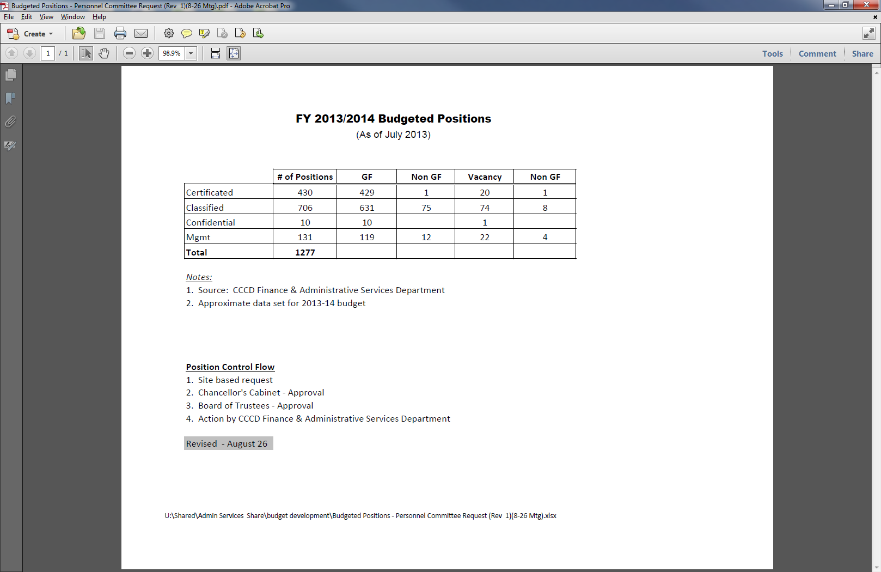

### Recent Budget Strategy and Stability Funding

As a part of the 2012-13 FY budget development strategy, Coast Community College District deliberately reduced enrollments with two issues in mind. First, as budget development was taking place in the spring and summer of 2012, Proposition 30 was not expected to pass. The State budget had been predicated on a voter approved tax initiative to fill a significant revenue gap. In the event of the failure of this ballot proposition, an automatic trigger cut built into the state budget would have resulted in a funding reduction of nearly $11 million and an associated workload reduction of 5.5%. Second, two strategically important yet diametrically opposed issues emerged, on one hand the district had a strong interest in maximizing service and access to its students and, on the other hand, was a fundamental interest in not having to lay-off any contract employees. In the end by utilizing the concept of “Stabilization” which held the district fiscally harmless in the year of enrollment decline, Coast Community College District avoided lay-offs and was still able to offer nearly 95% of the access that had been made available in the prior year.

### Strategic Direction and Growth

It is important to emphasize that the protections offered under Stability only hold the district harmless for one fiscal year. If in 2013-14, the District fails to return to its funded base CA RESIDENT FTES of 32,449, as determined by the 2011-12 FY Final Recalculation, we risk eroding our apportionment funding base. At the close of the 2012-13 FY, Coast reported 30,103 CA RESIDENT FTES putting us 2,346 FTES, or more than 7%, below base which equates to approximately $10.7 million in apportionment funding.

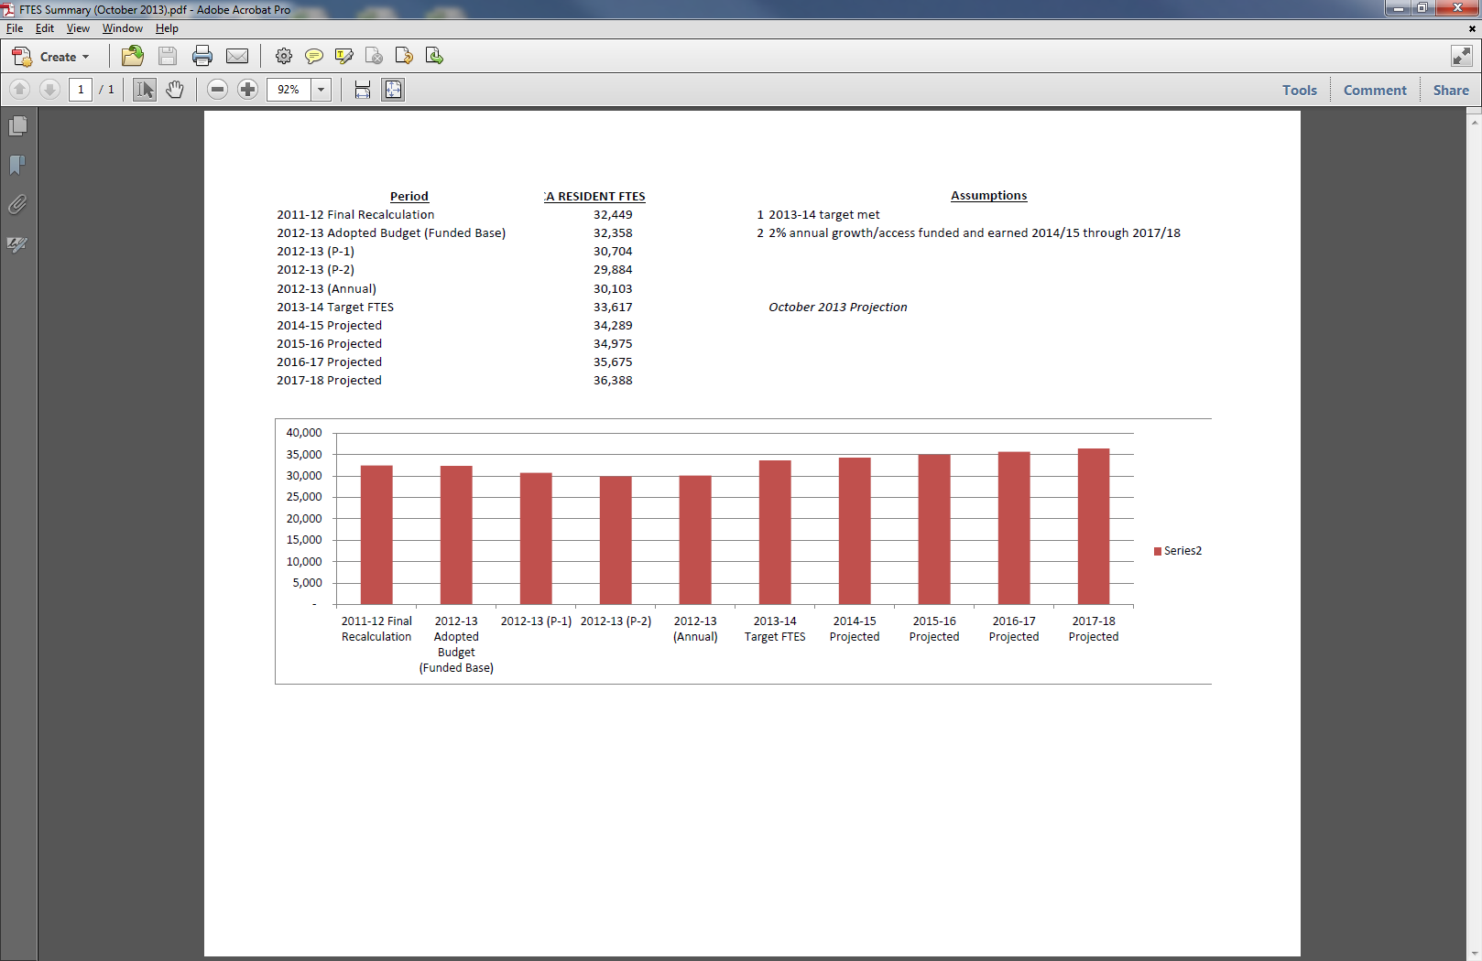

As we look forward to the BOG directive for the fall of 2013, preliminarily and due to declining enrollments discussed in greater detail above, we anticipate the regulatory requirement governing the Full-Time Faculty Obligation (FON) to decline to approximately 360. Coast has an ambitious but not unrealistic growth goal of 33,617 FTES for the coming year. if that goal is achieved we can expect our FON, as determined by the BOG, to increase for the following year. Our multi-year projections at this juncture reflect a rough-order-of-magnitude projection of 2% annual growth.

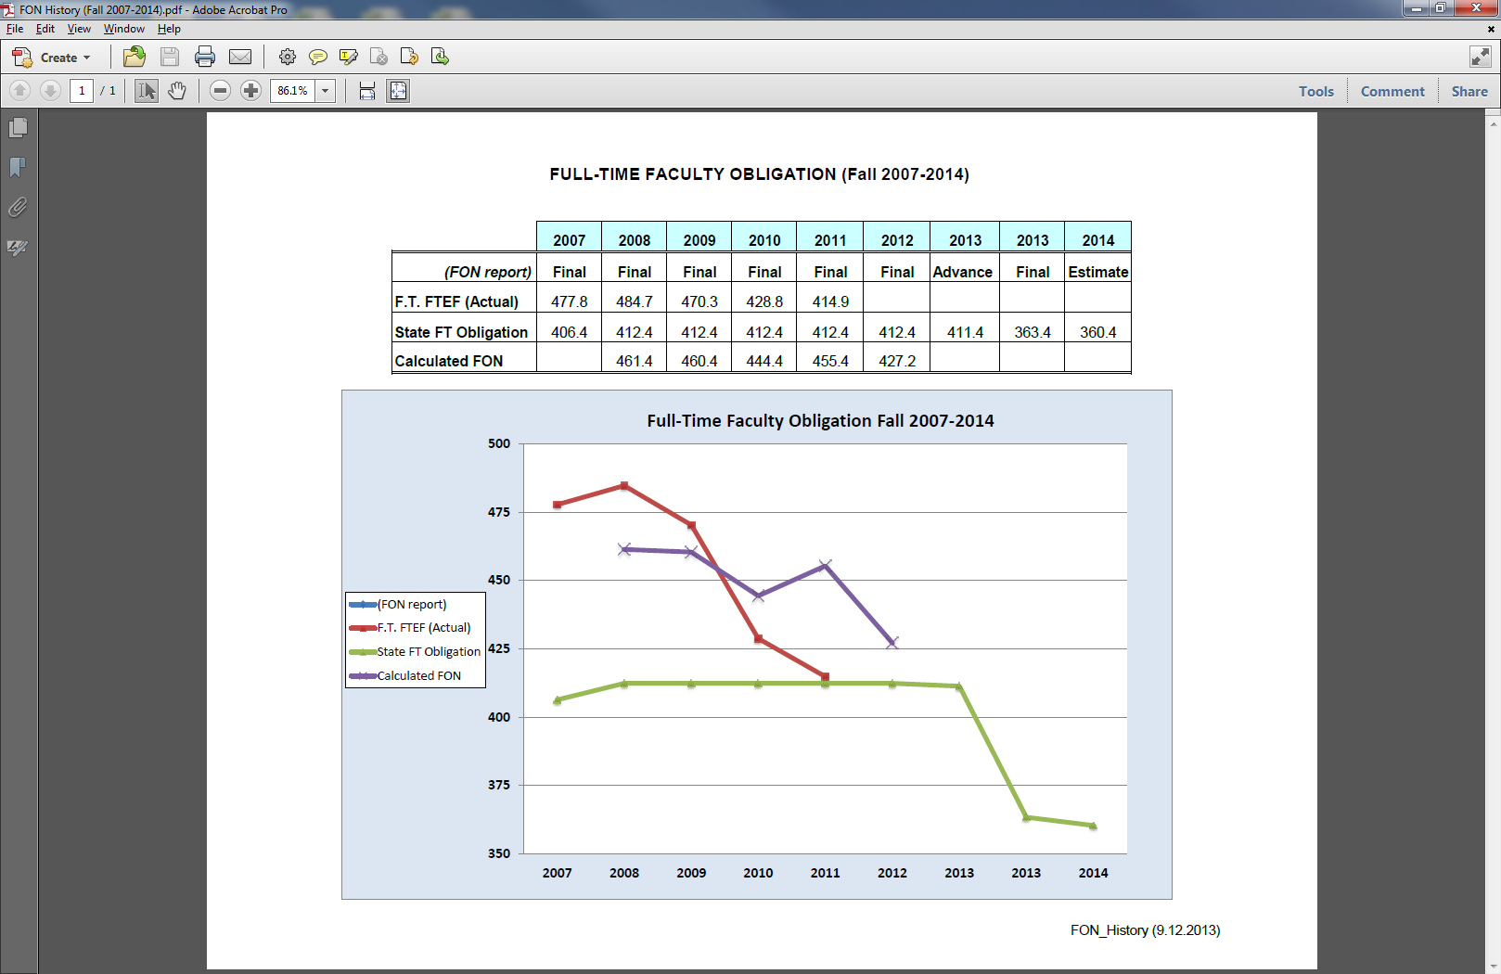

# Current College Faculty Hiring Prioritization Processes

## Process Description/Maps

CCC

**Coastline Community College Full-Time Faculty Hiring Process and Timeline**

Note: This is the process used in the recent past, however, the process in currently being revised.

1. **SEPTEMBER**: **Data compiled**   
   1. **Office or Institutional Research:** The College researchers compile data needed for faulty evaluation support, review, and comparison and post the data on the Research and Planning page of the College website so it is easily accessible.
   2. **Disciplines:** The Dean, Department Chair, and/or lead faculty member(s) for a discipline/program retrieve appropriate data from the Research and Planning webpage. The discipline compiles other required data (FTEF, Number sections, FTES, WSCH/FTEF, number of current full-time faculty, Number of current part-time faculty, availability of part-time faculty, future need projections for courses in program areas, and need for new full-time position in order to support present and future college priorities) and forwards any additional requests for data to the Office of Institutional Research or their Dean.
   3. **Instructional Researcher:** Compiles enrollment and FTES data: Enrollment trends (reflected as FTES) for 5+ years for all disciplines and for top twelve highest FTES-producing disciplines and for any discipline that submits an Intent to Request a Full-Time Position, the number of sections (active and cancelled for three years), average class size, ratio of site-based to distance learning FTES (three years), number of full-time and part-time faculty (expressed as full-time equivalent faculty), percent of sections taught by full-time and part-time faculty (most recent completed semester—generally previous Spring Semester). Instructional Researcher provides copies of data to the Academic Senate, Vice President of Instruction, Vice President of Student Services, and to the disciplines that have filed an Intent to Request a Full-Time Position.
2. **OCTOBER: Prioritization discussions begin**
   1. **Academic Senate:** Senate invites disciplines and the counseling department to present their requests for a full-time position (teaching faculty, librarian, counselors, etc.) to the Senate. Requests should respond to the nine points identified on the Criteria to Prioritize Need for Additional Full-Time Faculty and include any additional data deemed pertinent by the Department Chair and/or Dean. The Senate will consider these requests along with data provided by the Instructional Researcher and develop and submit a prioritized list of their recommendations and rationale to the Program Review Steering Committee, with copies to the Vice President of Instruction, the Vice President of Student Services, and the College President.
   2. **Instructional Managers:** Discuss instructional needs for full-time faculty (positions reporting to Instruction) based on Criteria to Prioritize Need for Additional Full-Time Faculty. Develop and submit a prioritized list of recommendations and rationale to the Program Review Steering Committee, with copies to the Academic Senate, Vice President of Instruction, the Vice President of Student Services, and the College President.

**Student Services/Counseling:** Discuss Student Services needs for full-time faculty (counseling and other positions reporting to Student Services) based on Criteria to Prioritize Need for Additional Full-Time Faculty. Develop and submit a prioritized list of recommendations and rationale to the Program Review Steering Committee, with copies to the Academic Senate, Vice President of Instruction, the Vice President of Student Services, and the College President.

1. **NOVEMBER: Prioritization recommendations are discussed**
   1. **Program Review Steering Committee** reviews and discusses recommendations and rationale for full-time faculty positions from (1) Academic Senate, (2) Instructional managers, and (3) Student Services. Additional areas for prioritization consideration may be discussed in light of recent Program Reviews or additional relevant information. Appropriate representatives (e.g., supervising manager, department chair, or designee) from targeted program areas *may* be invited to a Program Review Steering Committee meeting to discuss the basis for their request. The Steering Committee develops and submits a prioritized list of their recommendations (generally one to three) to the College President, with copies to the Academic Senate, the Vice President of Instruction, and the Vice President of Student Services; the Steering Committee also forwards copies of the prioritized lists and rationale from Academic Senate, instructional managers, and Student Services.
2. **DECEMBER: College priorities are finalized**
   1. **The President** reviews prioritizations from the Academic Senate, instructional managers, Student Services, and the Program Review Steering Committee and generally shares the Program Review Steering Committee’s recommendations with **College Council** before taking action.
   2. **College Council** discusses hiring recommendations and advises the President.
   3. **The President**, based on availability of adequate budget information, responds to the prioritizations, accepting, rejecting, or revising the recommendations received from the Program Review Steering Committee, identifies the number of positions that may be filled, and informs the Steering Committee, Academic Senate, and Vice Presidents of Instruction and Student Services so that the paperwork process can be initiated.
3. **SPRING: Except for extenuating circumstances (including unfavorable budget conditions)**, the general goal is to identify faculty hire positions in the fall, advertise in the spring, and hire for the succeeding fall term.

**INTERIM ACTIONS: Responding to vacancies**

* 1. **Inclusion in the normal prioritization process:** Given adequate notice and to the extent that it is possible without unduly impacting class offerings or program vitality, disciplines/programs that lose a full-time faculty member through retirement, resignation, or other circumstances will follow the procedures outlined above in pursuing authorization to refill the position.
  2. **Responding to vacancies outside the normal prioritization cycle:** If a vacancy occurs after prioritizations have been prepared for the year, a program may submit a request to refill the position by responding to the nine points identified on the Criteria to Prioritize Need for Additional Full-Time Faculty. The program’s request will be submitted to the appropriate Vice President (Instruction or Student Services), who will concur with or deny the request. If concurring, the Vice President will forward the program’s request along with rationale for support to the Academic Senate and the Program Review Steering Committee for immediate review and recommendation to the President. Recommendations by these groups should be made with consideration of the program’s request in relation to hiring priorities identified during the Fall Semester. The President, generally in consultation with College Council, will grant or deny authorization to refill the vacant position.

Revised 17 April 2007 (draft only)

OCC

**Full-Time Faculty Hiring Prioritization**

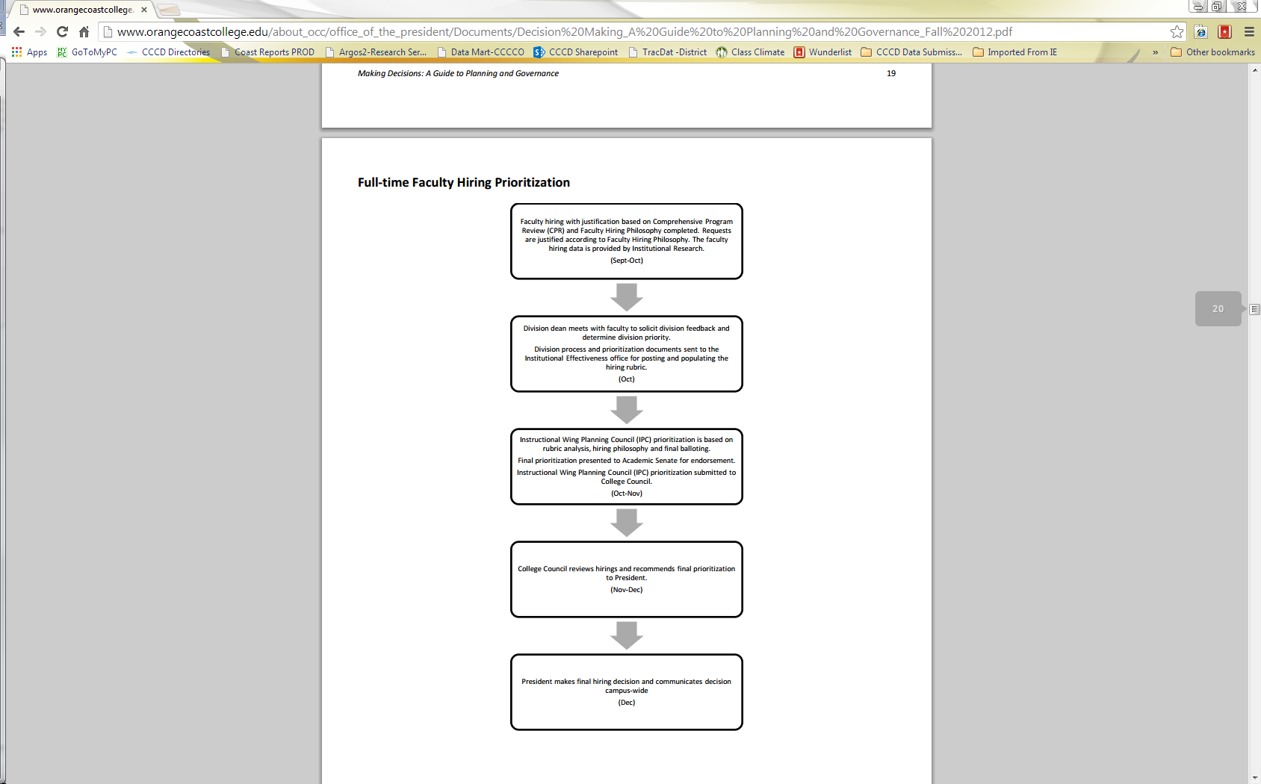

GWC

Faculty Hiring Prioritization Process Map

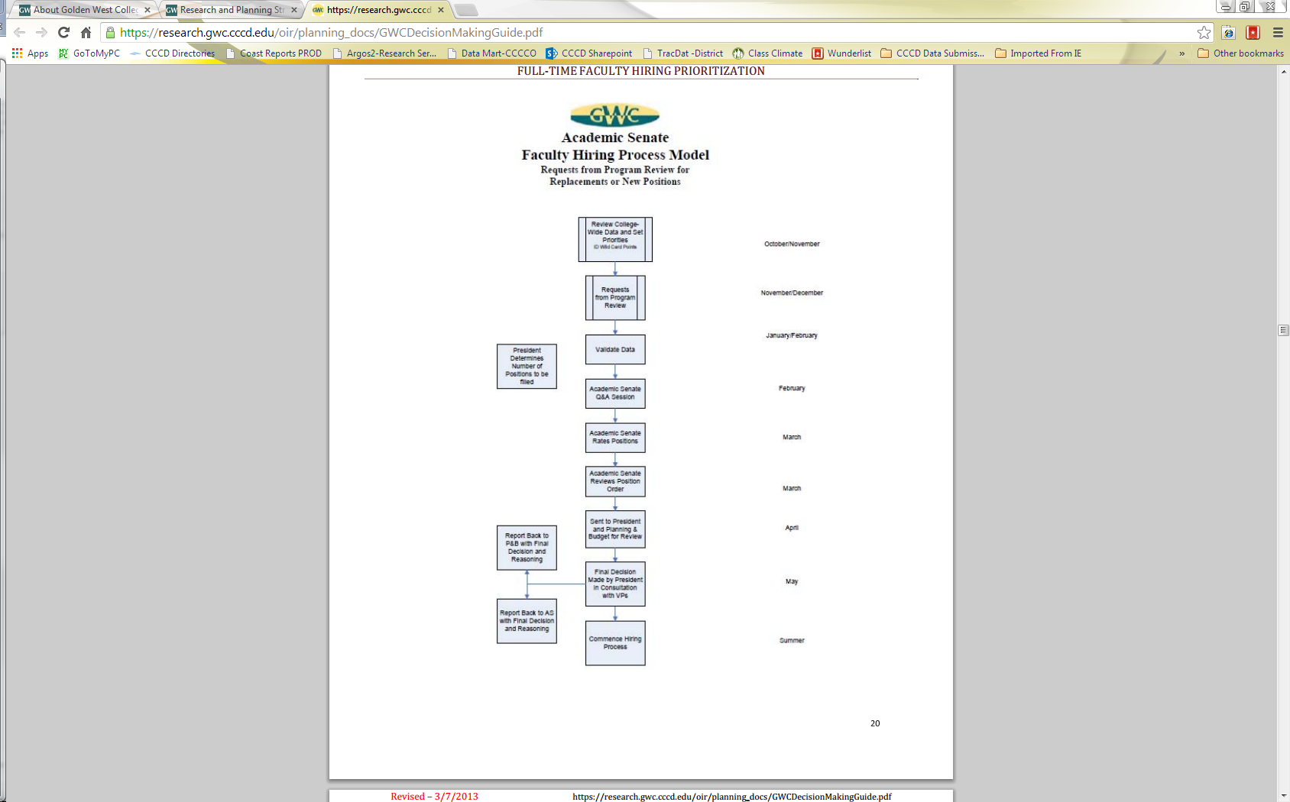

**GWC Faculty Hiring Process for Vacancies Occurring Outside of the Two-year Planning Cycle**

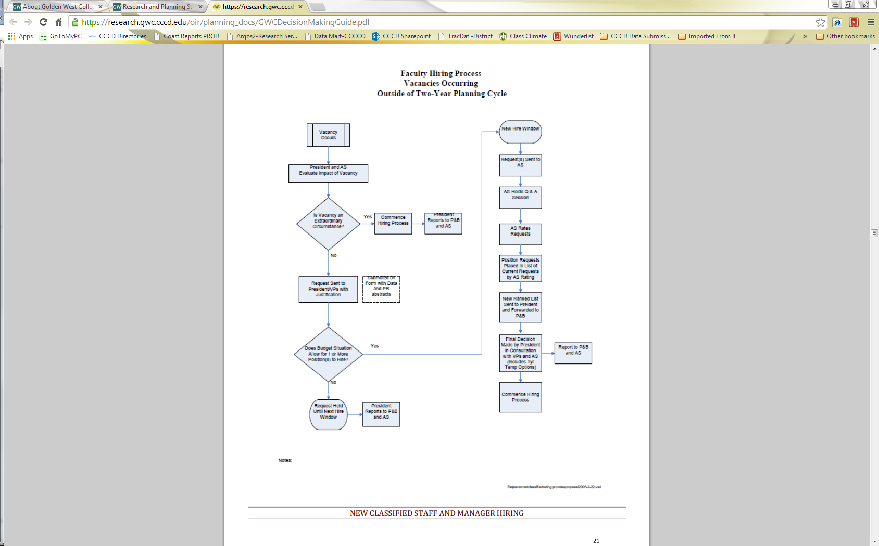

## Criteria Used at the Colleges for Prioritizing Faculty Requests

CCC

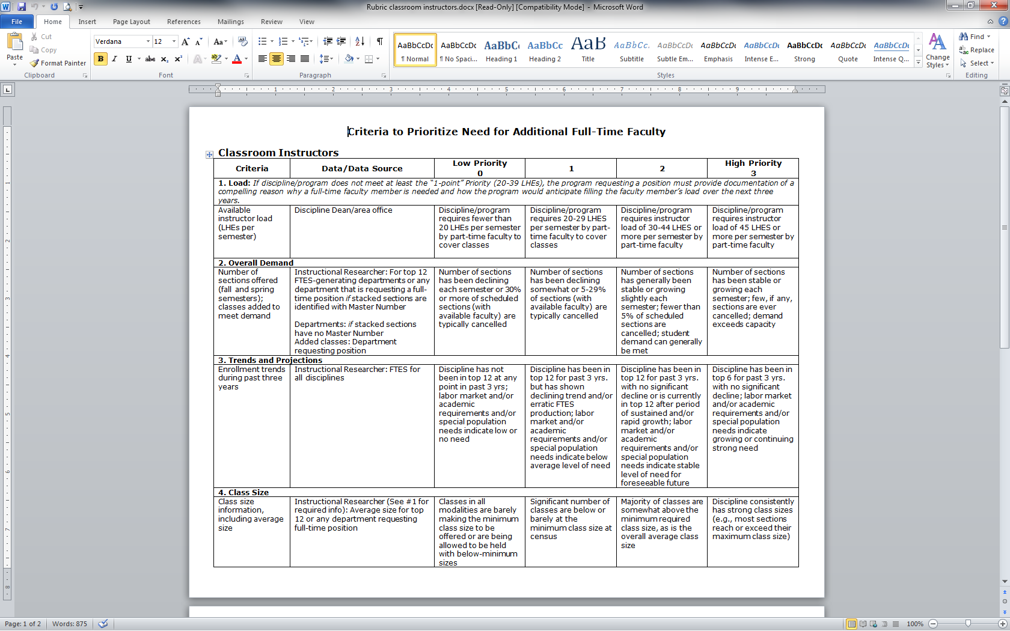

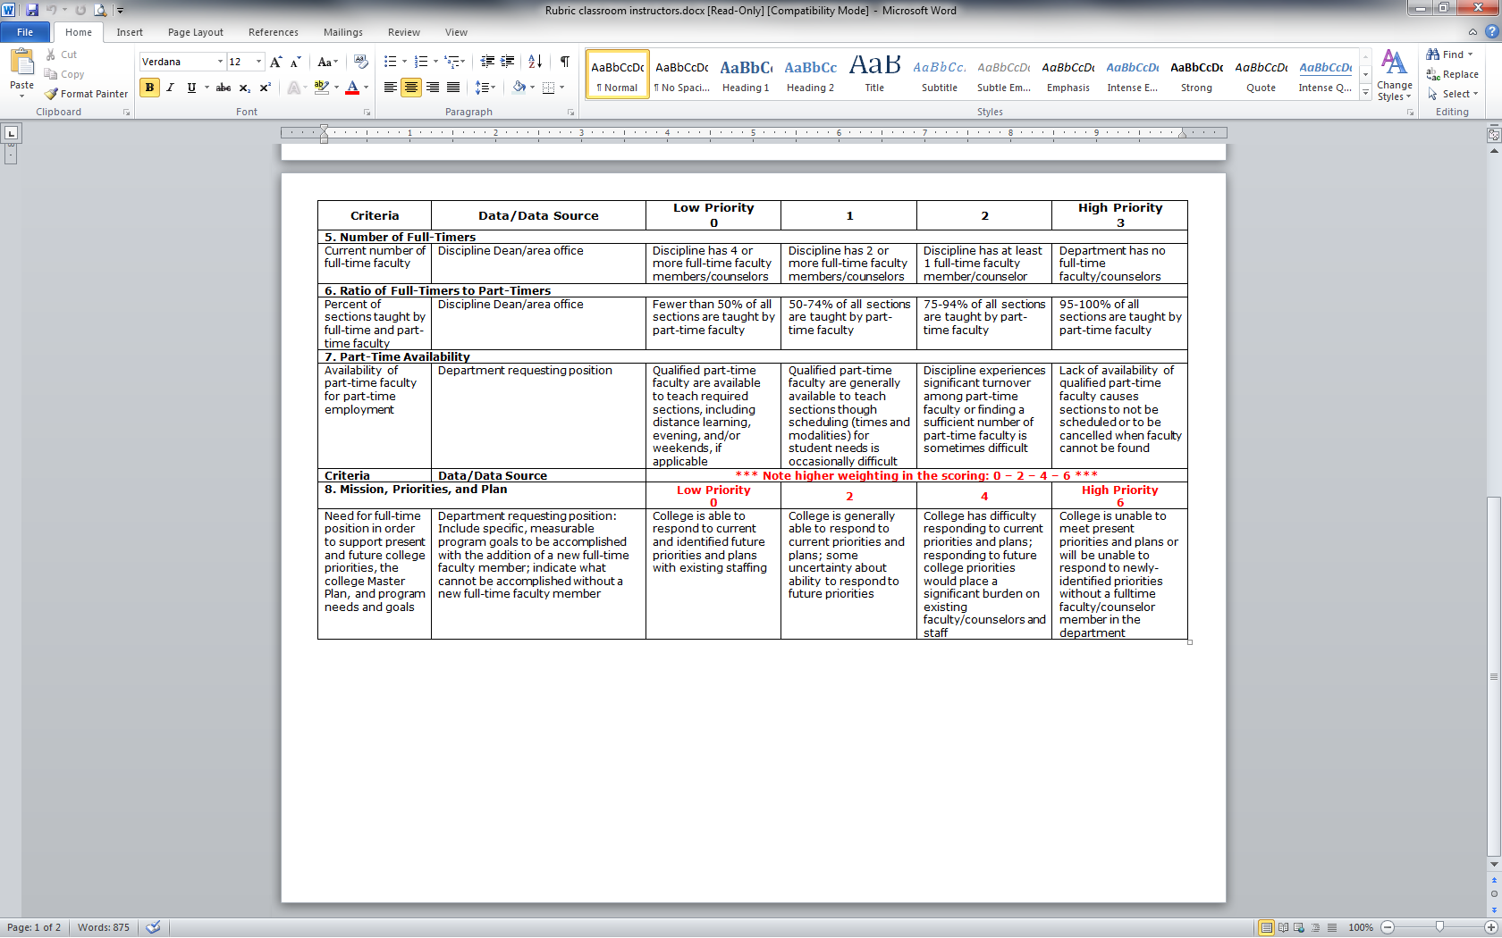

OCC

**0-40 Points**

**35-40 Very high priority** (for the college, division and department/program). Request justification is well documented and supported by compelling evidence. Impact of not receiving the position would be immediate and could jeopardize department/program continuance or college operations.

|  |  |  |  |
| --- | --- | --- | --- |
| **Justification well documented?** | **Supported by compelling evidence?** | **Not receiving the position would have immediate impact?** | **Not filling could jeopardize program continuance or college operations?** |

**29-34 High priority** (for the division and department/program). Request justification is well documented and supported by compelling evidence. Impact of not receiving the position would be substantial on the department and might eventually jeopardize program continuance, but there would be limited current impact on the college.

|  |  |  |  |
| --- | --- | --- | --- |
| **Justification well documented?** | **Supported by compelling evidence?** | **Not receiving the position would be substantial on the department/ program?** | **Not receiving might eventually jeopardize program continuance?** |

**23-28 Priority** (for the department/program). Request justification is documented and supported by evidence. Not receiving the position would result in or continue a negative impact on department teaching and operations, but would not jeopardize program continuance.

|  |  |  |  |
| --- | --- | --- | --- |
| **Justification documented?** | **Supported by evidence?** | **Not receiving the position would result in or continue a negative impact on teaching/ operations?** | **No effect on program continuance?** |

**17-22 Moderate priority** (limited current impact on the department/program). Request justification is documented and evidence is cited. Not receiving the position would result in or continue a limited but manageable negative impact on department teaching and operations. Strategic plans cannot be implemented at this time.

|  |  |  |  |
| --- | --- | --- | --- |
| **Justification documented?** | **Evidence is cited?** | **Not receiving the position would result in or continue a manageable negative impact on teaching/operations?** | **Strategic plans cannot be implemented at this time.** |

**11-16 Low priority** (no current impact on the department/position). Request justification may not be clear, and evidence may not be cited. Department will continue to operate normally, but strategic plans will not be implemented in the future.

|  |  |  |  |
| --- | --- | --- | --- |
| **Justification not clear?** | **Evidence will not be cited?** | **No effect on normal department operations?** | **Strategic plans will not be implemented in the future?** |

**5-10 Lower priority** (no impact on the department). Request justification is not clear or meaningful, and evidence may not be cited. Department will continue to operate normally, but strategic plans may not be implemented in the future.

|  |  |  |  |
| --- | --- | --- | --- |
| **Justification is not clear or meaningful?** | **Evidence may not be cited?** | **No effect on normal department operations?** | **Strategic plans may not be implemented in the future?** |

**0-4 Lowest priority** (no current or future impact on the department). Lacks demonstrated need for the position; justification is weak; little evidence is cited, or the evidence contradicts the stated justification.

|  |  |  |  |
| --- | --- | --- | --- |
| **Lack of demonstrated need for the position?** | **Justification is weak?** | **Little evidence is cited?** | **Evidence contradicts the justification?** |

GWC

**Academic Senate Faculty Hiring Criteria**

Rating Criteria

**1. Program/Department Need 0-60 Points**

**2. College-Wide Need 0-40 Points**

The primary sources of information for rating program/department need are:

• The Faculty Request Form

• Abstract from Program Review

• Abstract from Program Vitality Reports

• Data tables summarizing key program measures such as student enrollment, student success, faculty assignments, and faculty hiring history (found on Banner under Coast Reports)

**#1 PROGRAM/DEPARTMENT NEEDS (0-60 points) –Be as specific as possible**

Important considerations in this prioritization process are conditions unique to the program/department, which Supports the need for additional full-time faculty such as:

• Programs/departments with no or few full-time faculty to teach in particular high demand area or for maintaining on-going (sequential) majors or certificates.

• Programs/departments with no or few full-time faculty

• Negative impact created by the loss of full-time faculty due to retirement or non-replacement of fulltime positions.

• The program/department cannot maintain a stable core of FT to PT ratio to provide a quality program or program growth.

• There is not sufficient full-time faculty to develop and maintain current curriculum for the program/department.

• Supervision required to reduce health and safety hazards.

• There are substantial problems of coordination/supervision of the program’s/department’s PT faculty. (There are not enough FT faculty to coordinate, train, and supervise the PT faculty.)

• Preparation for careers/employment in fields with strong current and future prospects

• There is a verified difficulty in finding and keeping qualified PT faculty (such as excessive numbers of PT selection processes yielding minimal additions to the PT pool.)

• New developments and/or trends in the service area that would influence a determination of need for the position

• Relevant, necessary courses are not taught or are cancelled because of the absence of qualified full or part-time faculty.

0-20 points: Little or no contribution or impact

21-40 points: Some contribution or impact

41-60 points: Significant contribution or impact

**#2 COLLEGE-WIDE NEEDS (0-40 pts)**

Stated long-term college priorities based on the results of appropriate College-wide discussions identified by College plans (see Mission/Vision Statement, Values and College Goals at http://www.goldenwestcollege.edu/about/mission.html)

* Where other considerations are relatively equal, positions in programs that contribute to the operations of other college programs are given greater priority. Other college programs include:
  + Coursework required or recommended for several degree/certificate programs,
  + Significant general education requirements
  + Serve substantial numbers of the student population
  + Serve a special population of students not served by other programs
* Application to Statewide Community College Goals of serving students in Transfer, Basic Skills, Degree and CTE programs
* New programs the college wants to develop and support through resources, facilities
* Contributions to district goals

0-14 points: Little or no contribution or impact

15-28 points: Some contribution or impact

29-40 points: Significant contribution or impact

## Data Elements Considered/Provided to the Prioritization Process

CCC

5+ years for all disciplines and for top twelve highest FTES-producing disciplines and for any discipline that submit an “Intent to Request a Full-Time Position” form.

* enrollment trends (reflected as FTES) ,
* the number of sections (active and cancelled for three years),
* average class size,
* ratio of site-based to distance learning FTES (three years),
* number of full-time and part-time faculty (expressed as full-time equivalent faculty),
* percent of sections taught by full-time and part-time faculty

OCC

Separate data sets for three academic years by Division and Discipline

* FT Faculty Headcount
* PT Faculty FTEF
* PT Faculty LHE
* % of Instruction Taught by PT Faculty
* FTES by Department

GWC

All validated data and analysis contained in the program review report is considered. No separate data set is produced. The Standard (minimum) data elements provided in Excel for four years for program review include the following: (The complete data cubes are also available for further analyses.)

* Enrollment Productivity: Sections, Enrollment, Fill-Rates, FTES, WSCH/FTEF (525), and WSCH/FTEF(595)
* Success by Modality and Class Size: Enrolled and Success Rate
* Access: Enrollment and Course Success Rate by Age, Gender, and Ethnicity
* Degrees and Certificates: Count of awards by Type and title

## Forms Used at the College for Faculty Requests

GWC

Golden West College

Faculty Request

Requestor’s name Phone #: 714-895-8966

Program Review Unit (PRU):

POSITION REQUESTED

( ) New

( ) Replacement Replaces faculty name:

How long has this position been vacant?

EXTRAORDINARY CIRCUMSTANCE

( ) Seeking immediate replacement due to Extraordinary Circumstance (as defined by the Academic Senate)

“Extraordinary circumstances shall be defined as an instructor resignation, incapacitation or death.”

What is the extraordinary circumstance justifying an immediate replacement?

What are the consequences if this position is not immediately replaced?

( ) Within Two-Year Planning Cycle

( ) Outside of Two-Year Planning Cycle: (Specifically note the “unanticipated” or “significant” change in faculty need since the last Program Review and Faculty Rating Process)

Reviewed by:

Dean: Date:

Vice President: Date:

How does this request for a faculty position meet the following criteria? (2 page max.)

(To be used by Senators to rate the request)

(See page 3 and 4 for descriptions of the rating criteria and point distributions.)

Respond fully to each of the following questions. Your responses are the basis from which Senators apply the criteria to determine the rating of this request. Be as specific as possible in your responses.

#1 PROGRAM/DEPARTMENT NEEDS (0-60 points)

What program/department conditions support the need for additional full-time faculty as opposed to part time faculty?

#2 COLLEGE-WIDE NEEDS (0-40 pts)

How does this position address stated long-term college priorities identified by College plans? (e.g. Master Plan, Instructional Plan, Student Support Plan, Facilities Plan, College Mission, Vision, Values and Goals, district goals, state goals and mandates)

OCC

**FACULTY PRIORITIZATION REQUEST**

**TRANSFER/BASIC SKILLS AND CTE PROGRAMS**

|  |  |
| --- | --- |
| Date: |  |
| Department: |  |
| Position Requested: |  |
| Department Ranking: | Ranked # of how many positions: |
| Division Ranking: | Ranked # |

**Department Characteristics**

Discuss the department characteristics, data and trends provided by Institutional Research, as appropriate in the box below. Identify the specific number of a question, when responding, as there may be specific trends that support the request. Please be concise in your answers as the word count is fixed to accommodate 500 words only with a font size of 8.

1. Number of full-time faculty members in the department in each of the past three academic years.
2. Part-time faculty (expressed as full-time equivalents) in each of the past three academic years.
3. LHE taught by part-time faculty in each of the past three academic years.
4. Percentage of instruction taught by part-time faculty in each of the past three academic years.
5. Number of FTES (full-time equivalent students) generated by the department in each of the past three academic years.

**Position Characteristics**

Discuss the position characteristics, as appropriate in the box below. Identify the specific number of a question, when responding, as there may be specific information that supports the request. Please be concise in your answers as the word count is fixed to accommodate 500 words only with a font size of 8.

1. Identify the position and include any desired qualifications, expertise, or position requirements.
2. Does the department have a sufficient number of well-enrolled sections to ensure an ongoing, full-contract load for the requested position? If there is not adequate load, please elaborate.

**Position Justification**

Discuss the position justification, as appropriate in the box below. Identify the specific number of a question, when responding, as there may be specific information that supports the request. Please be concise in your answers as the word count is fixed to accommodate 1500 words only with a

font size of 8.

1. Answer the following questions to justify the need to hire a full-time faculty member, rather than hiring additional part-time faculty members. These questions are intended as prompts, not as a comprehensive list of all possible needs. Provide descriptions supported by data and evidence where possible. Departments should answer as many of the prompts as are appropriate to the request.
   1. What does the department’s program review identify as the reasons the position is needed? (Include the year of the program review and the page number[s]. <http://occportal/Departments/Administration/InstitutionalEffectiveness/program-review/Pages/InstructionalProgramReview.aspx>)
   2. Is the position needed to replace recent or anticipated retirements/resignations? (Cite the number of non-replaced positions and the years in which they occurred. Refer to the full-time headcount numbers, PT – LHE and percentage of instruction taught by PT in the department characteristics data.)
   3. Does the department need to reduce the percentage of part-time instruction, reduce the number of part-time faculty, and/or alleviate the difficulty in finding qualified part-time faculty?
   4. Is the position needed to revise the curriculum? (Describe the modifications and why current faculty—full- and part-time—and potential part-time faculty are not able to accomplish this. If CTE, summarize the Advisory Committee minutes or other documentation of curricular need. See last PR and/or latest Advisory Committee minutes.)
   5. If CTE, what is the labor market outlook for students taught by the position? (See PR Biennial Review Discussion and/or check the web site: <http://occportal/Departments/Instruction/career%20education/Pages/default.aspx>)
   6. If CTE, is the position needed to support or increase the number of students receiving internships or employment opportunities? How will a new full-time faculty member help with this?
   7. Is the position needed to increase the number of students transferring, receiving degrees, and/or receiving certificates? How will a new full-time faculty member help with this? (Provide the most current numbers from PR.)
   8. Is the position needed to assist with program review, SLO assessment, evaluation of part-time faculty, recommending textbooks, attending advisory committees, recommending program scheduling, and other unique department needs? How will a new full-time faculty member help with this?
   9. How might this position complement other departments and the college? (What other departments might benefit and how?)
   10. What are the consequences of not receiving the position? (Accreditation or licensing status, program continuity, program vitality, etc. Consider productivity level-refer to FT faculty FTES generated.)
   11. Describe any other reasons the position is needed.

**OTHER**

1. What other information does the Prioritization Committee need to know to make an informed decision about your request? Discuss as appropriate in the box below. Please be concise in your answers as the word count is fixed to accommodate 500 words only with a font size of 8.